**Dates for your diary:**

* Curriculum meeting: 9am on Thursday 21st September
* Harvest Festival at St. Mary’s: 9am on Thursday 28th September
* INSET DAY: 20th October
* Half term: Monday, October 23rd – Friday, October 27th
* Beginning of Term 2: Monday, October 30th
* Parent Consultations:

Tuesday, November 7th 3.30pm - 5.30pm

Thursday, November 9th 5.30 - 7.30pm

Wednesday, November 15th 4 - 6pm

**Things you could try at home to enrich this term’s project:**

* Visit the Weald and Downland Open Air Museum
* Read T.H. White’s Sword in the Stone
* See the Sutton Hoo treasure at the British Museum in London
* Read books on Norse mythology
* Visit a castle or palace

**Our school website address is:**

[www.barcombe.e-sussex.sch.uk](http://www.barcombe.e-sussex.sch.uk) and our class blog is at <http://barcombefoxes.wordpress.com> where you will find information about the class, home learning, upcoming events and links to useful websites.

**Fox Class information:**

**P.E**.

Our P.E afternoon will be **Monday** this term. Please can children have their full P.E kits in school, remembering a tracksuit to keep warm in case we are able to go outside.

**Homework**

Homework will be sent home on Fridays to be returned to school the following Thursday.

**Reading Diaries:**

Try to hear your child read 3 times a week and update the reading diaries. Please bring reading books back to school every day.

Teacher: Ms Battle

Teaching Assistant: Mrs Wigley

**Welcome to**

**Fox Class**

**Curriculum Information**

**Term 1 and 2**

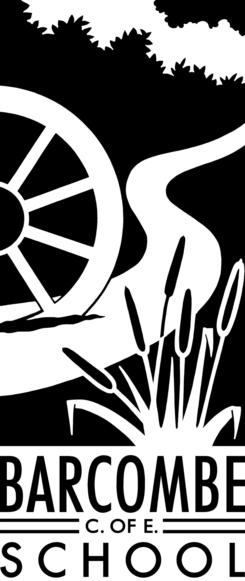

ART & DT

This term the children will investigate textiles through weaving. They will also have the opportunity to learn to create patterns in their weaving. Linking with the Anglo-Saxon history theme, we will look at jewellery of the time to create our own Saxon brooches. In Term 2 we will explore light and shadow through drawing.

HISTORY and GEOGRAPHY

In history this term we will learn about the Anglo-Saxons and the Vikings and their struggle for the Kingdom of England to the time of Edward the Confessor and his death in 1066. Through our ‘Take One Monarch’ topic, we will be exploring the life of King Arthur the Great, comparing the time he was alive with today. In term 2 we will learn about economic activity through trade links.

MUSIC

This term, we will be learning to sing, play, improvise and compose through the song Mamma Mia. In term 2 we will focus on Five Gold Rings.

ENGLISH

During English this term we will be looking at story writing and biographies. At first, we will become familiar with the structure of the legends of King Arthur. Children will use the features of a legend to write their own story and include fronted adverbials for cohesion and add speech and dialogue to convey character and advance action. Later in the term we will learn about King Alfred the Great in order to write his biography, using factual knowledge. Children’s understanding of grammar, punctuation and vocabulary will be developed throughout the year during all topics and handwriting will be practised frequently.

P.E.

In P.E. we will be looking at the skills involved in competitive games with the emphasis on communicating, collaborating and competing with each other. The children will develop their ability to use a variety of passes, using throwing techniques as well as with equipment. They will also be learning attacking and defending skills and putting them into use in competitive games. In term 2, the children will focus on movement and co-ordination, and further development of flexibility, strength, technique and control.

MATHEMATICS

In Maths we will be developing a solid understanding of number and place value and exploring various techniques to add, subtract, multiply and divide, both mentally and using a formal written method. We will be investigating negative numbers, rounding, ordering and comparing numbers, estimating and applying this knowledge to real life situations. The children will also be developing their ability to reason with and solve problems involving number and place value. In Year 4 the emphasis will be on the place value of numbers beyond 1000, whereas in Year 5 it will be numbers up to 1,000,000. In Fox Class we will continue to practice our times tables by becoming scholars, wizards and masters!

Our Learning Journeys are:

**Take One Monarch**

and

**Trading Posts**

R.E.

In RE we will be learning about The Q’ran and understanding some of its stories. In term 2 we will explore religious music and compare the ways in which music is used in different religions. We will also have a Christmas focus next term.

FRENCH

We will be learning how to count in French, the days of week and to identify some animals. We will learn that all nouns have gender. We will focus on recognising and using the correct pronunciation of key vocabulary.

SCIENCE

This term we will be investigating animals, including humans, and what they need to survive. We will develop our knowledge of teeth, the digestive system and food chains, including producers, predators and prey. Next term, the topic will be ‘Light’ where we will explore and develop our knowledge of how light behaves, including light sources, reflection and shadows. The children will also be developing their ability to think scientifically through investigation, making predictions and drawing conclusions.

P.S.H.E

In P.S.H.E the topics are ‘Being me in the world’ and ‘Celebrating differences’. The children will be using group discussions, games and role-play techniques to develop their awareness of themselves, others and the world around them.

COMPUTING

Our first Computing unit is about e-safety. We will be learning how to stay safe online by finding out more about privacy settings, online conversations, connecting with others and digital literacy as well as writing a blog.