Term 4 Newsletter 1 |  | February 24th , 2017

Barcombe CE Primary School

Executive Headteacher: Stewart James  Head of School: Ruth Force | office@barcombe.e-sussex.sch.uk  www.barcombe.e-sussex.sch.uk Address: School Path, Barcombe Cross, BN8 5DN  Tel: 01273 400287
Dear Parents and Carers,  Welcome to Term 4! We are half-way through the school year and what fun everyone in school is having with all the learning that is going on. Our new learning journeys have started: Hedgehogs and Squirrels are finding out all about knights, castles and dragons while Badgers, Foxes and Owls are heading across the Atlantic to find out about North and South America.  Maths Day  As you will see when you visit the school during the next few weeks and see our wonderful corridor displays, we are focussing on maths. Thanks as always to Mrs Edwards for her excellent artwork! We are putting a special emphasis on reasoning - explaining how we have got our answers and convincing others that we are correct.  Today, we have had an exciting Maths Reasoning Day in school. The children have been working on a wide range of maths challenges where they have had to explain their thinking and prove they are correct. As part of the day, we had a visit from a real Mathemagician, Andrew Jeffrey.  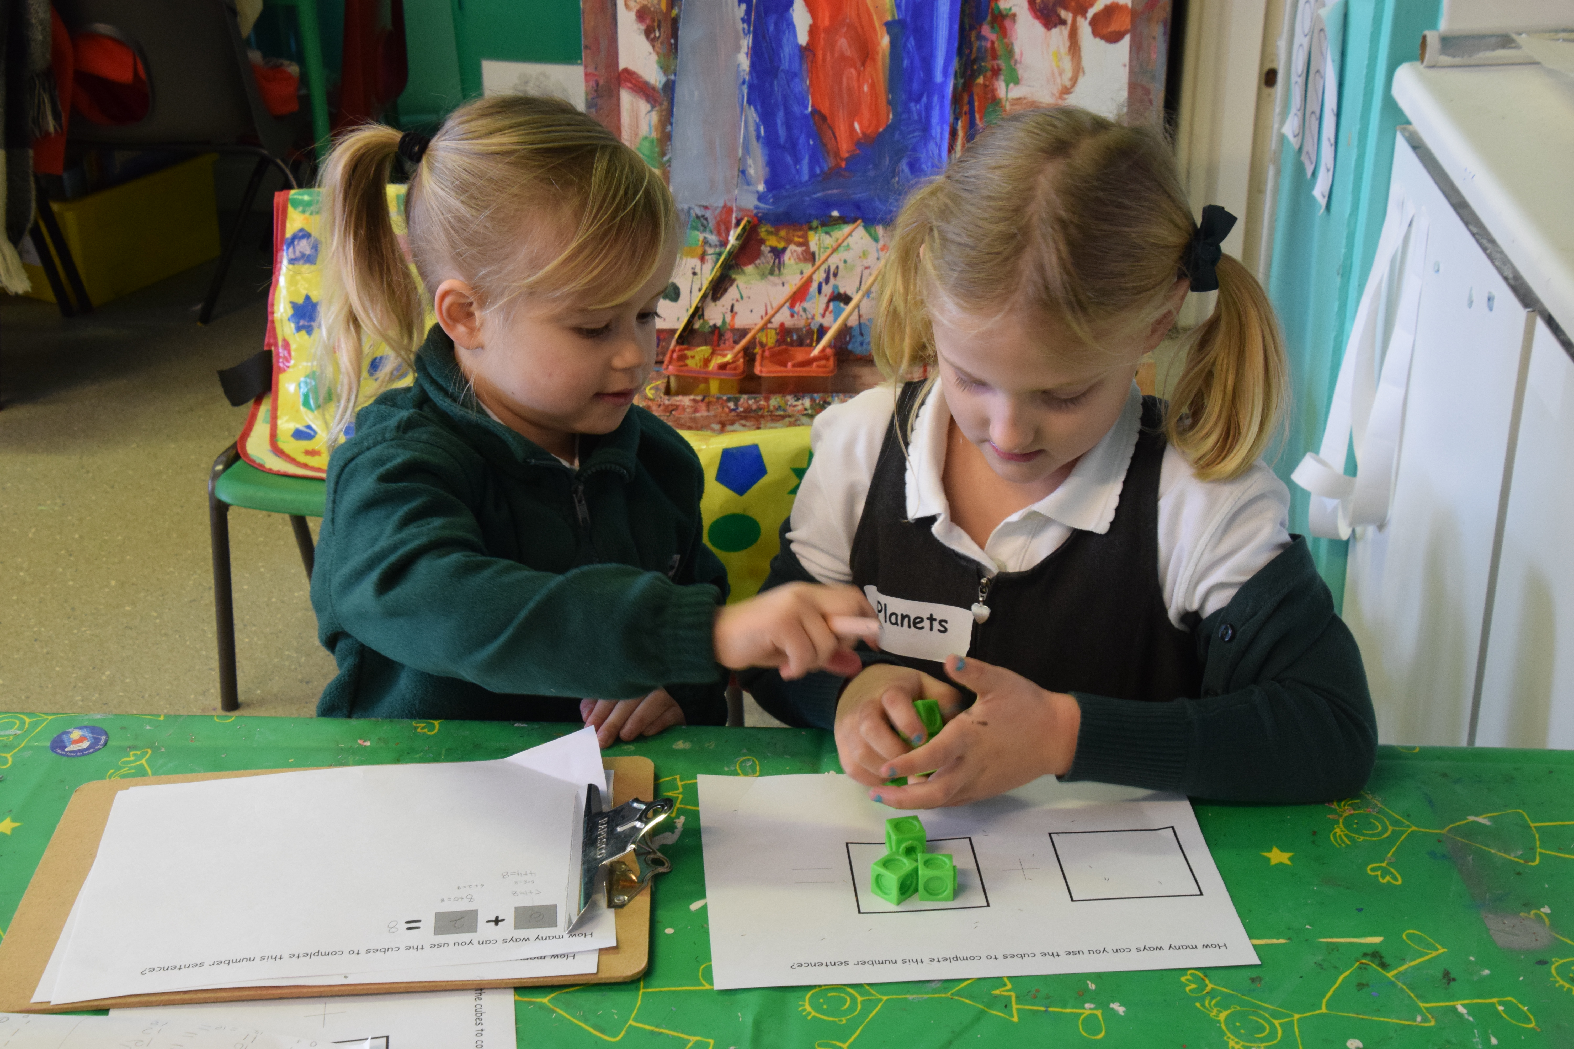  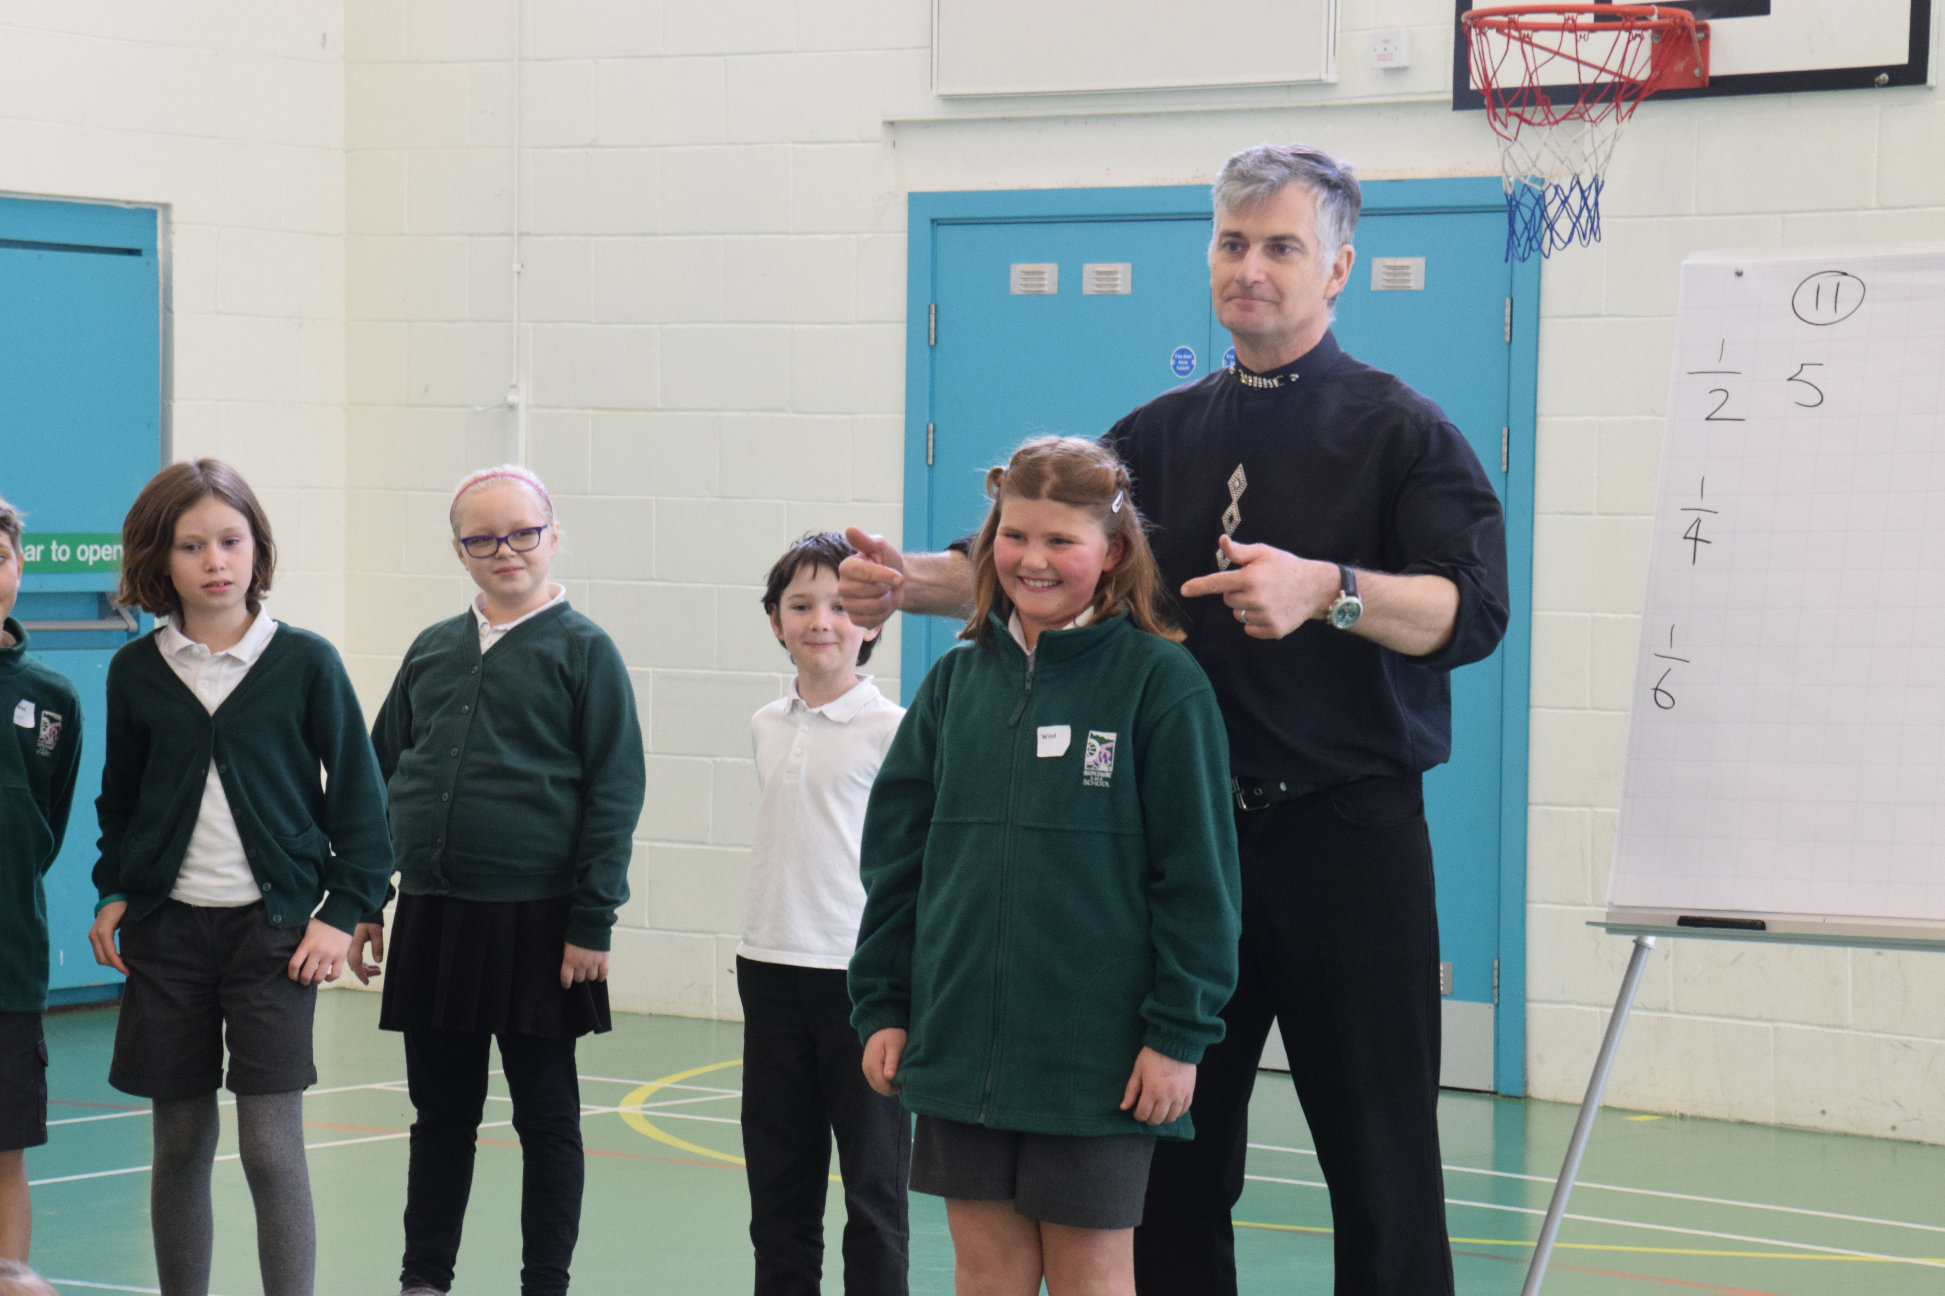  Have a look on our class blogs and see what other exciting things have been happening today.  Attendance  Badgers Class are this week’s winners of the attendance cup with attendance of 98.7%. Well done, Badgers! The other class attendance figures are:  The threshold for ‘good’ attendance is 95%. Please help us to keep our attendance percentage as high as possible by making sure your child is in school and on time every day.  Extreme Singing!  We are still waiting for your wonderful photos to create our Extreme Singing display. We would like photographs of your child/children singing in an ‘extreme’ place, perhaps up a tree, hanging upside down from a climbing frame…..the possibilities are endless! Let your creativity go wild! Please email your photos to the school office ready to go on display in school or print them out and hand them to Mrs Force.  Playground  Thank you for encouraging your children to be in the playground before the bell rings. This is working well for everyone. The school gates are open for children from 8.35am and after that time they are supervised by staff while in the school playground. When in the school playground, please be aware of where your child is. We kindly ask that our pupils and their siblings do not play on the playground equipment before or after school.  Blogs  Our class blogs are regularly updated with news and photos linked to what the children have been doing in class. There are also new pages on the blogs with information about spellings, recommended reading books and key instant recall facts for maths for each year group. Using these lists and recommendations is a perfect way to support your child at home. | School Uniform  Please can we remind you that we ask that children should wear sensible, dark coloured shoes to school; trainers are to be worn for PE sessions only. It would be helpful if you could ensure that all items of clothing are clearly marked with your child’s name. Please ensure that your child has his/her PE kit in school every day, especially for taking part in the Daily Mile initiative.  Good News.  We have recently been visited by our School Improvement Partner. All aspects of our work and the children’s learning were checked during the visit and I am delighted to tell you that Barcombe is still regarded as being an outstanding school. Well done to all the staff and children.  Welcome  We are pleased to welcome Miss Hayes to Barcombe’s staff team. She will be working as the teaching assistant in Owls Class and will also be coordinating sports events. She has a lot of experience of working in schools and of organising sporting events. The first event of the term will be next week when we send a team off to play Tag Rugby. Good luck to those involved.  Keys  A set of keys was found just outside the school gates before the half term break. If you know of anyone who has lost some, please point them in the direction of the school office.  Dates for your diary  Please note these dates are not exhaustive and can be subject to change.  Best wishes,  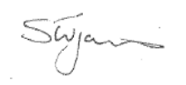  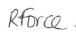  Ruth Force Stewart James
  Foxes | 98.1%
  Hedgehogs: | 95.1%
  Squirrels | 93.1%
  Owls | 92.9 %
  March 2017
  Thursday 2nd | Hedgehogs class assembly (note date change)
  Thursday 2nd | World Book Day
  Wednesday 8th | VIAM Year 5 and 6
  Thursday 9th | Badgers class assembly
  Tuesday 14th | Parent consultations  3.30pm – 5.30pm
  Wednesday 15th | Parent consultations  5.30pm – 7.30pm
  Thursday 16th | Squirrels class assembly  (note date change)
  Friday 17th | Hedgehogs Break Out of Barcombe
  Tuesday 21st | Badgers, Foxes, Owls to Herstmonceux Science Centre
  Wednesday 22nd | Parent consultations  4pm – 6pm
  Thursday 23rd | Owls class assembly
  Friday 24th | Year 3 Break Out of Barcombe
  Tuesday 28th | Skipping Workshops
  Thursday 30th | Easter Service at St Mary’s 9am
  Friday 31st | End of Term 4

