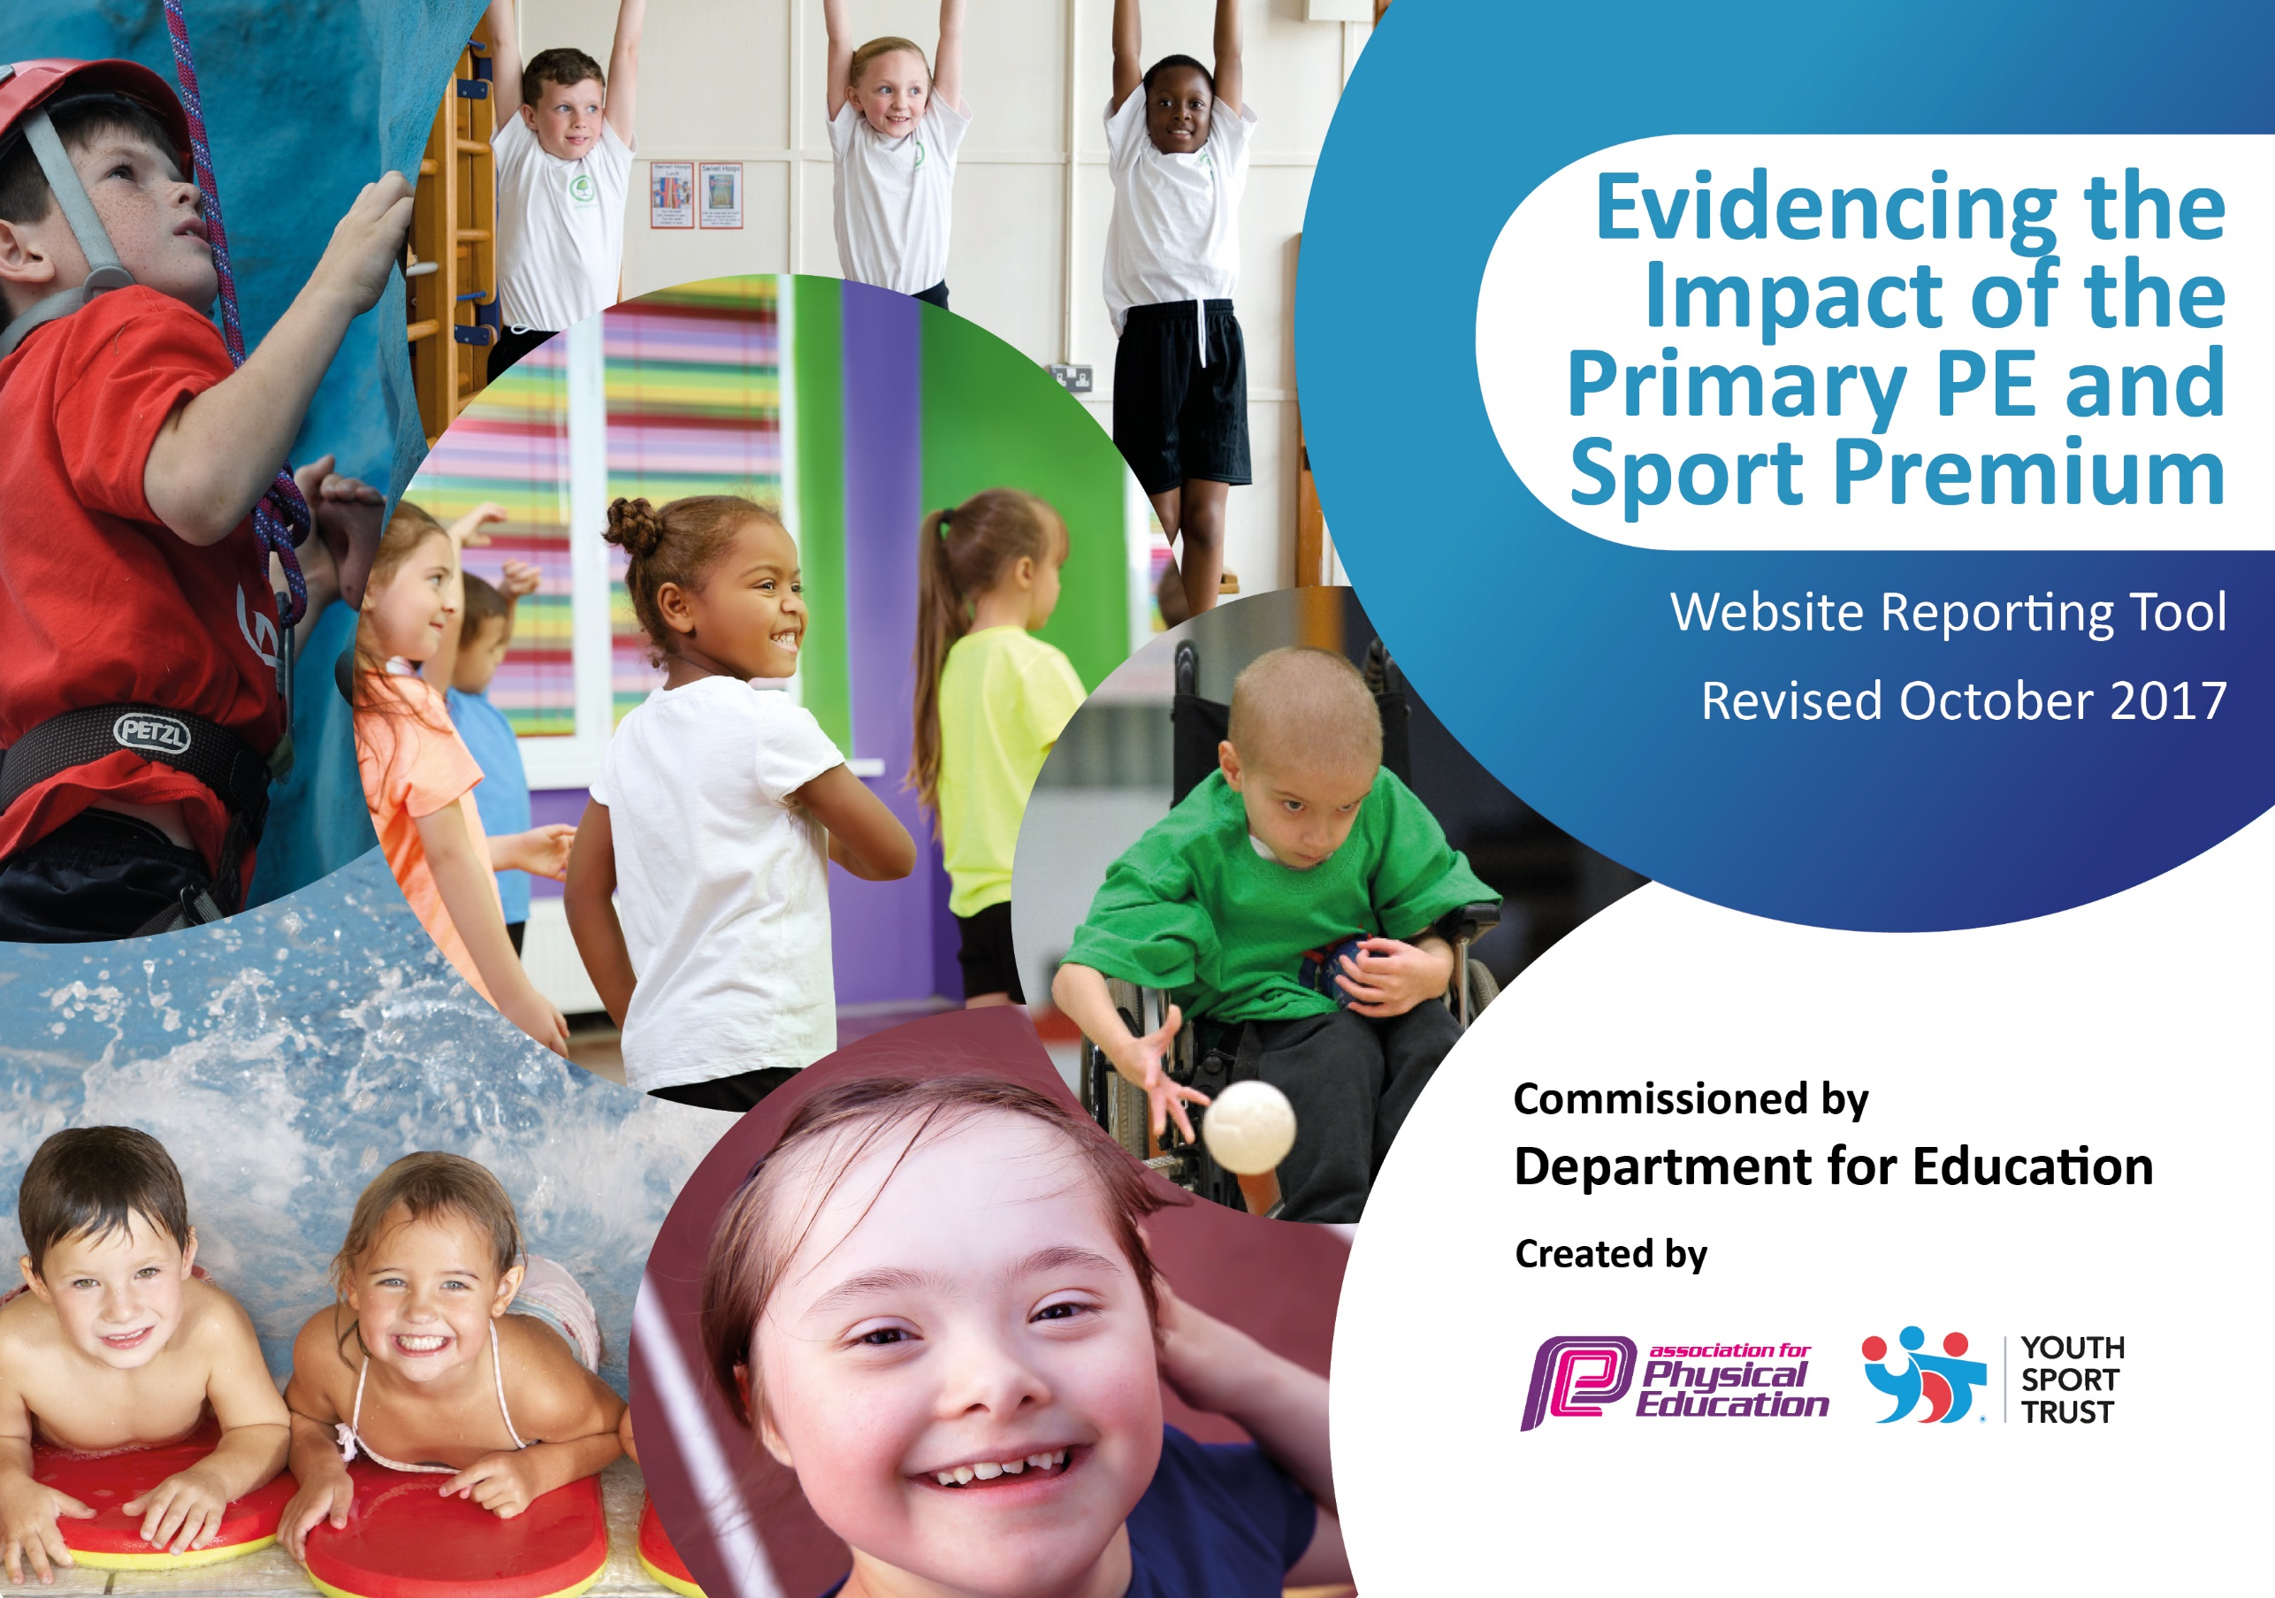

Schools must use the funding to make additional and sustainable improvements to the quality of PE and sport they offer. This means that you should use the Primary PE and Sport Premium to:

- develop or add to the PE and sport activities that your school already offers
- build capacity and capability within the school to ensure that improvements made now will benefit pupils joining the school in future years

Please visit gov.uk for the revised DfE guidance including the 5 key indicators across which schools should demonstrate an improvement. This document will help you to review your provision and to report your spend. DfE encourages schools to use this template as an effective way of meeting the reporting requirements of the Primary PE and Sport Premium.

We recommend you start by reflecting on the impact of current provision and reviewing the previous spend.
Under the Ofsted Schools Inspection Framework, inspectors will assess how effectively leaders use
the Primary PE and Sport Premium and measure its impact on outcomes for pupils, and how effectively governors hold them to account
for this.

Schools are required to publish details of how they spend this funding as well as on the impact it has on pupils’ PE
and sport participation and attainment.
We recommend regularly updating the table and
publishing it on your website as evidence
of your ongoing review into how you are using the money
to secure maximum, sustainable impact. To see an example of how to complete the table please click HERE.

Support for review and reflection - considering the 5 key indicators from DfE, what development needs are a priority for your setting and your students now and why? Use the space below to reflect on previous spend, identify current need and priorities for the future.

Barcombe:  Sports Premium Spend 2016-17 Total Allocation: £8313  Key achievements to date: | Areas for further improvement and baseline evidence of need:
Key indicator 1: The engagement of all pupils in regular physical activity – Chief Medical Officer guidelines recommend that primary school children undertake at least 30 minutes of physical activity a day in school.  Across the Federation of three schools, qualified Sports Coach supports and mentors teachers in the delivery of high quality PE provision. Introduction of the daily mile, daily circuits.  Training for Yr. 6 Sports Leaders to lead playtime games.  Key indicator 2: The profile of PE and sport being raised across the school as a tool for whole school improvement.  New PE equipment purchased to ensure teachers are better equipped to teach high quality PE lessons.  Qualified coach leading Football, netball, Yoga after school clubs.  Key indicator 3: Increased confidence, knowledge and skills of all staff in teaching PE and sport.  Qualified coaches supporting teachers during PE sessions.  Key indicator 4: Broader experience of a range of sports and activities offered to all pupils.  Qualified coaches supporting teachers during PE sessions.  Key indicator 5: Increased participation in competitive sport.  Support from Chailey Secondary School to plan and lead competitive events.  Training for HLTA to prepare and lead groups /teams of children to offsite tournaments. | Increase the role of the sports coach to include working with vulnerable groups. Improve social /communication skills.  Sports coach to focus on health and nutrition, use fitbits to measure heart rate and demonstrate increased physical health.  Introduce a range of new sports to the Federation –Extreme Frisbee, Stoolball, tennis coaching. Introduce more outdoor and adventurous activities –link to a qualification to be gained by children.  Sports leader to raise the profile and frequency of intra sports competitions.

Meeting national curriculum requirements for swimming and water safety | Please complete all of the below:
What percentage of your Year 6 pupils could swim competently, confidently and proficiently over a distance of at least 25 metres when they left your primary school at the end of last academic year? | 90%
What percentage of your Year 6 pupils could use a range of strokes effectively [for example, front crawl, backstroke and breaststroke] when they left your primary school at the end of last academic year? | 80%
What percentage of your Year 6 pupils could perform safe self-rescue in different water-based situations when they left your primary school at the end of last academic year? | 20%
Schools can choose to use the Primary PE and Sport Premium to provide additional provision for swimming but this must be for activity over and above the national curriculum requirements. Have you used it in this way? | No

Action Plan and Budget Tracking
Capture your intended annual spend against the 5 key indicators. Clarify the success criteria and evidence of impact that you intend to measure to evaluate for students today and for the future.

Academic Year: 2017/18 | Total fund allocated: £ 17300 | Date Updated: 12.1.18
Key indicator 1: The engagement of all pupils in regular physical activity – Chief Medical Officer guidelines recommend that primary school children undertake at least 30 minutes of physical activity a day in school |  |  |  | Percentage of total allocation:
 |  |  |  | 50%
School focus with clarity on intended impact on pupils: | Actions to achieve: | Funding allocated: | Evidence and impact: | Sustainability and suggested next steps:
Increase the role of the sports coach to include working with vulnerable groups. Improve social /communication skills. Lead and support playtime games.  Sports lead to lead children through a selection of physical activities before school on at least two occasions a week.  Training for playground buddies /MDSA’s  To support more children have opportunities to access playground games. To reduce incidents of inappropriate behavior during playtimes.  Update and replenish sports equipment and resources | Sports lead to work with Inclusion Manager and class teachers to identify vulnerable pupils /groups of pupils.  Increased physical exercise opportunities before the school day  Sports lead to support playground leaders to set up a rota and train to lead a variety of playground games.  Buy new equipment to ensure teachers are able to deliver high quality PE sessions. | £8580  (Sports Leader)  £200 ( training)  £100 (training)  £1000  (equipment) | Identified individuals and vulnerable groups to show improvement in stamina when completing exercise.  Over the period of the intervention for heart rate to return to resting pace quicker than before the intervention commenced.  More children having opportunities to access playground games.  Less incidents of inappropriate behaviour at break times  More physical activity taking place before the school day.  Improved punctuality and attendance.  Increased proportion of children involved in playground games.  Pupil voice indicates greater enjoyment of playtime games.  Teachers’ able to deliver high quality PE sessions with appropriate resources. | Sports coach raising profile of PE within the school. Sports coach modeling good PE sessions for teachers to improve the quality of their own delivery.  Sustainable, Year 5 children being trained to deliver during mornings and playtimes.  Teachers to be trained to deliver during in class sessions  Sustainable, Year 5 /play leaders being trained to deliver during mornings and playtimes.  New equipment has been purchased so teachers have the resources to deliver sessions. Sustainable but will need to be replenished.
Key indicator 2: The profile of PE and sport being raised across the school as a tool for whole school improvement |  |  |  | Percentage of total allocation:
 |  |  |  | 4%
School focus with clarity on intended impact on pupils: | Actions to achieve: | Funding allocated: | Evidence and impact: | Sustainability and suggested next steps:
Sports coach to focus on health and nutrition, use fitbits to measure heart rate and demonstrate increased physical health.  Continue with daily sport breakouts –Daily mile, circuits, before school exercise opportunity.  Increase the amount of intra sporting competitions across the Federation. | Buy fitbits and stop watches.  Train children to use them.  Weekly class challenges across a term to identify initial ability and level of fitness. Weekly monitoring to show improvement.  Continue to raise profile of daily sports breakouts – circuits etc… | Purchase equipment  (£780) | Children increase awareness and ability to monitor their physical health and wellbeing.  Children to have increased opportunities of carrying out more physical activities throughout the school day | Monitoring needs to be completed weekly so children can challenge themselves to improve.

Key indicator 3: Increased confidence, knowledge and skills of all staff in teaching PE and sport |  |  |  | Percentage of total allocation:
 |  |  |  | 28%
School focus with clarity on intended  impact on pupils: | Actions to achieve: | Funding  allocated: | Evidence and impact: | Sustainability and suggested  next steps:
Coach to team teach with class teachers to raise the quality of PE provision and skill development within lessons.  Purchase new line markings for the school playground to support sporting activities during break times and ensuring team games and competitive games can be taught to the highest quality. | Sports coach to team teach with teachers.  Purchase new markings. | £8580  (Sports Leader)  £5000  (Line Markings) | Raise profile of high quality sports provision.  Children have access to high quality PE provision.  Teachers improve knowledge and skill development in delivering high quality PE. | Not currently sustainable, over time the teachers will have the skills to deliver high quality PE sessions.
Key indicator 4: Broader experience of a range of sports and activities offered to all pupils |  |  |  | Percentage of total allocation:
 |  |  |  | 16%
School focus with clarity on intended  impact on pupils: | Actions to achieve: | Funding  allocated: | Evidence and impact: | Sustainability and suggested  next steps:
Additional achievements:  Introduce a range of new sports to the Federation –Extreme Frisbee, Stoolball, tennis coaching. Introduce more outdoor and adventurous activities –link to a qualification to be gained by children. | Speak with sports providers.  Work with local coaches.  Meet with ecology /OAA provider.  Plan, organise and prepare a series of sessions to achieve John M | £600  £2400  (OAA support) | Across the year a range of after school clubs will be offered.  The school will work with local stoolball coach.  Mark Gilbert / Laura Hill to set up and deliver sessions across KS2. All children to work towards and achieve John Muir award. | Increase range of clubs on offer.  Celebrate John Muir award to parents.
Key indicator 5: Increased participation in competitive sport |  |  |  | Percentage of total allocation:
 |  |  |  | 6%
School focus with clarity on intended  impact on pupils: | Actions to achieve: | Funding  allocated: | Evidence and impact: | Sustainability and suggested  next steps:
Sports leader to raise the profile and frequency of intra sports competitions.  HLTA to shadow the sports leaders one afternoon a week to learn how to prepare and lead intra sporting events across the Federation.  School to buy into inter school academic cluster competitions | Sports leader to organise and lead intra sporting events, termly across the Federation.  HLTA to shadow sports leader to begin to plan for a sustainable model in following year.  Buy into competition support from Chailey Secondary School | £350  £1000 | At least one intra sports tournament a term across the Federation.  HLTA to plan and prepare all risk assessments / paper work and organisation.  HLTA to take over leading the tournament over a period of time.  School to buy into support offered by local secondary school. | Sustainable – This needs to be developed further with support from SLT  Currently an agreement with local secondary.  If funding was withdrawn it is likely inta school competitions will not be organised.

