**Kate Baker**



Parent Governor

**Caroline Bragg**



Parent Governor

**Sally Buchan**

Head of Plumpton School & Co-Opted Governor

**Teresa Brinkley**



Co-Opted Governor

**Peter Clark**



Co-Opted Governor

**Ruth Force**

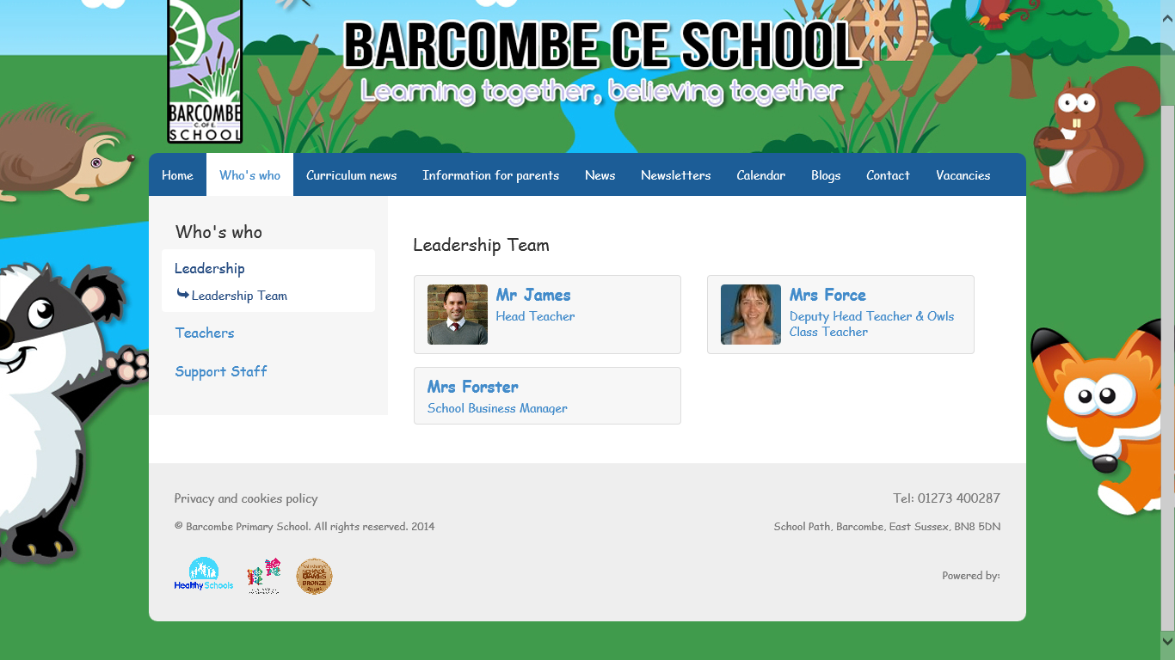

Head of Barcombe School & Staff Governor

**Reverend James Hollingsworth**



Foundation Governor & Vice-Chair of Governors

**Stewart James**



Executive Head Teacher

**Janice McBrown**



Authority Governor & Chair of Governors

**Canon Neil Milmine**



Foundation Governor

**Jane Nurse**



Co-Opted Governor

**Gemma Roxburgh**



Head of Hamsey School & Co-Opted Governor

**Sue Seymour**



Foundation Governor

**Amber Ward**



Co-Opted Governor

**Verity Brown**



Clerk to Governors