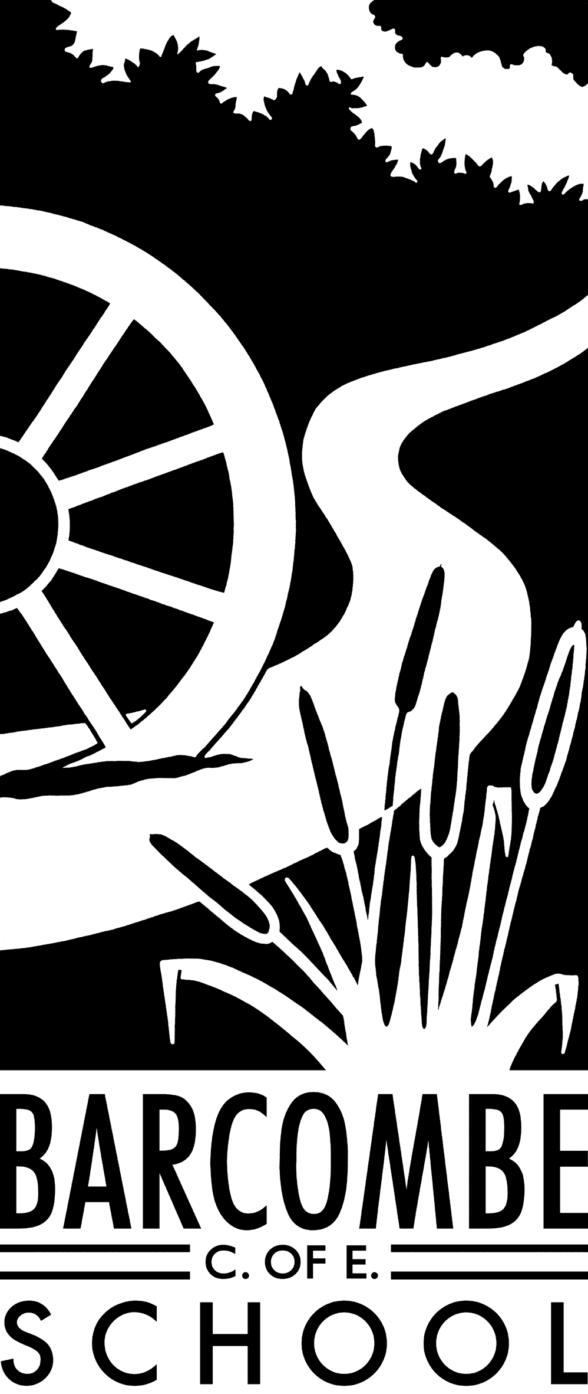

**Things you could try at home to enrich this term’s project:**

* Practise the Spanish language at home
* Try some traditional Spanish or Mexican food
* Make a Mayan mask using bright colours

**Our school website address is:**

[www.barcombe.e-sussex.sch.uk](http://www.barcombe.e-sussex.sch.uk) and our class blog is at <http://barcombefoxes.wordpress.com> where you will find information about the class, home learning, upcoming events and links to useful websites.

**Dates for your diary:**

* Curriculum meeting: 9am on Tuesday, 1st May
* Bank Holiday Monday: Monday 7th May
* Half term: Monday 28th May – Friday 1st June
* Beginning of Term 6: Monday 4th June
* Sports Day: Friday 15th June
* End of Term 6: Thursday 19th July

**Fox Class information:**

**P.E**.

Our P.E afternoon will be **Monday** this term. Please can children have their full P.E kits in school, remembering a tracksuit to keep warm in case we are able to go outside. Trainers need to be bought into school daily for the daily mile.

**Homework**

Homework will be sent home on Fridays to be returned to school the following Thursday.

**Reading Diaries:**

Try to hear your child read 3 times a week and update the reading diaries. Please bring reading books back to school every day.

Teacher: Ms Battle

Teaching Assistant: Mrs Wigley

**Welcome to**

**Fox Class**

**Curriculum Information**

**Term 5 and 6**

Our Learning Journeys are:

**Magic and Mystery: the Mayan Civilisation**

and

**Bonjour**

HISTORY and GEOGRAPHY

Term 5’s topic is the ancient Maya civilisation Term 5’s topic is the ancient Maya civilisation. It’s an interesting and exciting topic and we will learn where and when they lived, their political system, religion, how they worshipped and what they ate. Our topic for term 6 is Hola and we will learn more about Spain and Spanish culture.

ENGLISH

Our writing genres in Terms 5 and 6 are diary, persuasive and narrative writing. We will continue to read a wide range of books – fiction and non-fiction – to practice reading for different purposes and to identify themes and conventions within these texts. The text will form the basis and inspiration for our writing and used to extend vocabulary. We will also focus on specific grammar and punctuation, such as speech punctuation, the correct use of apostrophes and using a variety of clauses and phrases in writing. We will practice spelling in class and focus on different spelling rules each week.

R.E.

Our RE topics for Terms 5 and 6 are Race and Diversity and What makes us happy? We will learn how we are different, but similar to others and what some religions teach about this.

ART & DT

In Art, Mrs Edwards will work with the children to create collages based on our Maya theme. In Term 6, Fox class will create sculptures under her supervision. In D.T. this term, we will make musical instruments.

MUSIC

We will link music, Science and D.T this term by making musical instruments. We will use the instruments to create an orchestra.

P.E.

In Term 5, Mr Munnery will teach competitive games. The children will learn the games’ rules and be encouraged to support each other. We will also be swimming this term. We will dedicate term 6 to athletics. We will continue to develop personal fitness by doing the daily mile.

MATHEMATICS

In Maths, we will start the term learning more about fractions and decimals and the relationship between these. Year 4s will then apply this knowledge by solving money problems, while Year 5 will extend their understanding by working with percentages. After this, we will do statistics and learn to draw and interpret graphs, charts and tables. Our next topic is measurement, specifically time and converting units. Towards the end of the school year we will cover geometry, where we will investigate properties of shape as well as position and direction. We will also continue practicing our mental maths skills, mental division and times tables as the class become Olympian mathematicians.

FRENCH

We will be learning the colours in French, the days of week and months of the year. We will focus on correct pronunciation and using phrases in simple conversations, asking and answering questions.

SCIENCE

In Term 5, we will investigate sound and how sound is made. Children will learn to recognise that sounds get fainter as the distance from the sound source increases. They will also identify how sounds are made, associating sound with something vibrating and recognise that vibrations from a sound travel through a medium (air/water) to the ear. Term 6’s topic is Living Things and their Habitats. We will study classification keys and environmental dangers. We will learn how to classify living things, including micro-organisms into broad groups.

P.S.H.E

In P.S.H.E the topics are ‘Relationships’ and ‘Changing Me’. The children will be using group discussions, games and role-play techniques to develop their awareness of themselves, others and the world around them.

COMPUTING

During the last two terms of the school year, we will be learning how to use spreadsheets and ordering and presenting data. We will also continue to code, using Scratch to program games.