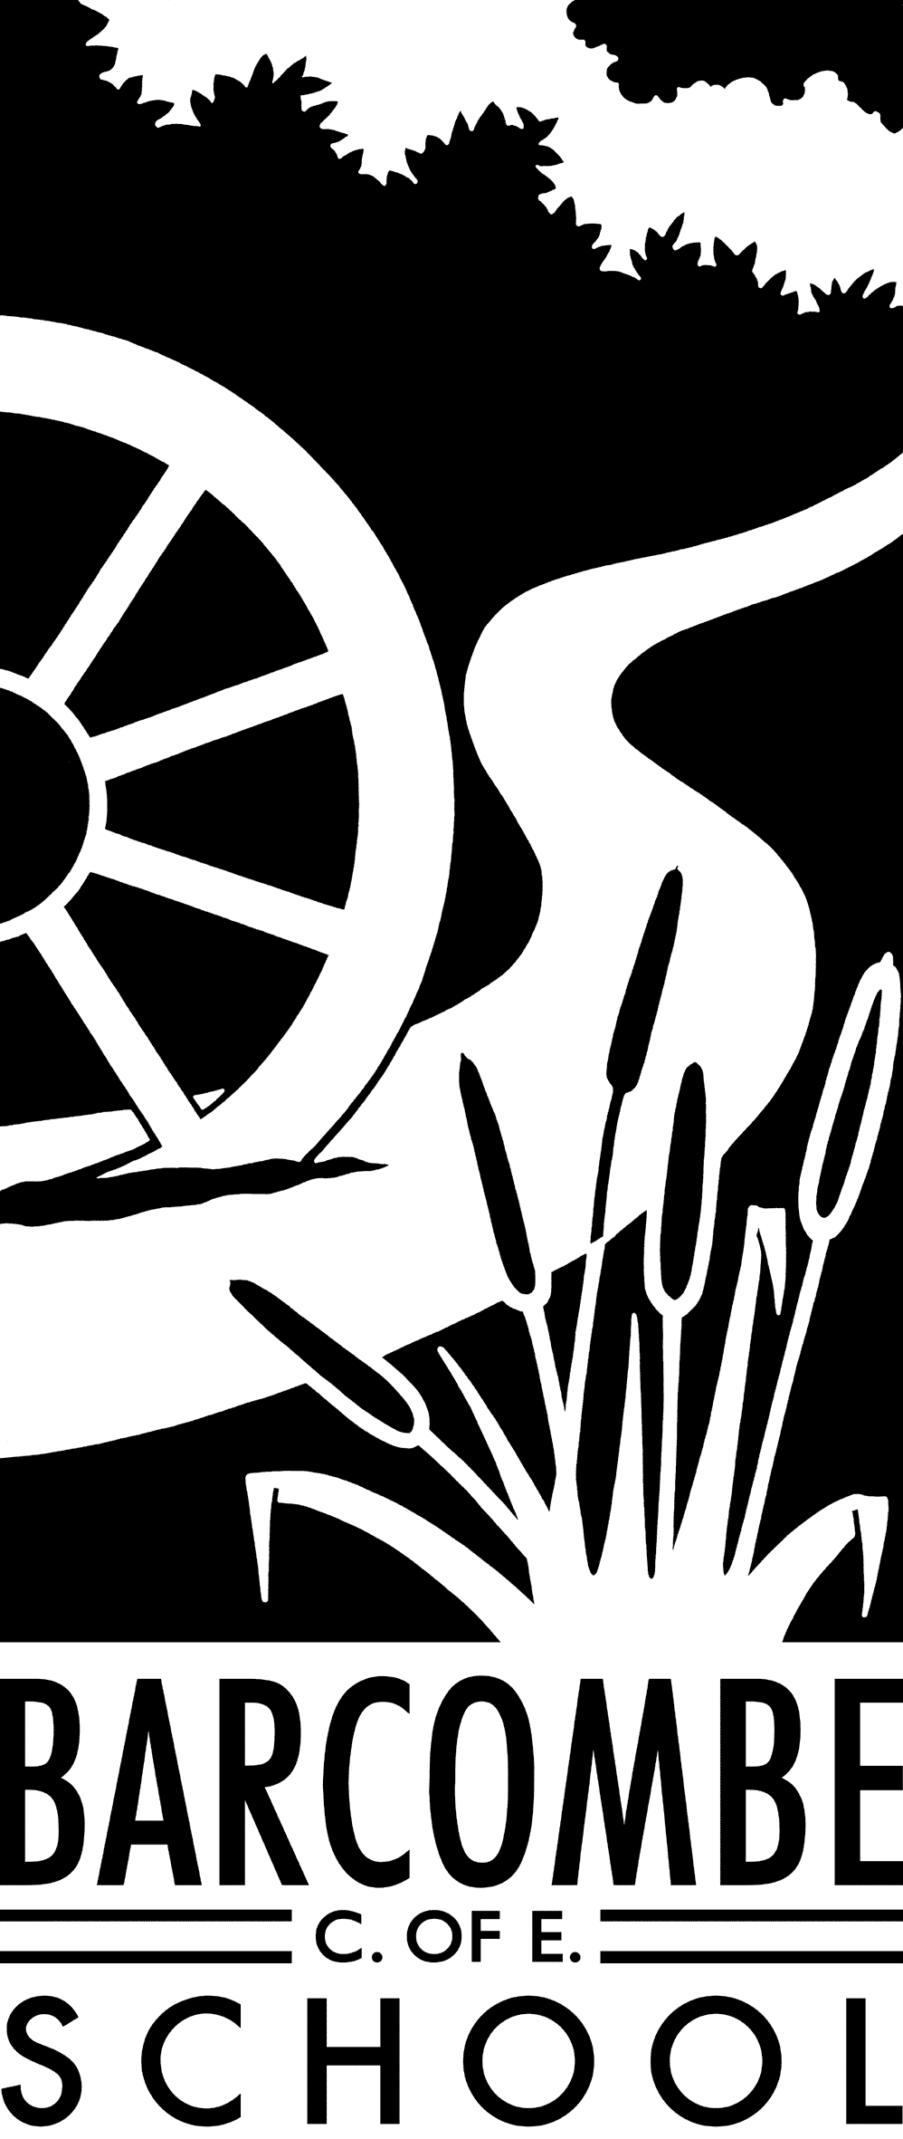

**Dates for your diary:**

* Curriculum meeting: 9am on Friday, April 27th
* SATs week for Y6: Monday May 14th - Thursday, May 17th
* Safety in Action Y6: Friday, May 25th
* Bikeability for Y6: Monday, June 4th – Friday, June 8th
* Lion King trip: Wednesday, June 13th
* Sports Day: Friday, June 15th
* PGL: Wednesday, June 20th – Friday, June 22nd
* Leavers’ Service Y6: Tuesday, June 26th
* Patina: Friday, July 6th
* Year 5 Connect with the Countryside: Thursday, July 12th
* Leavers’ assembly (all Owls): Thursday, July 19th

**Things you could try at home to enrich this term’s project:**

* Practise the Spanish language at home
* Try some traditional Spanish or Mexican food
* Make a Mayan mask using bright colours

Teachers: Mrs Force and Mrs Matheson

Teaching Assistant: Miss Hayes

**Our school website address is:**

[www.barcombe.e-sussex.sch.uk](http://www.barcombe.e-sussex.sch.uk) and our class blog is at <http://barcombeowls.wordpress.com> where you will find information about the class, home learning, upcoming events and links to useful websites.

**Owls Class information:**

**P.E**.

Our P.E afternoon will be **Tuesday** this term. Please make sure children have their full P.E kits in school every day.

**Homework**

Homework will be sent home on Fridays to be returned to school the following Thursday.

**Reading Diaries:**

Try to hear your child read 3 times a week and update the reading diaries. Please bring reading books back to school every day.

**Welcome to**

**Owls Class**

**Curriculum Information**

**Term 5 and 6**

ENGLISH

In Term 5, our work will be linked with our topic work on the Maya Civilisation and will cover a range of genres including explanations, instructions and myths. We will use a Mayan folk tale called The Chocolate Tree to help develop the myths.

The text for Term 6 has not been selected yet as there are so many recently-published children’s books to choose from. We may do a World Cup of Books to decide!

We will continue to read a wide range of books – fiction and non-fiction – to practise reading for different purposes and to identify themes and conventions within these texts. The text will form the basis and inspiration for our writing and be used to extend vocabulary.

COMPUTING

We will code using Scratch to create games to be played by others. We will also explore stop-frame animation and spreadsheets for different purposes.

HISTORY and GEOGRAPHY

The Maya Civilisation. When was it? Where was it? What were the people like? What did they believe? How did they live? What similarities and differences are there with the way we live today? All these questions and more will be answered during this exciting topic. Let’s just say that they weren’t always the friendliest people to meet…

Our Term 6 learning journey is Hola when we will learn more about the geography and cultures of South America.

Our Learning Journeys are:

**‘Magic and Mystery – The Maya Civilisation’ and ‘Hola!’**

MUSIC

We will explore different instruments and the timbre of their sounds before making some of our own tuned instruments.

In Term 6, we will try our hand at Samba. You’ll probably hear us from miles away!

SCIENCE

How are sounds created? How can they be changed? How do we hear sounds? In Term 5, we will investigate sound and try to answer lots of questions. This learning will be linked with DT work too so we can create our own sounds. We will attempt to make tuned instruments putting into practice all we have learnt in science….

Term 6’s topic is Living Things and their Habitats. We will study classification keys and environmental dangers. We will learn how to classify living things, including micro-organisms into broad groups.

FRENCH

We will be continuing our work on naming places and things and how knowing whether they are masculine or feminine can be important when using a dictionary. We will look at prepositions and asking/answering questions in order to find things.

P.E.

In Term 5, Mr Munnery will teach competitive games, focussing specifically on football. The children will learn basic and more complex skills for games and will then apply them in match situations. We will dedicate term 6 to athletics in preparation for Sports Day. We will continue to develop personal fitness by doing the daily mile.

ART & DT

The Maya were great artists and have left evidence of all sorts of interesting collage, paintings and sculpture. We will create our own Mayan art – but we won’t use blood!

In DT, we will be making our own musical instruments.

MATHEMATICS

In Maths we will be working on many different areas of maths. Year 6 will be revising everything they have been taught so they are ready for their SATs in May. After that, the focus will be on Year 5 and developing their skills in reading and creating graphs and charts and in applying their skills in different types of problems. Towards the end of the school year we will cover geometry, where we will investigate properties of shape as well as position and direction. Children will bring home a copy of their current passport to work on ready for testing in school.

R.E.

Our RE topics for Terms 5 and 6 are Race and Diversity and What Makes Us Happy? We will learn how we are different but similar to others and what some religions teach about this.

P.S.H.E

In P.S.H.E our topics are ‘Relationships’ and ‘Changing Me’. The children will be using group discussions, games and role-play techniques to develop their awareness of themselves, others and the world around them.