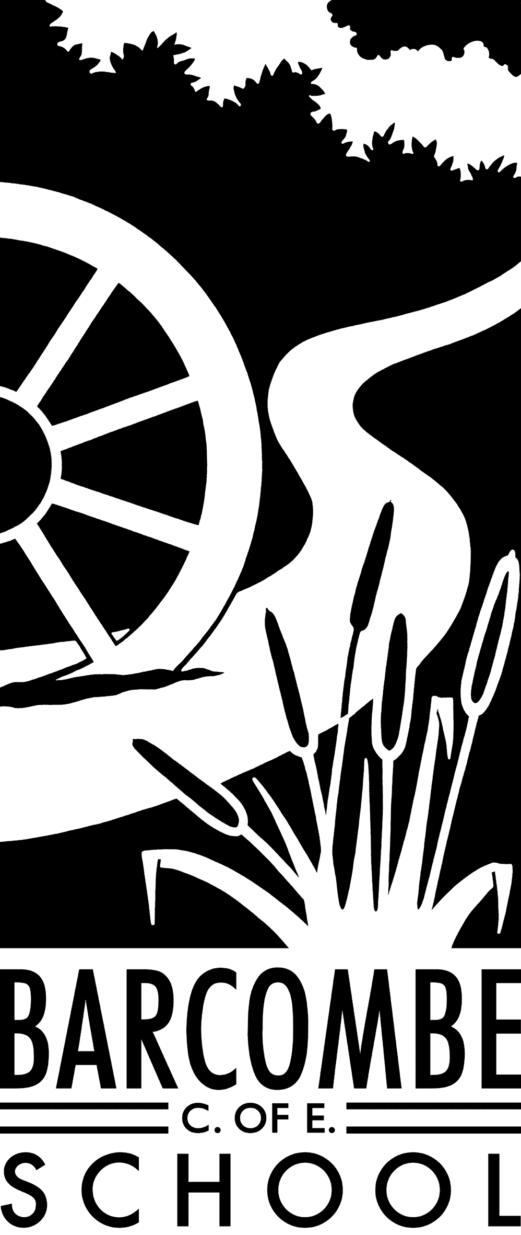

**Things you could try at home to enrich this term’s project:**

* Visit a planetarium, perhaps Greenwich where you will find astrolabes too!
* Visit a castle – Lewes Castle is a perfect example.
* Go on a nature trail or walk around your local area.
* Research old maps of Barcombe and see the differences between past and present.
* Spend an evening watching the night sky – what stars can you see?

Teachers: Mrs Force and Mrs Matheson

Teaching Assistant: Miss Hayes

**Dates for your diary:**

* Curriculum meeting: 9am on Monday 15th January
* Half term: Monday 12th February – Friday 16th February
* Beginning of Term 4: Monday 19th February
* Owl Class Assembly: Thursday 1st March
* Easter Service at St Mary’s: Tuesday, 27th March
* Easter Holidays: Friday 30th March – Friday 13th April
* Start of Term 5: Monday 16th April

**Our school website address is:**

[www.barcombe.e-sussex.sch.uk](http://www.barcombe.e-sussex.sch.uk) and our class blog is at <http://barcombeowls.wordpress.com> where you will find information about the class, home learning, upcoming events and links to useful websites.

**Owls Class information:**

**P.E**.

Our P.E afternoon will be **Wednesday** this term. Please can children have their full P.E kits in school every day, remembering a tracksuit to keep warm in case we are able to go outside.

**Homework**

Homework will be sent home on Fridays to be returned to school the following Thursday.

**Reading Diaries:**

Try to hear your child read 3 times a week and update the reading diaries. Please bring reading books back to school every day.

**Welcome to**

**Owls Class**

**Curriculum Information**

**Term 3 and 4**

COMPUTING

In Term 3, we will create a Powerpoint slideshow about space, researching online and using hyperlinks to connect pages to each other and external links. In term 4 we will create a stop-animation film using appropriate software.

MUSIC

We will listen to and appraise Holst’s The Planets Suite and will use ideas from our listening to develop our own compositions based on new planets or parts of the solar system.

SCIENCE

This term we will be learning about Earth and Space. The children will learn to describe the movement of the Earth, and other planets, relative to the Sun in the solar system. We will discover and describe the movement of the Moon relative to the Earth. Children will learn that the Sun, Earth and Moon are approximately spherical bodies and that the Sun is at the centre of our solar system. We will use the idea of the Earth’s rotation to explain day and night and the apparent movement of the sun across the sky. We will also delve deep into the solar system to explore the far reaches of the universe.

FRENCH

This term’s poem is Les Oeufs on which we will use our interpretation skills. Then we will take this into looking at different rooms of a house, household items and prepositions to allow us to explain where one thing is in relation to another.

P.E.

In Term 3, the children will learn and perform dances using a range of movement patterns and sequences. They will be encouraged to compare their performances with previous ones and demonstrate improvement to achieve their personal best. In Term 4, children will develop flexibility, strength, technique, control and balance through gymnastic activity. We will continue to develop personal fitness by doing the daily mile.

Our Learning Journeys are:

**Don’t Get Lost**

and

**ATTACK!**

ART & DT

This term the children will learn about great artists and develop a range of design and painting techniques. In Term 4, the focus will be on developing and mastering drawing techniques. In DT we will build structures, exploring how they can be made stronger, stiffer and more stable.

HISTORY and GEOGRAPHY

Through our ‘Don’t Get Lost!’ topic, we will be learning to read and interpret maps. We will be looking at co-ordinates and grid references and will be creating our own maps.

In Term 4, the children will be learning about castles in the local area through the ‘Attack!’ topic. They will learn technical vocabulary for castles and look at the development of castles over time.

ENGLISH

This term we are blasting off into space with our first book, Phoenix by S F Said. This is a gripping science fiction fantasy which will engage the children’s imaginations and will be the focus for lots of writing activities. We will also be focussing on writing information texts based on the planets and other features of our solar system and on aliens and new planets. Grammar, punctuation and Spelling continue to form an important part of our lessons and we aim to develop the children’s understanding through modelling how they can be used to enhance the children’s writing.

After half term, we will be working on writing stories, basing our work on the topic of castles.

MATHEMATICS

In Maths we will continue to master fractions and link them with decimals and percentages. In all our lessons, we apply our skills to reasoning problems – these might be number problems or word problems. There is so much more to maths than just doing the calculations! Reasoning is an important part of the national curriculum for maths and is challenging but exciting. The children will also be developing their ability to understand and solve word problems involving money, space shape and measure. Times tables will continue to be a focus and the mental maths passports will continue. Children will bring home a copy of their current passport to work on ready for testing in school.

R.E.

Our focus this term is religious charities. We start by researching a major charity for each of the main world religions and then will look at how to develop a charity of our own. This will involve deciding on an aim and how to fulfil that aim!

P.S.H.E

In P.S.H.E the topics are ‘’Dreams and Goals’ and ‘Healthy Me’. The children will be using group discussions, games and role-play techniques to develop their awareness of themselves, others and the world around them.