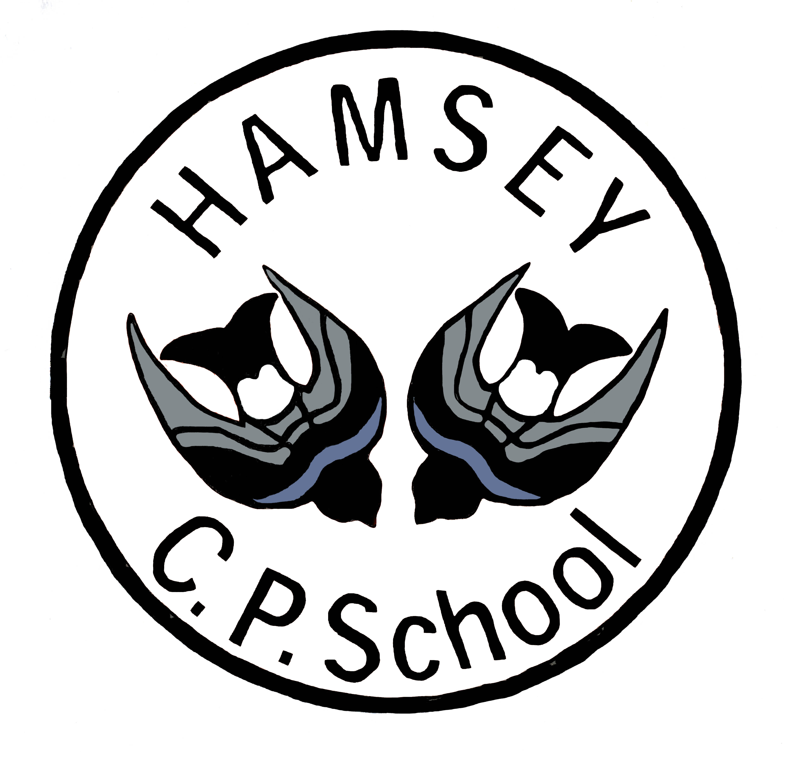

Monday 9th January 2017

**Consultation for the federation of the governing bodies of   
*Barcombe Church of England School and Plumpton Primary School, Hamsey Community Primary School Federation***

Dear Parents and Carers,

As you are aware, Plumpton, Hamsey and Barcombe schools began to officially collaborate in June 2016, in order to strengthen the infrastructure of the three schools and continue to enhance their school improvement journeys. The initial rewards of this collaboration are clear with children and staff already benefiting from wider expertise and resources as well as improved teaching and learning opportunities.

We plan to build on this success by making the arrangement more formal through establishing a formal federation across all three schools. This will enable us to invest strategically in a forward thinking federation that has the ability to provide the highest of standards across all levels of school life.

We would like to invite you to share your views on our proposed federation.

The accompanying consultation paper outlines the benefits of federation. We welcome your views as stakeholders, as we believe it is important that you have your say in shaping the future of education in all three schools. Whilst your views will be taken into consideration it is important to note that this process does not act as a voting mechanism.

You are invited to attend a briefing meeting where we can share our aims for the federation and you will have an opportunity to ask any questions. These will be held on:

Dates of consultation to federate meetings:

17th January – 6.30-7.30pm at Barcombe

18th January – 6.30-7.30pm at Plumpton

23rd January – 6.30-7.30pm at Hamsey

Please feel free to attend any meeting at any of the three schools, regardless of which is your child’s school or school in your community. In addition, for more information regarding the Federation proposal and frequently asked questions please refer to the Parent Partnership tab in the ‘Information for Parents’ section on the individual schools websites.

To comment on our proposed federation please complete and return the feedback form at the end of this consultation paper. Forms should be returned in a sealed envelope, addressed to the “Clerk to the Governors” via one of the school offices. Letters should be clearly marked “Federation Consultation”. These should be received at the schools no later than **3.30pm on 3rd March 2017**. All responses should include your full name, address and signature which will remain confidential to the clerk who will report to the governing bodies.

We believe that federation is the best way to ensure that children in all three schools will continue to have, highly effective schools that provide them with an excellent, well-rounded education, in partnership with parents and our local communities.

Yours faithfully

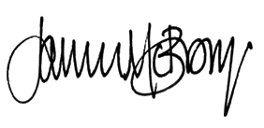



**Janice McBrown** **James Hollingsworth**

**Chair of Governors,** **Chair of Governors,**

**Hamsey and Plumpton Schools Barcombe Church of England School**

**Federation**

This letter and consultation paper has been circulated to all our stakeholders including:

* The Local Authority – Director of Children’s Services, East Sussex County Council
* The executive head teacher and heads of schools
* All staff paid to work at any of the schools
* Volunteers at either of the schools
* The parents/carers of registered pupils at either of the schools
* Parish Councils of Plumpton and Hamsey
* Lewes District Councillors of Plumpton and Hamsey
* County Councillors for the both schools’ wards
* Maria Caulfield MP
* Ashdown Alliance education improvement partnership member school head teachers
* The Secretary of State via steve.jones@education.gsi.gov.uk

**Consultation on the Federation of:**

**Barcombe Church of England School**

**Plumpton Primary School**

**Hamsey Community Primary School**

**Consultation start date: Monday 9 January 2017**

**Consultation end date: Friday 3 March 2017**

We believe that federation is the key to future sustainability, not only maintaining our schools, but helping us grow them and improve them for our children today and in years to come.

**Our aims**

Our key aim is to ensure that our children will have access to outstanding, well-run schools that provide them with an excellent, well-rounded education, working in partnership with parents/carers and the wider community. We want to encourage our children to have aspirations that lead to great achievements as they learn and grow in caring, safe and friendly community of schools.

All our schools currently have a strong ethos of care, good behaviour and hard work. The strong ethos and deep sense of community that exists within each of our schools are all things that we wish to maintain, encourage and develop further - building on the success of our existing collaboration.

We would like to formalise the closer working relationship that has been forged between the schools by establishing a federation. We look forward to entering into a consultation period where we can tell you more about our proposals and find out your views.

**What is a federation?**

A federation is where two or more schools work very closely together under one governing body. Each school remains legally separate and parents/carers and pupils should see no change. Federation is not a merger or a conversion to an academy; it represents a stable, long term commitment to working in partnership to the benefit of children in both schools.

Federation means that All schools:

* continue to be registered separately with Ofsted, retain their existing judgments and continue to be maintained by the local authority.
* continue to have their own separate budget.
* have a single governing body that would set the strategic direction across both schools and ensure educational and financial sustainability and accountability.
* would continue with the current admission arrangements which would remain the responsibility of East Sussex County Council.

**Our proposal**

The proposal is to federate Barcombe Church of England School, Plumpton Primary, Hamsey Community Primary and, starting on **5th June 2017.**

Barcombe Church of England, Plumpton Primary and Hamsey Community Primary schools entered an official collaboration in June 2016. By working collaboratively the three schools have been able to develop consistent educational approaches and share skills, expertise and resources across all the school communities.

Should the federation go ahead, it will be led by an executive head teacher and head of schools to oversee the continued improvement, with a robust senior leadership structure in place at each school.

**Why form a federation?**

We are passionate about ensuring the very best education for the children in our communities. We are aware of the vulnerability of rural schools which operate as a single entity and recognise this model as mutually supportive and one which provides long term stability. It brings an opportunity to achieve economies of scale to secure financial stability and sustainability of our schools into the future. Federation has been fully discussed with governors and the Local Authority and we feel it is the best way to achieve our goals and secure a supportive future for both schools.

**The benefits and opportunities of federating**

There are greatly improved opportunities for children and staff at all schools to interact, learn from each other and share best practice.

**For children:**

* Children will have greater access to specialist expertise from each school’s current staff and a wider range of resources to broaden their curriculum.
* Children within the federation will continue to receive the highest quality teaching and learning, enriched by collaborative working and enhanced resources across both schools.
* Stability and continuity with increased opportunity to meet and work with other children in a wider community.

**For parents/carers and communities:**

* It strengthens the ability of our schools to develop and improve while maximising our ability to cope with changes in educational policy, enabling us to continue to provide excellent education in our villages.
* It provides the opportunity to develop the relationships between our village communities, to the benefit of all.
* It extends the opportunities available to children and their families by creating a long term, stable school structure.

**For staff:**

* Leadership will be secured for the future and staff development opportunities will enable our schools to retain valued staff.
* Shared staff meetings and combined staff training have the effect of widening the circle of peers that our staff can call upon for fresh and creative ideas and support.
* Shared ideas and resources help staff avoid needless duplication of effort and materials and will allow for more time to be devoted to teaching and learning.
* Increased joint working enables us to develop our subject leads across the three schools as well as giving us an opportunity to jointly develop and plan our school curriculum to the benefit of all our pupils.
* It will enhance our capacity to respond effectively to the changes in assessment and curriculum.

**For governors:**

* A single governing body will be formed to replace the existing governing bodies. This new single group of governors will be able to benefit from shared experience and good practice.
* The membership of the governing body will be skills based.

**The governing body**

The role of the federated governing body will be to:

* ensure that the character of each school is maintained whilst moving forward as one.
* define a shared vision and strategic direction for the schools that places the children at its heart.
* ensure due diligence and financial probity; honest and effective financial management.
* hold the executive head teacher to account for the educational performance of the schools.

There would be a maximum of 18 governors, of which there would be:

* 3 x parent elected governors (1 from each school)
* 1 x executive headteacher
* 3 Diocese representatives
* 1 x Local Authority governor
* 3 x staff elected governor
* Up to 7 x co-opted governors (elected for their skills, knowledge and expertise)

This structure complies with Department for Education regulations regarding the constitution of governing bodies.

**Staffing**

Moving to federation in itself will not imply any change in the schools’ current staffing teams. The executive head teacher, supported by the leadership team will lead and manage the federation. Staffing levels will continue to be determined by the school budgets. Federation will allow employment of specialists and new staff across all schools when vacancies arise.

**What are the timescales?**

Governing Bodies of both schools are bound by Department for Education regulations that dictate the process to be followed.

|  |  |  |
| --- | --- | --- |
| **Stage** | **What will happen?** | **When will it happen?** |
|  |  |  |
| 6 week | During this stage the consultation document is widely | Monday 9 January 2017 to Friday 3 March 2017 |
| stakeholder | circulated for comment, the last page of this document |  |
| consultation | provides details of how to submit your views and |  |
|  | opinions. |  |
|  |  |  |
| Decision | The joint executive committee of the collaboration | w/c Monday 13 March 2017 |
|  | meets to discuss the consultation responses and |  |
|  | makes a recommendation to the two governing bodies. |  |
|  | Each governing body then meets separately to decide |  |
|  | whether to proceed with federation. |  |
|  |  |  |
| Parents/carers and other key stakeholders will be advised in writing of the | | w/c Monday 20 March 2017 |
| governing bodies’ decisions | |  |
|  |  |  |
| Outcome | If both governing bodies agree to federate, it is | w/c Monday 5th June 2017 |
|  | envisaged that the new governing body would be |  |
|  | formed and federation take place on 5th June.  The current governing bodies will continue to operate as they have previously within the Federation / Collaboration until the governing body has been formed. |  |
|  |  |  |
|  |  |  |

**What do you think?**

Please complete the response form and return it by 3.30pm on Friday 3 March 2017 to one of the following:

Clerk to the Governors

School Office

Barcombe CE Primary School

School Path

Barcombe

Clerk to the Governors, Clerk to the Governors,

School Office, School Office,

Plumpton Primary School Hamsey Community Primary School

South Downs Cooksbridge

Plumpton Green Lewes

Lewes BN8 4SJ

BN7 3EB

*Remember, all responses must include your full name and address (in capital letters), and signature (anonymous responses will not be considered) and will remain confidential to the clerk who will report to the governing bodies.*

**Consultation on Proposed Federation of**

**Barcombe Church of England Primary, Plumpton Primary and Hamsey Community Primary and Schools**

**Do you support the proposal to federate Plumpton Primary, Hamsey Community Primary and Barcombe Church of England schools? (Please tick one box)**

**Yes**

**No**

**Name:**

**Address:**

**Postcode:**

**Please tick one box that you feel most appropriately represents your interest in this matter:**

Parent/Carer of a child at Plumpton Primary School

Parent/Carer of a child at Hamsey Community Primary School

Parent/Carer of a child at Barcombe Church of England School

Member of staff at Plumpton Primary School

Member of staff at Hamsey Community Primary School

Member of staff at Barcombe Church of England School

Volunteer at Plumpton Primary/ Hamsey Community Primary Schools/Barcombe Church of England *

Parish Councillor of Plumpton/Hamsey/Barcombe*

Lewes District Councillor*

County Councillor

MP for the constituency

Headteacher in Ashdown Alliance

Director of Children’s Services, ESCC, or representative

The Secretary of State via email

Other (Please specify)

*(please delete as appropriate)

**Ideas / Comments / Concerns /:**

**Signed............................................................................................................ (Respondent)**