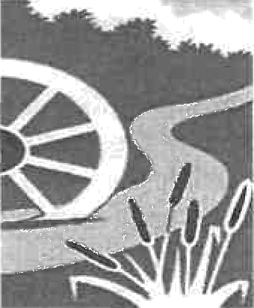

Parental Consent Medicine Form

To be completed by the parent/guardian of any child to whom drugs may be administered under the supervision of school staff. The school will not give your child medicine unless you complete and sign this form, and the school has a policy that the staff can administer medicine.
If you need help to complete this form, please contact the School or the Health Visitor attached to your doctor’s surgery.
Please complete in block letters

Date for review to be initiated by Name of school/setting
Name of child Date of birth Group/class/form
Medical condition or illness

Medicine
Name/type of medicine
(as described on the container)
Expiry date
Dosage and method Timing
Special precautions/other instructions
Are there any side effects that the school/setting needs to know about?
Self-administration — y/n Procedures to take in an emergency

NB: Medicines must be in the original container as dispensed by the pharmacy

Contact Details
Name
Daytime telephone no. Relationship to child Address

I accept that I must deliver the medicine personally to the school office. The above information is, to the best of my knowledge, accurate at the time of writing and I give consent to the school staff administering medicine in accordance with their policy. I will inform the school immediately, in writing, if there is any change in dosage or frequency of the medication or if the medicine is stopped.

I understand that it may be necessary for this treatment to be carried out during educational visits and other out of school activities, as well as on the school premises.

I undertake to supply the school with the drugs and medicines in properly labelled containers.

I accept that whilst my child is in the care of the school, the school staff stand in the position of the parent and that the school staff may therefore need to arrange any medical aid considered necessary in an emergency, but I will be told of any such action as soon as possible.

Signature(s):- …………………………………………………………………………………………………………..

Date:- ……………………………………………………………………………………………………………………

