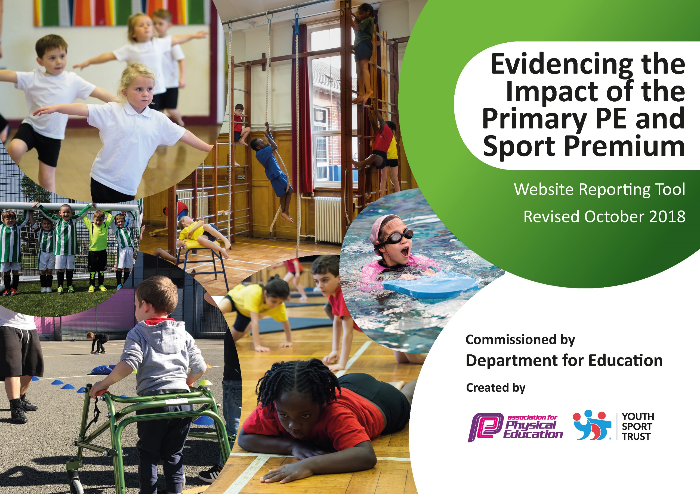
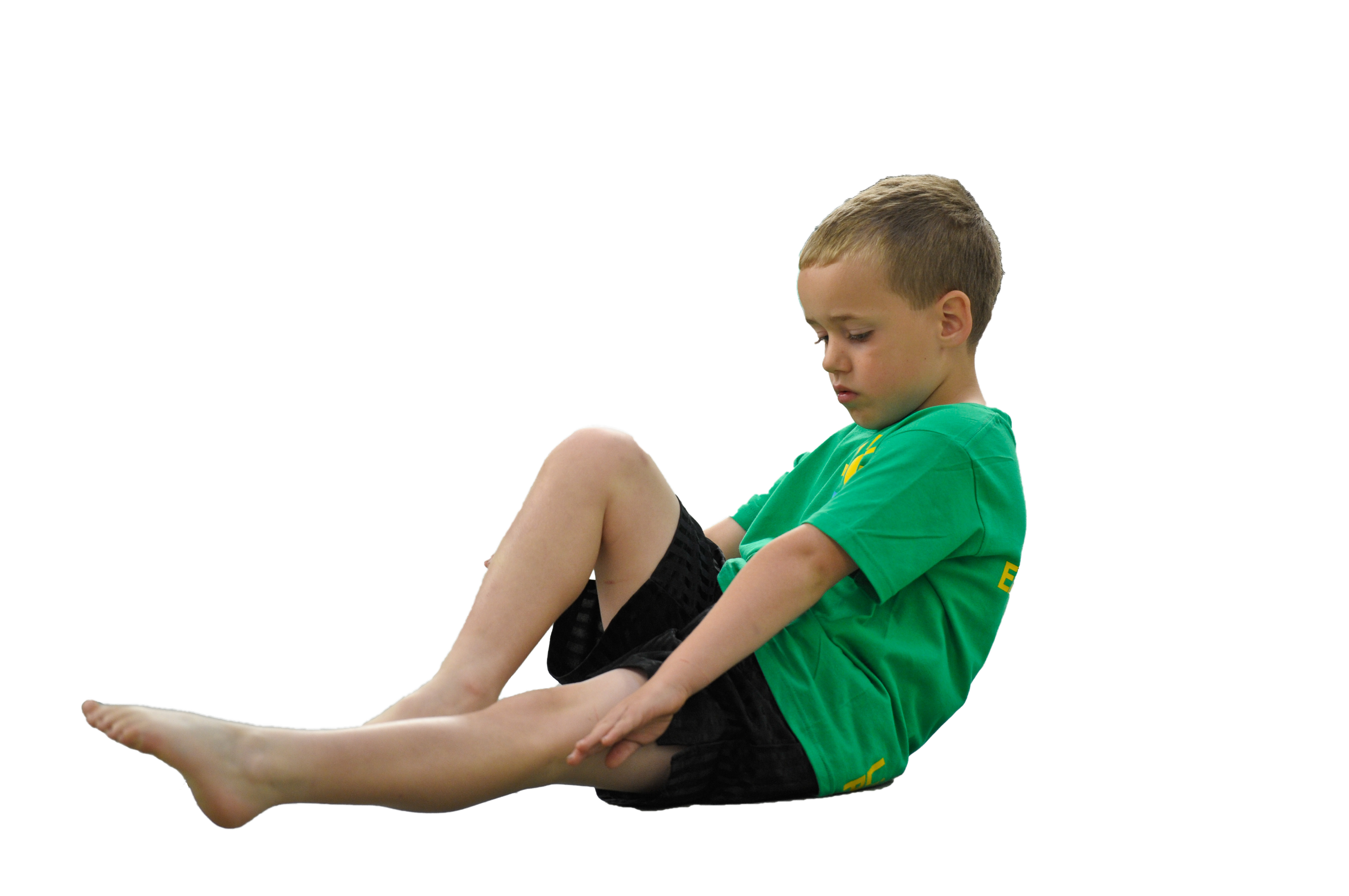
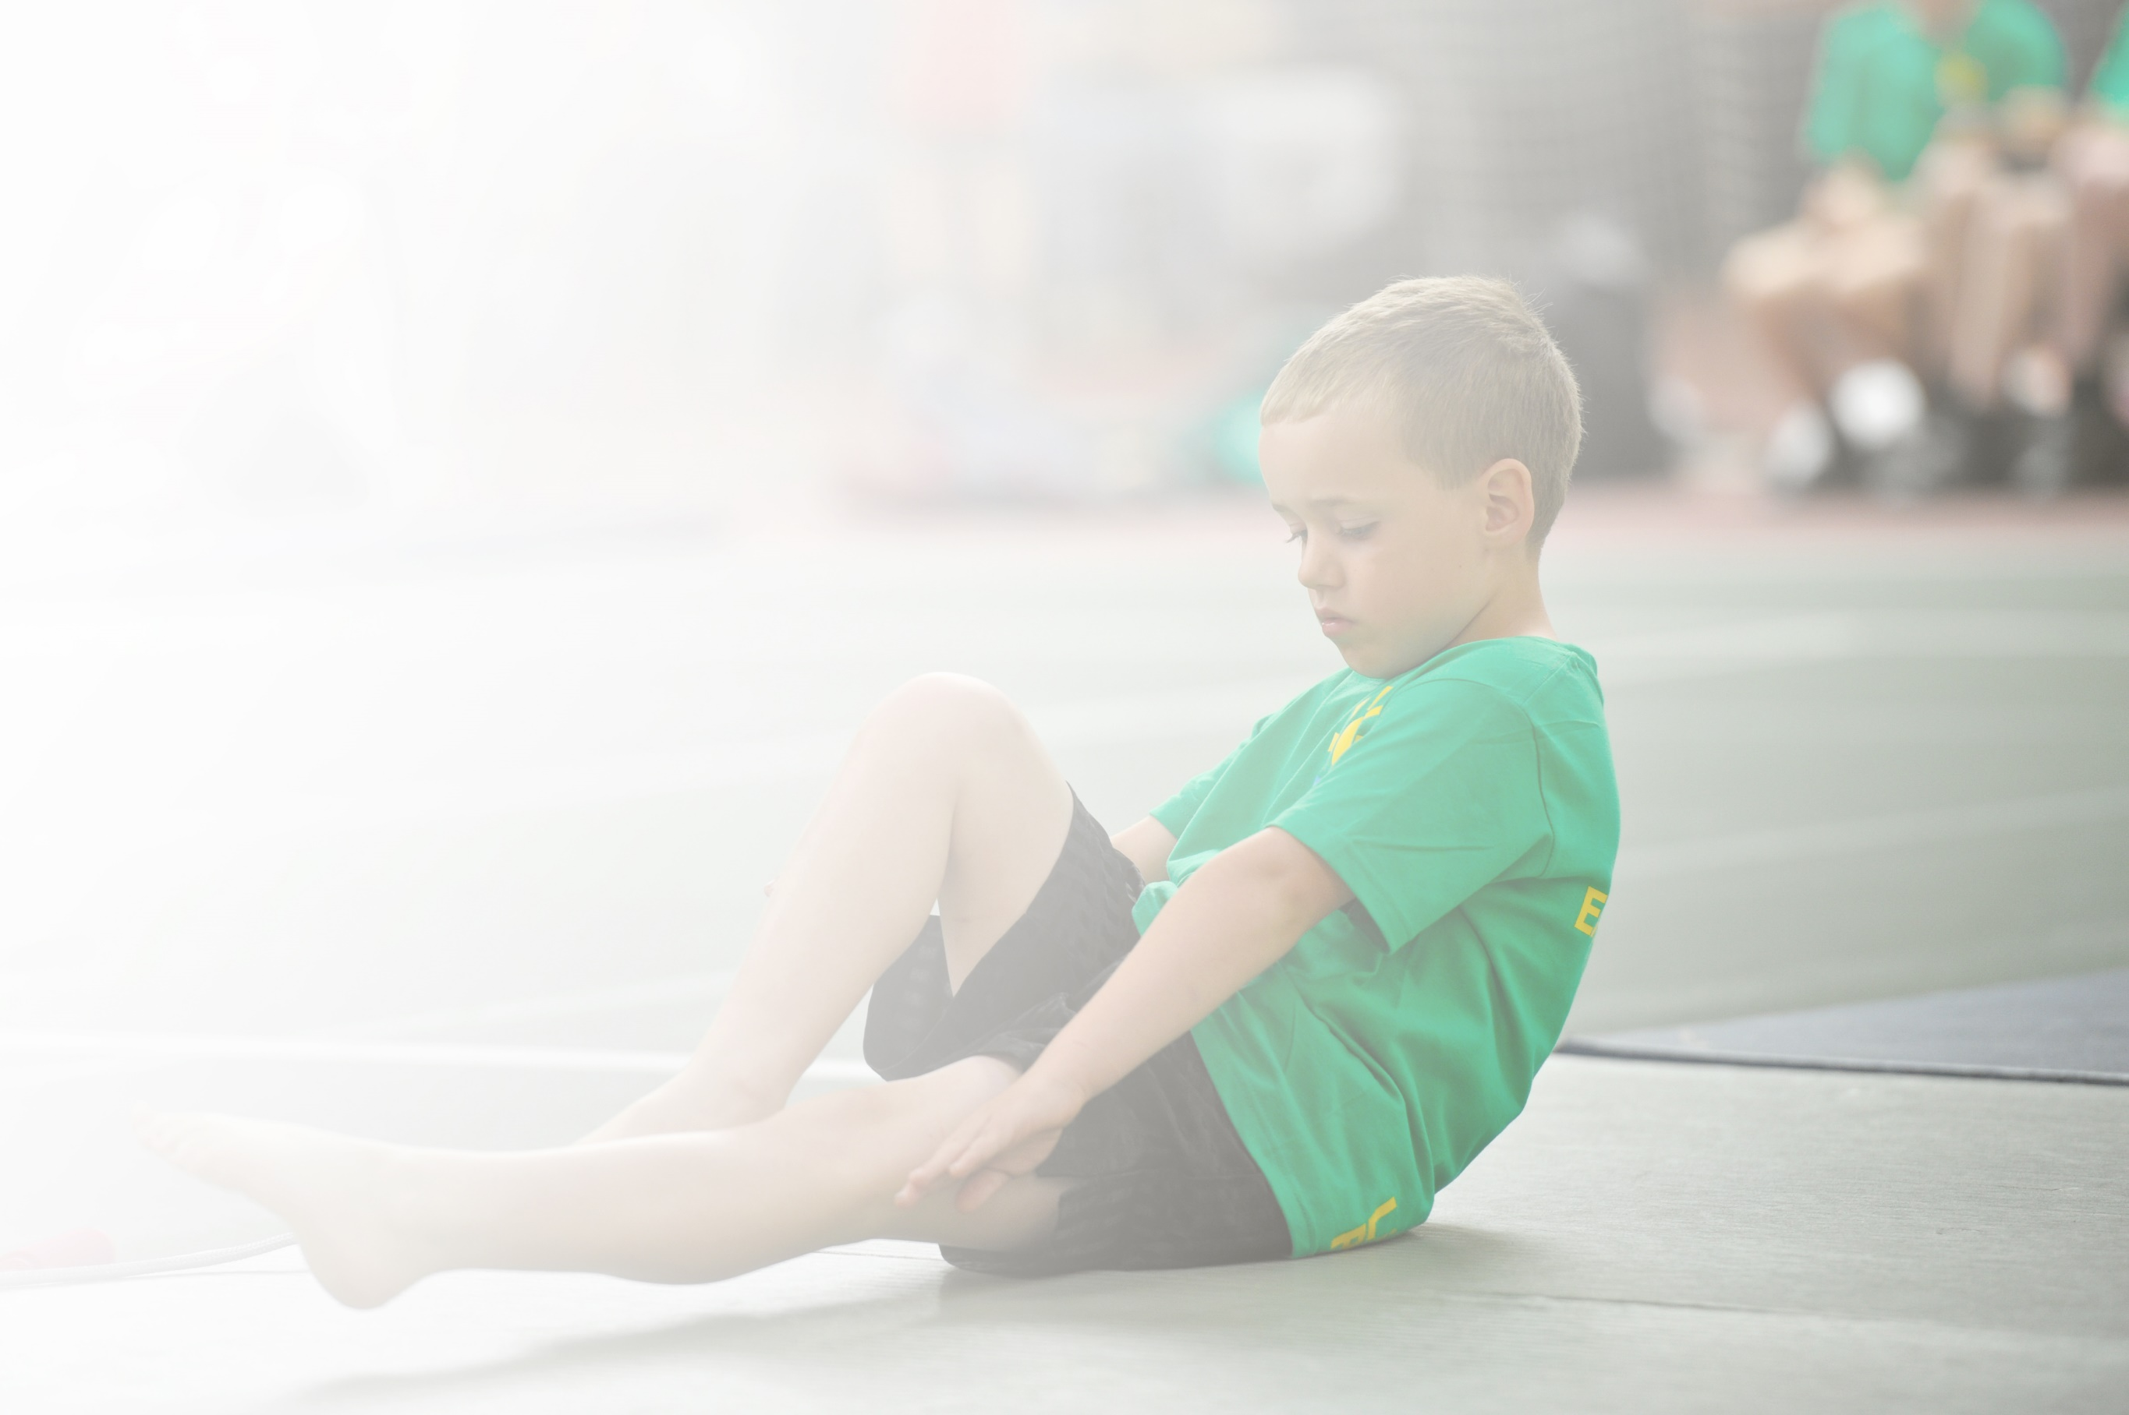
Schools must use the funding to make additional and sustainable improvements to the quality of Physical Education, Sport and Physical Activity (PESPA) they offer. This means that you should use the Primary PE and Sport Premium to:

- Develop or add to the PESPA activities that your school already offer
- Build capacity and capability within the school to ensure that improvements made now will benefit pupils joining the school in future years

Please visit gov.uk for the revised DfE guidance including the 5 key indicators across which schools should demonstrate an improvement. This document will help you to review your provision and to report
your spend. DfE encourages schools to use this template as an effective way of meeting the reporting requirements of the Primary PE and Sport Premium.

We recommend you start by reflecting on the impact of current provision and reviewing the previous
spend. Under the Ofsted Schools Inspection Framework, inspectors will assess how effectively leaders use the Primary PE and Sport Premium and measure its impact on outcomes for pupils, and how effectively governors hold them to account for this.

Schools are required to publish details of how they spend this funding as well as on the impact it has on pupils’ PE and sport participation and attainment by the end of the summer term or by 31 July 2019 at the
latest.
We recommend regularly updating the table and publishing it
on your website throughout the year, as evidence of your
ongoing review into how you are using the money to
secure maximum, sustainable impact. To see an
example of how to complete the table please
click HERE.

Support for review and reflection - considering the 5 key indicators from DfE, what development needs are a priority for your setting and your students now and why? Use the space below to reflect on previous spend, identify current need and priorities for the future.

Key achievements to date: | Areas for further improvement and baseline evidence of need:
Engagement of all pupils in regular physical activity  Playground equipment purchased to promote ongoing physical activity.  Training for Sports Leaders (from the Sports Coach) to organise physical activities for all children to access at playtime and lunchtime.  Across the Skylark Federation the Sports Coach continues to support and mentor teachers and support staff in the delivery of high quality PE provision.  Throughout 2019/ 2020 there will be enhanced opportunities for the Sports Coach to work with vulnerable pupils. A focus on working with pupils whose attendance is a concern is also a priority for this year.  Record keeping by the Sports Coach is robust and evidences pupils’ progress.  Daily Mile continues to be part of every day’s timetable for every child.  Special sports days for all children to access to give them an insight into different physical activities.  On-going training for Playground Buddies and MDSAs.  Continue to update and replace sports equipment and play resources as required.  The profile of PE and sport being raised across the school as a tool for whole school improvement  Focus on health and nutrition continues. Whole school Take One Heart topic at start of the 2019/ 2020 academic year. Includes input from the Medical Mavericks for Key Stage Two pupils.  Increase the range of inter-sports competitions across the Federation.  Increased confidence, knowledge and skills of all staff in teaching PE and sport  Class Teachers and TAs have benefitted from working with the Sports Coach. Plans and activities are shared continually.  Broader experience of a range of sports and activities offered to all pupils  Barcombe continues to offer a range of sports and activities, including a variety of extra-curricular clubs.  Increased participation in competitive sport  Continue to work, closely, with Chailey Secondary School in order to facilitate participation in a range of sporting events. These include football, netball, hi-5 netball, multi skills (Key Stage One), cross country, swimming and athletics. | Sports Mentor and Sports Coach to work with parents of vulnerable children and children whose attendance is a concern, too.  Sports Coach’s work with staff new to Barcombe is a focus for this year. This includes Class Teachers and INAs.  Continue to refresh how the Daily Mile is promoted; explore further cross-curricular opportunities.  Increase opportunities for participation in inter-school and intra-school sporting activities (Key Stage One focus in 2019/ 2020).  Ensure that plans are accessible for all.  The School Council members have voiced that they want more variety by 2020.  Explore opportunities to participate in additional events; organising transport and staffing for this is always a challenge.

Meeting national curriculum requirements for swimming and water safety | Please complete all of the below:
What percentage of your current Year 6 cohort swim competently, confidently and proficiently over a distance of at least 25 metres?  N.B. Even though your children may swim in another year please report on their attainment on leaving  primary school. | %
What percentage of your current Year 6 cohort use a range of strokes effectively [for example, front crawl, backstroke and breaststroke]? | %
What percentage of your current Year 6 cohort perform safe self-rescue in different water-based situations? | %
Schools can choose to use the Primary PE and Sport Premium to provide additional provision for swimming but this must be for activity over and above the national curriculum requirements. Have you used it in this way? | Yes/No

Action Plan and Budget Tracking
Capture your intended annual spend against the 5 key indicators. Clarify the success criteria and evidence of impact that you intend to measure to evaluate for students today and for the future.

Academic Year: 2019/ 2020 | Total fund allocated: £ | Date Updated:
Key indicator 1: The engagement of all pupils in regular physical activity – Chief Medical Officer guidelines recommend that primary school children undertake at least 30 minutes of physical activity a day in school |  |  |  | Percentage of total allocation:
 |  |  |  | %
School focus with clarity on intended impact on pupils: | Actions to achieve: | Funding allocated: | Evidence and impact: | Sustainability and suggested next steps:
Outdoor play equipment and sports equipment updated and replenished to promote ongoing physical activity. Input from the School Council to support this. Across the Skylark Federation our qualified Sports Coach supports and mentors Class Teachers in the delivery of high quality PE provision.  Continuing focus on involvement of all pupils; Sports Coach to work with most vulnerable including children for whom attendance and punctuality are issues.  Sports Coach leads children through a selection of physical activities before school on at least two occasions each week; this practice is to continue on the three days when he is not in attendance.  Continuing training for Playground Buddies and MDSAs; more children to have access to a diverse range of playground activities.  As required, physical activity equipment ordered for playtimes and lunchtimes to support the improvement of the fitness and skill levels of all of the children.  Daily physical activity in the classrooms promoted by all staff. | All classes have an indoor and outdoor PE timetable with allocated slots on rotation for each term. All pupils participate in regular physical activity (Daily Mile and ‘brain breaks’, for example).Early morning activity sessions extended to the wider school community (all staff and parents, for example).  All staff to identify activities in which all pupils can be involved. | £6920-Sports Coach  £4351-Equipment, further training and additional resources. | All classes experience at least 30 minutes of physical activity every day. Children are active and ready to learn (this has a positive impact on their learning behaviour, too). Early morning sessions ensure an active start to the school day.  Playtime and lunchtime supervisors are trained to monitor active play.  Children’s activity levels increase resulting in improved fitness and skill levels for a greater number of children.  All children join in.  Pupils have the opportunity to exercise indoors and outdoors.
Key indicator 2: The profile of PESSPA being raised across the school as a tool for whole school improvement |  |  |  | Percentage of total allocation:
 |  |  |  | %
School focus with clarity on intended impact on pupils: | Actions to achieve: | Funding allocated: | Evidence and impact: | Sustainability and suggested next steps:
Continue to increase the profile of PE, physical activity, health and nutrition. Sports Mentor to lead on this and a range of additional initiatives (working with the Public Health sector and Kent NHS, for example).  Medical Mavericks session with Key Stage Two pupils in October 2019.  Take One Heart whole school learning journey has a focus on health, fitness and well-being.  Create stronger links with disadvantaged families and the local community.  Continue to promote PE in whole school assemblies and class assemblies.  Focus on sport in other countries. Sports Coach to introduce children to new opportunities from across the world (Romania and India in Term 1 and Term 2, for example).  Continue to seek opportunities for Barcombe pupils to participate in intra and inter school competitions. | Develop the working wall in the Sports Hall area that Class Teachers and support staff utilise to promote sport and children’s achievements.  Take One Heart Open Afternoon to share learning with parents.  SLT to promote sport, collaboration and good physical health in assemblies throughout each term.  Children have the chance to try new sports.  Participation in the Brighton and Hove Half Marathon in June 2020, for example. | £4351 (as in Key Indicator 1; see above) | All staff enjoy opportunities to celebrate pupils’ progress and achievements in PE. Displays in communal areas evidence this. Children’s self-esteem and aspirations are raised.  Disadvantaged families are aware of activities that they can access.  Children are aware of the achievements of their peers.  Children are aware of sport in other societies around the world.

Key indicator 3: Increased confidence, knowledge and skills of all staff in teaching PE and sport |  |  |  | Percentage of total allocation:
 |  |  |  | %
School focus with clarity on intended  impact on pupils: | Actions to achieve: | Funding  allocated: | Evidence and impact: | Sustainability and suggested  next steps:
Sports Coach team teaching and joint planning with Class Teachers to raise the quality of PE provision and skill development in lessons. Focus on staff new to the school.  Ensure that team games and competitive sports are being taught and played to a high level. | Planning and assessment of PE and sports opportunities is robust and moves learning forwards-for pupils and staff. Colleagues’ confidence with PE continues to improve.  Staff have the capacity to revise and refresh physical activity opportunities. | £6920 (as Key Indicator 1) | SLT monitoring of planning; evidence that it is thorough and supports children’s skill development and progress.  Children’s skill levels-and enjoyment levels-increase.
Key indicator 4: Broader experience of a range of sports and activities offered to all pupils |  |  |  | Percentage of total allocation:
 |  |  |  | %
School focus with clarity on intended  impact on pupils: | Actions to achieve: | Funding  allocated: | Evidence and impact: | Sustainability and suggested  next steps:
Additional achievements:  Forest School to continue across the school. Wild About Barcombe provides an additional opportunity for outdoor learning. Children to continue to explore ways of working collaboratively outdoors.  Inter class competitions.  Offer a broader range of sporting activities. Sports Coach to teach a broad range of sports, including sports from different countries. | Continue to develop Forest School, including on-going staff training for this.  All Key Stage Two children are given the chance to participate in inter class sporting activities. Increasing opportunities for Key Stage One pupils, too.  PE Co-ordinator and Sports Coach to promote different sports in different year groups which are, then, shared across the school. | £4829 | Children enjoy outdoor physical activity where the emphasis is on working collaboratively rather than competitively.  All children have the opportunity to participate, not just the few that are selected to take part in local competitions.  Children’s experience of sport is extended.
Key indicator 5: Increased participation in competitive sport |  |  |  | Percentage of total allocation:
 |  |  |  | %
School focus with clarity on intended  impact on pupils: | Actions to achieve: | Funding  allocated: | Evidence and impact: | Sustainability and suggested  next steps:
Barcombe participates, regularly, in inter-sports competitions/festivals with other local schools (predominantly those within the Chailey cluster). These are organised by the Primary Sports Co-ordinator for the Chailey area. | Continue to work closely with Chailey School and ensure that Barcombe attends as many competitive events as possible. | £1000 (Chailey Co-ordinator fees) | Children become better equipped with skills and self-confidence to compete in a range of sporting activities.

