****Weekly Information 18.09.20

**Urban Jump Trampoline Park**

**Now Open**

There is a “rule of 6”

booking is essential

For more information and booking ctrl & click below:

[Urban Jump Trampoline Park in Heathfield, East Sussex](https://urbanjump.co.uk/)

**Defiant Sports**

Our mission is ‘connecting through sport’. We believe getting and keeping people active is paramount to improving wellbeing. We aim to reach those who have a barrier to participation, especially with disabilities or long-term conditions. Whilst breaking down barriers to increase inclusivity we involve the community by asking “what would you like to do?” Find out more crtl & click below:

[Welcome to Defiant Sports – Connecting Through Sport](https://defiantsports.org.uk/)

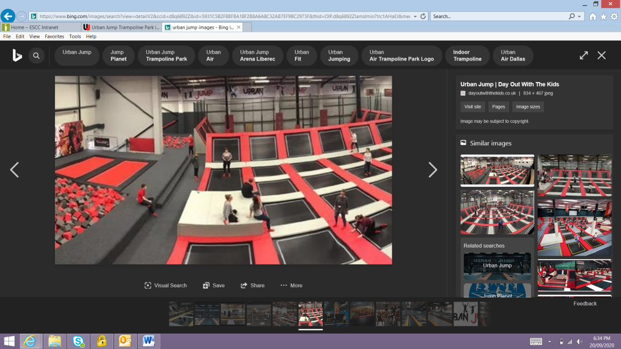

**Young Sibs for brothers and sisters of disabled children and adults**

This month we’re talking about how important it is to look after your mental health when you have to stay at home. We know that you will be spending lots more time with your brothers and sisters than you usually do at the moment. This might be because school has stopped or because respite care is not happening at the moment. We’ve got ideas on how to ask for help if you are struggling or finding things difficult and what you can do to help yourself too.

Take a look at our website for lots more information, crtl & click below:

[Siblings and staying at home - YoungSibs](https://www.youngsibs.org.uk/siblings-and-staying-at-home/)

