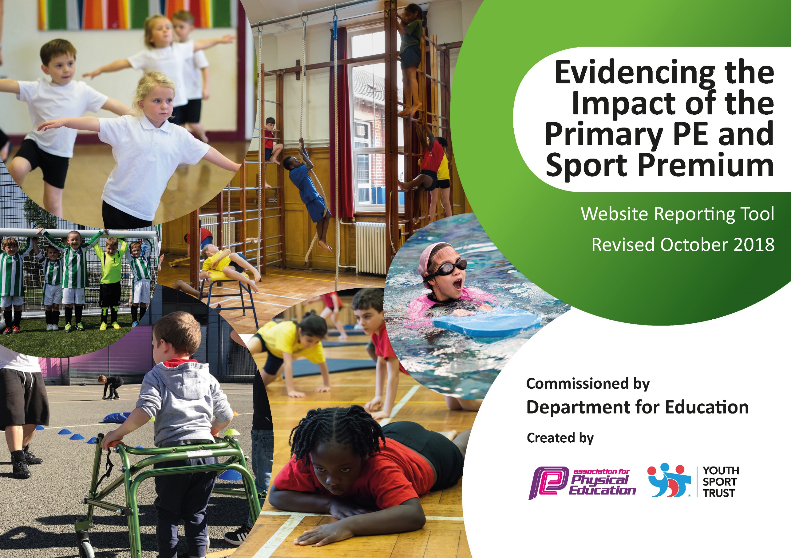
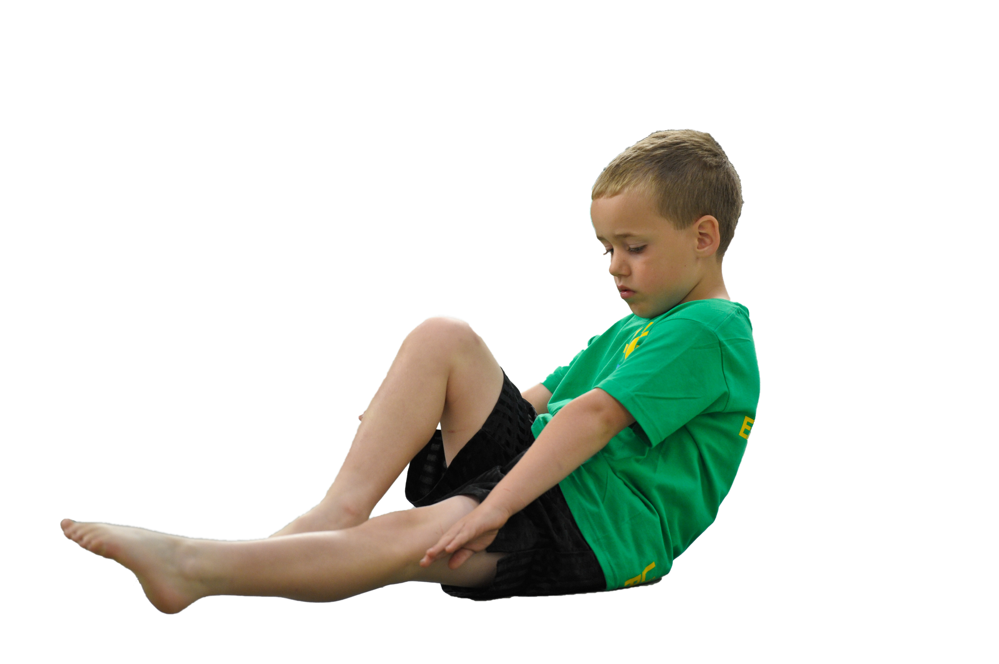
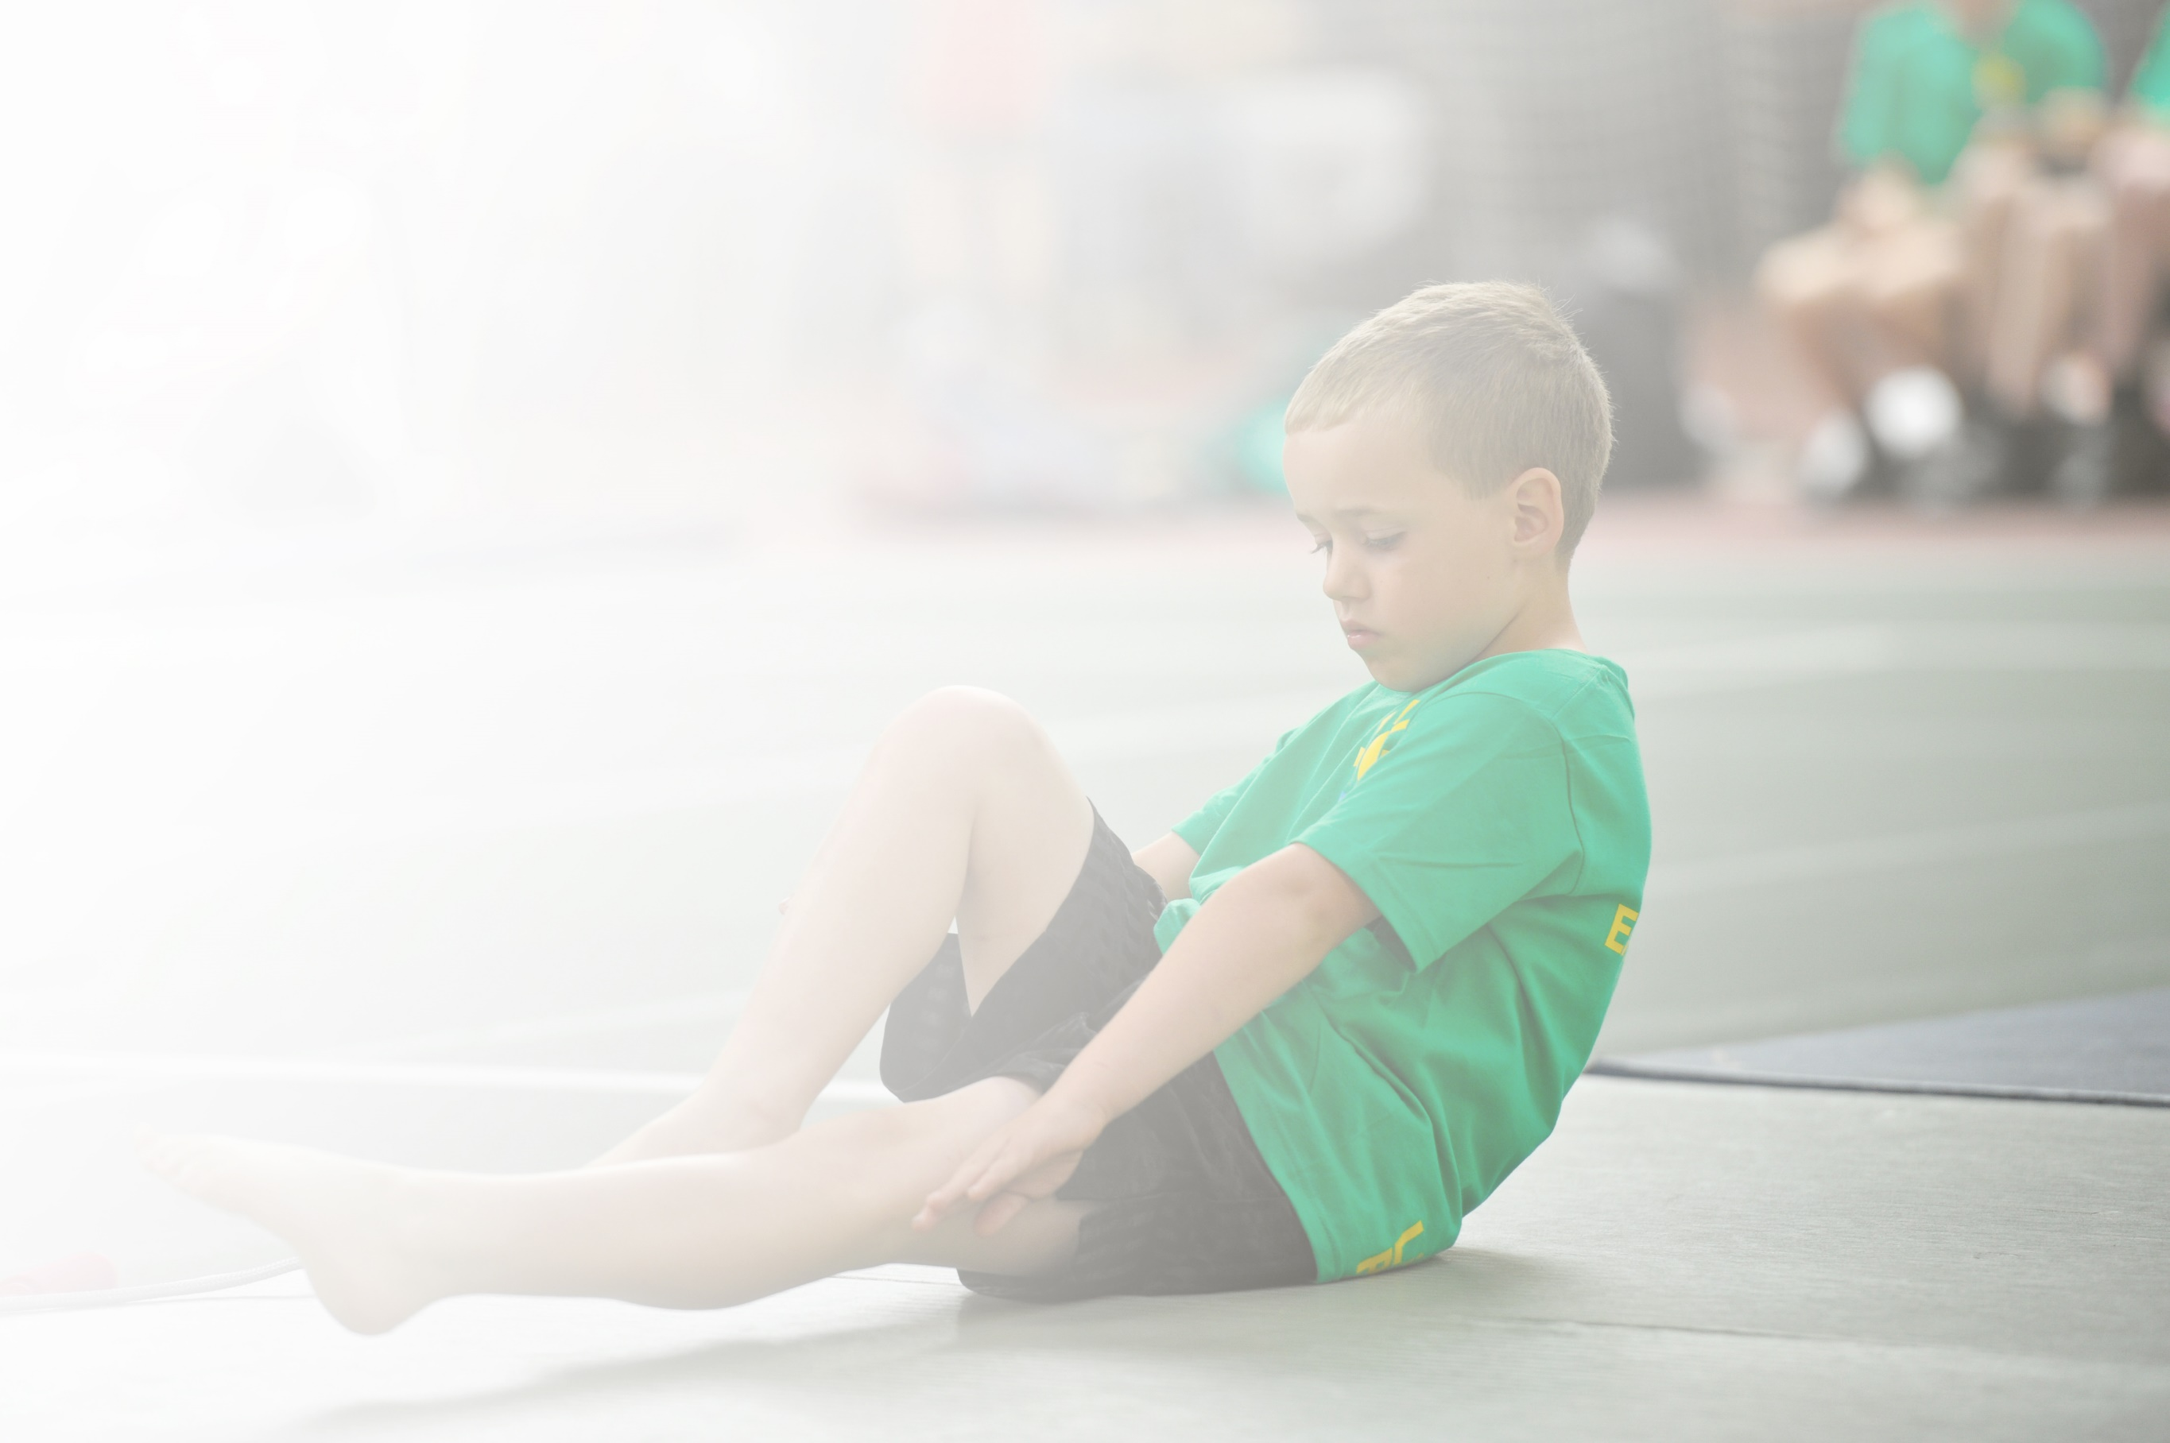
Schools must use the funding to make additional and sustainable improvements to the quality of Physical Education, Sport and Physical Activity (PESPA) they offer. This means that you should use the Primary PE and Sport Premium to:

- Develop or add to the PESPA activities that your school already offer
- Build capacity and capability within the school to ensure that improvements made now will benefit pupils joining the school in future years

Please visit gov.uk for the revised DfE guidance including the 5 key indicators across which schools should demonstrate an improvement. This document will help you to review your provision and to report
your spend. DfE encourages schools to use this template as an effective way of meeting the reporting requirements of the Primary PE and Sport Premium.

We recommend you start by reflecting on the impact of current provision and reviewing the previous
spend. Under the Ofsted Schools Inspection Framework, inspectors will assess how effectively leaders use the Primary PE and Sport Premium and measure its impact on outcomes for pupils, and how effectively governors hold them to account for this.

Schools are required to publish details of how they spend this funding as well as on the impact it has on pupils’ PE and sport participation and attainment by the end of the summer term or by 31 July 2019 at the
latest.
We recommend regularly updating the table and publishing it
on your website throughout the year, as evidence of your
ongoing review into how you are using the money to
secure maximum, sustainable impact. To see an
example of how to complete the table please
click HERE.

Support for review and reflection - considering the 5 key indicators from DfE, what development needs are a priority for your setting and your students now and why? Use the space below to reflect on previous spend, identify current need and priorities for the future.

Key achievements to date: | Areas for further improvement and baseline evidence of need:
Engagement of all pupils in regular physical activity  Playground equipment purchased to promote ongoing physical activity.  Sports Hall timetable facilitates regular opportunities for all in PE.  Across the Skylark Federation our qualified Sports Coach supports and mentors teachers in the delivery of high quality PE provision.  Sports Coach’s role increased to include working with vulnerable groups.  Active start to the school day; Sports Coach to lead a range of activities from 8.30am on at least two mornings each week.  Daily Mile is part of every day’s timetable for every child.  Training for Playground Buddies and MDSAs.  Emphasis on more children having opportunities to enjoy an increasing range of playground games (supporting the reduction of low level disruptive behaviour on the playground).  Update and replace sports equipment and play resources as required.  The profile of PE and sport being raised across the school as a tool for whole school improvement  Sports Coach to focus on health and nutrition, using a range of resources to demonstrate increased physical health.  Continue with daily sports breakouts (including the Daily Mile or a wet weather alternative).  Increase the range of inter-sports competitions across the Federation.  Increased confidence, knowledge and skills of all staff in teaching PE and sport  Class Teachers and TAs have benefitted from working with the Sports Coach. Plans and activities are continually shared.  Broader experience of a range of sports and activities offered to all pupils  Barcombe currently offers a range of sports and activities, including a variety of extra-curricular clubs.  Increased participation in competitive sport  Barcombe participates in a variety of sporting events organised by the Primary Schools Co-ordinator. These include: netball; hi-5 netball; football; cross country; swimming galas; athletics. | Training for Sports Leaders to organise physical activities for all children to access at playtime and lunchtime.  Revise intervention schedules for work with vulnerable children to ensure that regular coaching is received. Record impact of this and next steps.  Consider how to utilise the Sports Coach to support attendance for pupils vulnerable to non-attendance.  Organise special sports days for all children to access to give them an insight into different physical activities.  Increased opportunity for participation in inter-school and intra-school sporting activities (for all children).  Sports Coach and PE Co-ordinator continue to increase focus on health and nutrition.  Daily sports breakouts are popular; children have voiced desire for more variety.  Inter-school competitions across the Federation in 2018/ 2019 included Key Stage One football tournament (held at Hamsey). More opportunities planned for 2019/ 2020.  Ensure that plans are accessible for all. Federation staff meeting training planned for 2019/ 2020.  Additional cricket coaching planned for 2019/ 2020.  The opportunity for swimming at Cumnor House was utilised in 2018/ 2019. Inter-school competition between the Federation and Cumnor is being considered for 2019/ 2020.

Meeting national curriculum requirements for swimming and water safety | Please complete all of the below:
What percentage of your current Year 6 cohort swim competently, confidently and proficiently over a distance of at least 25 metres?  N.B. Even though your children may swim in another year please report on their attainment on leaving  primary school. | %
What percentage of your current Year 6 cohort use a range of strokes effectively [for example, front crawl, backstroke and breaststroke]? | %
What percentage of your current Year 6 cohort perform safe self-rescue in different water-based situations? | %
Schools can choose to use the Primary PE and Sport Premium to provide additional provision for swimming but this must be for activity over and above the national curriculum requirements. Have you used it in this way? | No

Action Plan and Budget Tracking
Capture your intended annual spend against the 5 key indicators. Clarify the success criteria and evidence of impact that you intend to measure to evaluate for students today and for the future.

Academic Year: 2018/19 | Total fund allocated: £ 17 100 | Date Updated: 4/10/19
Key indicator 1: The engagement of all pupils in regular physical activity – Chief Medical Officer guidelines recommend that primary school children undertake at least 30 minutes of physical activity a day in school |  |  |  | Percentage of total allocation:
 |  |  |  | 41%
School focus with clarity on intended impact on pupils: | Actions to achieve: | Funding allocated: | Evidence and impact: | Sustainability and suggested next steps:
Outdoor play equipment purchased to promote ongoing physical activity. Regular classroom ‘brain breaks’. Across the Skylark Federation our qualified Sports Coach supports and mentors Class Teachers in the delivery of high quality PE provision. Focus on involvement of all pupils; Sports Coach has worked with vulnerable pupils. Sports Coach leads children through a selection of physical activities before school on at least two occasions each week.  Training for Playground Buddies and MDSAs; more children to have access to a diverse range of playground games.  New physical activity equipment ordered for the Sports Hall, playtimes and lunchtimes to improve fitness and skill levels of all children.  Daily physical activity in classrooms promoted by PE Co-ordinator and Sports Coach.  Jump Start Johnny and other indoor exercise schemes to be utilised during wet playtime sessions. | All classes have an indoor and outdoor PE timetable with allocated slots on a rotation for each term.  Classes to participate in daily physical activity ‘brain breaks’ to help increase the opportunity to partake in at least 30 minutes of physical activity per day. Early morning sessions to be extended to the wider school community (parents, for example).  Equipment storage to be reviewed in the Sports Hall.  All staff to be made aware of, and use, GoNoodle, BBC Supermovers and Cosmic Kids.  Member of staff to be identified to undertake activities in which all pupils can be involved. | £6920  £100 | All classes are now experiencing at least 30 minutes of physical activity a day. Children are active and ready to learn in the classroom as a result. Early morning sessions ensure an active start to the school day.  Playtime and lunchtime supervisors are trained to monitor active play. Children responding positively to variety of equipment available.  Children are more active in PE lessons and outside at playtimes. This has resulted in improved fitness and skill levels for a greater number of children.  All children join in physical activities to energise and learn.  Pupils have the opportunity to exercise indoors if the weather precludes outdoor activity. | Update and replenish sports equipment and resources with input from the Sports Council.  Next steps-include training of new support staff and additional children as Play Leaders to monitor and encourage use of equipment and promote physical activity at playtimes.  Promote different providers in staff meetings.  Continue to explore opportunities to use the outdoor environments to promote physical activity and a healthy lifestyle.
Key indicator 2: The profile of PESSPA being raised across the school as a tool for whole school improvement |  |  |  | Percentage of total allocation:
 |  |  |  | 24%
School focus with clarity on intended impact on pupils: | Actions to achieve: | Funding allocated: | Evidence and impact: | Sustainability and suggested next steps:
Continue to increase the profile of PE, physical activity, health and nutrition. Sports Mentor to lead on this and a range of additional initiatives.  PE referred to in whole school assemblies.  Increase the amount of intra and inter sporting competitions across the Skylark Federation. | Create a working wall in the Sports Hall area that all Class Teachers utilise. Look into indoor exercise schemes (for example, Jump Start Johnny).  SLT to be aware of current sporting events and children’s achievements (and those of the staff) and use them in assemblies.  Opportunities for children (from all year groups) to participate in a range of competitions. | £4251 | All staff enjoy opportunities to celebrate pupils’ progress and achievements in PE (within school and beyond school). Displays in communal areas evidence this. Children’s self-esteem and aspirations are raised.  Children are aware of current focus in PE and attitudes to learning improved as a result.  Competition opportunities for Key Stage One pupils increased in 2018/ 2019 with Skylark football tournament. | Create stronger links with disadvantaged families and the community.  Ensure every child gets a mention during the school year.  Continue to seek opportunities; Brighton and Hove Half Marathon in June 2020 to be participated in, for example.

Key indicator 3: Increased confidence, knowledge and skills of all staff in teaching PE and sport |  |  |  | Percentage of total allocation:
 |  |  |  | 40% (as Key Indicator 1)
School focus with clarity on intended  impact on pupils: | Actions to achieve: | Funding  allocated: | Evidence and impact: | Sustainability and suggested  next steps:
Sports Coach team teaching with Class Teachers to raise the quality of PE provision and skill development within lessons.  Ensure line markings purchased in the previous academic year are being used to support physical activities during break times. Ensure team games and competitive games are being taught to a high level. | Planning and assessment of PE and sports opportunities is robust and moves children’s learning forward. Colleagues’ confidence with PE increases.  Ensure line markings are being used and Play Leaders know which games can be played and enjoyed. | £6920 (as Key Indicator 1) | SLT monitoring of PE planning shows it is thorough and age-appropriate. Opportunities for differentiated learning are evident.  Children enjoy playing outside. Low level lunchtime behaviour issues are eradicated. | Enhanced focus on staff new to Bacrombe CE School.  Sports Coach to generate survey to evaluate provision and initiatives.  Review training of Play leaders and MDSAs to ensure that games are revised and refreshed.
Key indicator 4: Broader experience of a range of sports and activities offered to all pupils |  |  |  | Percentage of total allocation:
 |  |  |  | 29%
School focus with clarity on intended  impact on pupils: | Actions to achieve: | Funding  allocated: | Evidence and impact: | Sustainability and suggested  next steps:
After school clubs offered include football, netball and cricket. Forest School to continue throughout the school. Wild About Barcombe offers an additional opportunity for outdoor learning. Children to continue active, outdoor learning and explore ways of working collaboratively.  Inter class competitions.  Offer a broader range of sporting activities. Sports Coach to teach a broad range of sports activities. New sports introduced across the Federation (tennis, golf and Frisbee, for example). | After school clubs advertised and promoted in school newsletters.  Retain and develop Forest School, including staff training for this.  All Key Stage Two children given the chance to participate in inter class sporting activities. Increasing opportunities for Key Stage One pupils, too.  PE Co-ordinator and Sports Coach to explore different workshops/ coaches to visit every year group and deliver high quality experiences in PE and sport. | £4829 | Clubs have full registers with many children wanting to take part in as much physical activity as possible. Children develop lifelong love of PE and sport. Children enjoy working collaboratively.  All children have the opportunity to participate, not just the select few that get to take part in inter school competitions.  Cricket coaching opportunity. | Continue to extend range of clubs offered. Monitor participation of disadvantaged and vulnerable children.  Profile of PE and sport is raised across the school with children inspired to join clubs outside the school.  Profile of PE and sport is raised across the school with children inspired to join clubs outside school; more variety inspires more children.
Key indicator 5: Increased participation in competitive sport |  |  |  | Percentage of total allocation:
 |  |  |  | 6%
School focus with clarity on intended  impact on pupils: | Actions to achieve: | Funding  allocated: | Evidence and impact: | Sustainability and suggested  next steps:
Barcombe participates, regularly, in inter-sports competitions/ festivals against other primary schools as organised by the Primary Sports Co-ordinator for the Chailey area. | Continue to work closely with Chailey School and ensure we attend as many competitive events as we can. | £1000 (Chailey Co-ordinator fees) | Children become better equipped with skills and self-confidence to compete in a range on sporting activities. | Links forged with other schools for similar events in the future. Support for pupils transitioning from Year 6 to Year 7.

