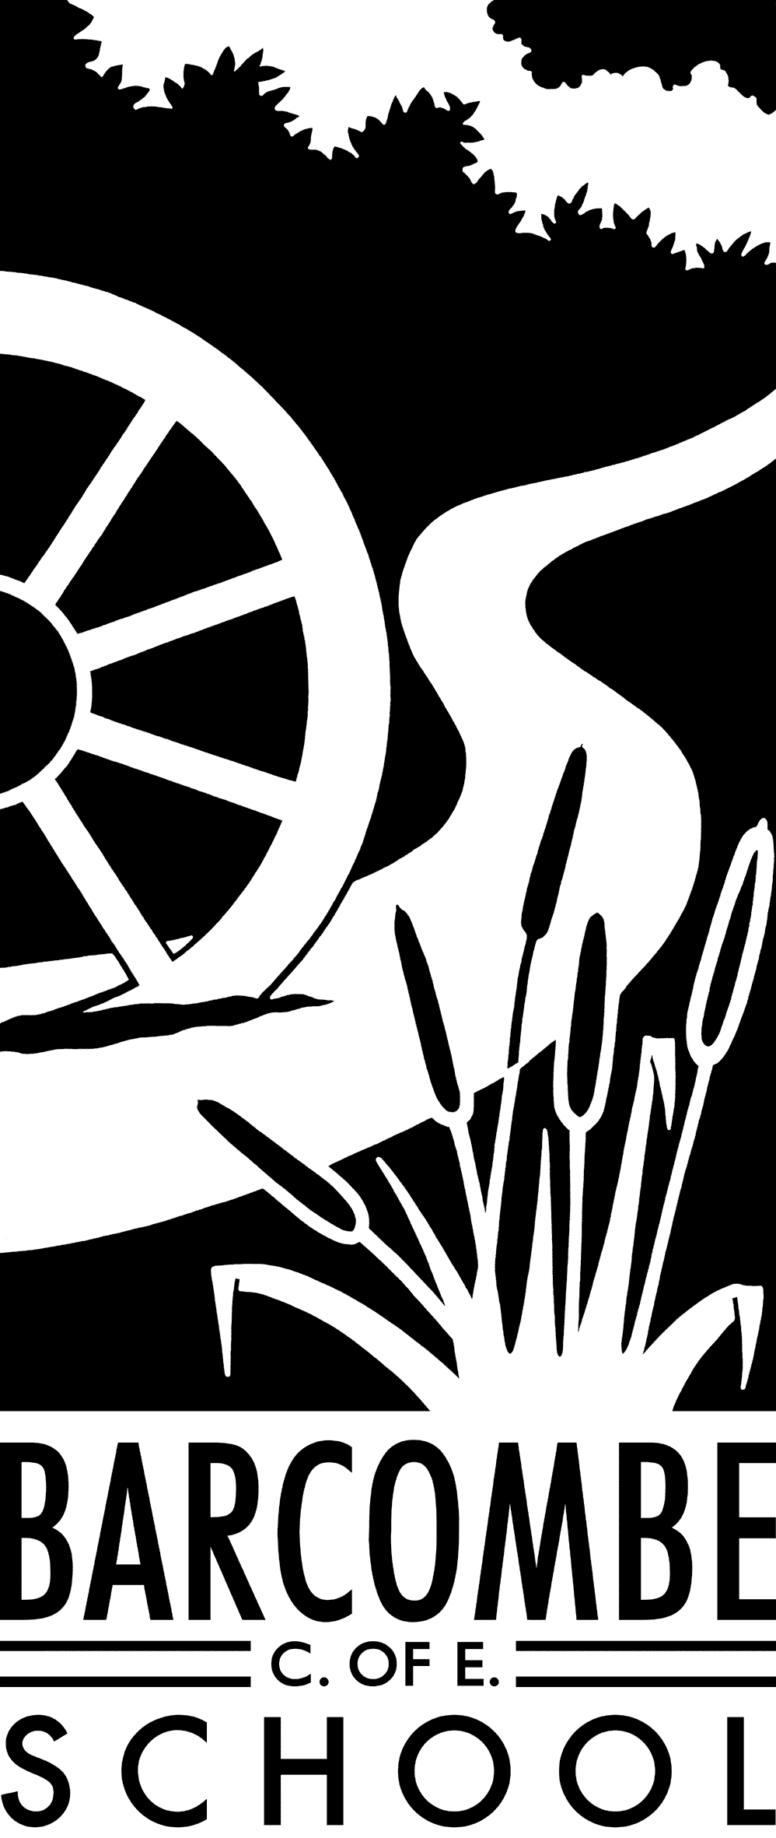

**Things you could try at home to enrich this term’s project:**

* Visit a planetarium
* Visit a castle or palace
* Go on a nature trail or walk around your local area.
* Research old maps of Barcombe and see the differences between past and present.
* Spend an evening watching the night sky – what stars can you see?

**Dates for your diary:**

* Curriculum meeting: 9am on Tuesday 16th January
* Half term: Monday 12th February – Friday 16th February
* Beginning of Term 4: Monday 19th February
* Fox Class Assembly: Thursday 8th March
* Easter Holidays: Friday 30th March – Friday 13th April
* Start of Term 5: Monday 16th April

**Our school website address is:**

[www.barcombe.e-sussex.sch.uk](http://www.barcombe.e-sussex.sch.uk) and our class blog is at <http://barcombefoxes.wordpress.com> where you will find information about the class, home learning, upcoming events and links to useful websites.

**Fox Class information:**

**P.E**.

Our P.E afternoon will be **Tuesday** this term. Please can children have their full P.E kits in school, remembering a tracksuit to keep warm in case we are able to go outside.

**Homework**

Homework will be sent home on Fridays to be returned to school the following Thursday.

**Reading Diaries:**

Try to hear your child read 3 times a week and update the reading diaries. Please bring reading books back to school every day.

Teacher: Ms Battle

Teaching Assistant: Mrs Wigley

**Welcome to**

**Fox Class**

**Curriculum Information**

**Term 3 and 4**

R.E.

The children will spend term 3 learning about different charities and their work, such as Christian Aid and Islamic Aid. In term 4, we will be learning about baptism in Christianity and Easter.

MUSIC

We will develop an appreciation of The Planets by Holst and make instruments to compose and perform our own music.

ART & DT

This term the children will learn about great artists and develop a range of design and painting techniques. In Term 4 the focus will be on developing and mastering drawing techniques. In DT we will build structures, exploring how they can be made stronger, stiffer and more stable.

FRENCH

We will be learning how to count in French, the days of week and to identify some animals. We will learn that all nouns have gender. We will contine to focus on recognising and using the correct pronunciation of key vocabulary.

HISTORY and GEOGRAPHY

In Geographywe will learn to understand the processes that give rise to key physical and human geographical features of the world, how these are interdependent and how they bring about spatial variation and change over time.Through our ‘Don’t Get Lost!’ topic, we will be learning to read and interpret maps. We will be looking at co-ordinates and grid references and will be creating our own maps!

Term 4 will have History focus where the children will be learning about castles in the local area through the ‘Attack!’ topic.

P.E.

In term 3, children will develop flexibility, strength, technique, control and balance and in term 4 they will learn and perform dances using a range of movement patterns and sequences. They will be encouraged to compare their performances with previous ones and demonstrate improvement to achieve their personal best. We will continue to develop personal fitness by doing the daily mile.

Our Learning Journeys are:

**Don’t Get Lost**

and

**ATTACK!**

ENGLISH

Our whole school topics lend themselves very well to the genres we will be focussing on in terms 3 and 4: information writing and narrative. Children will be given the opportunity to discuss writing similar to that which they are planning to write in order to understand and learn from its structure, vocabulary and grammar. We will write an information booklet about Space, using the key features of non-chronological report writing. This will help build a varied and rich vocabulary and increase the use of a range of sentences. Children’s understanding of grammar, punctuation and vocabulary will be developed throughout the year during all topics and handwriting will be practised frequently.

MATHEMATICS

In Maths we will continue to master number and place value, particularly in multiplication and division. In Year 4 the emphasis will be on multiplying two-digit and three-digit numbers by a one-digit number using formal written layout. In Year 5 we will multiply numbers up to 4 digits by a one- or two-digit number using a formal written method, including long multiplication for two-digit numbers divide numbers up to 4 digits by a one-digit number using the formal written method of short division. Later in the term, we will investigate fractions, including decimals, and solve problems and reason within context. We will also continue practicing times tables as the class become Olympian mathematicians.

SCIENCE

This term we will be learning about Earth and Space. The children will learn to describe the movement of the Earth, and other planets, relative to the Sun in the solar system. We will discover and describe the movement of the Moon relative to the Earth. Children will learn that the Sun, Earth and Moon are approximately spherical bodies and that the Sun is at the centre of our solar system. We will use the idea of the Earth’s rotation to explain day and night and the apparent movement of the sun across the sky.

P.S.H.E

In P.S.H.E the topics are ‘’Dreams and Goals’ and ‘Healthy Me’. The children will be using group discussions, games and role-play techniques to develop their awareness of themselves, others and the world around them.

COMPUTING

In Term 3 we will create a stop-animation film using appropriate software. We will also use search technologies effectively, appreciate how results are selected and ranked, and be discerning in evaluating digital content.