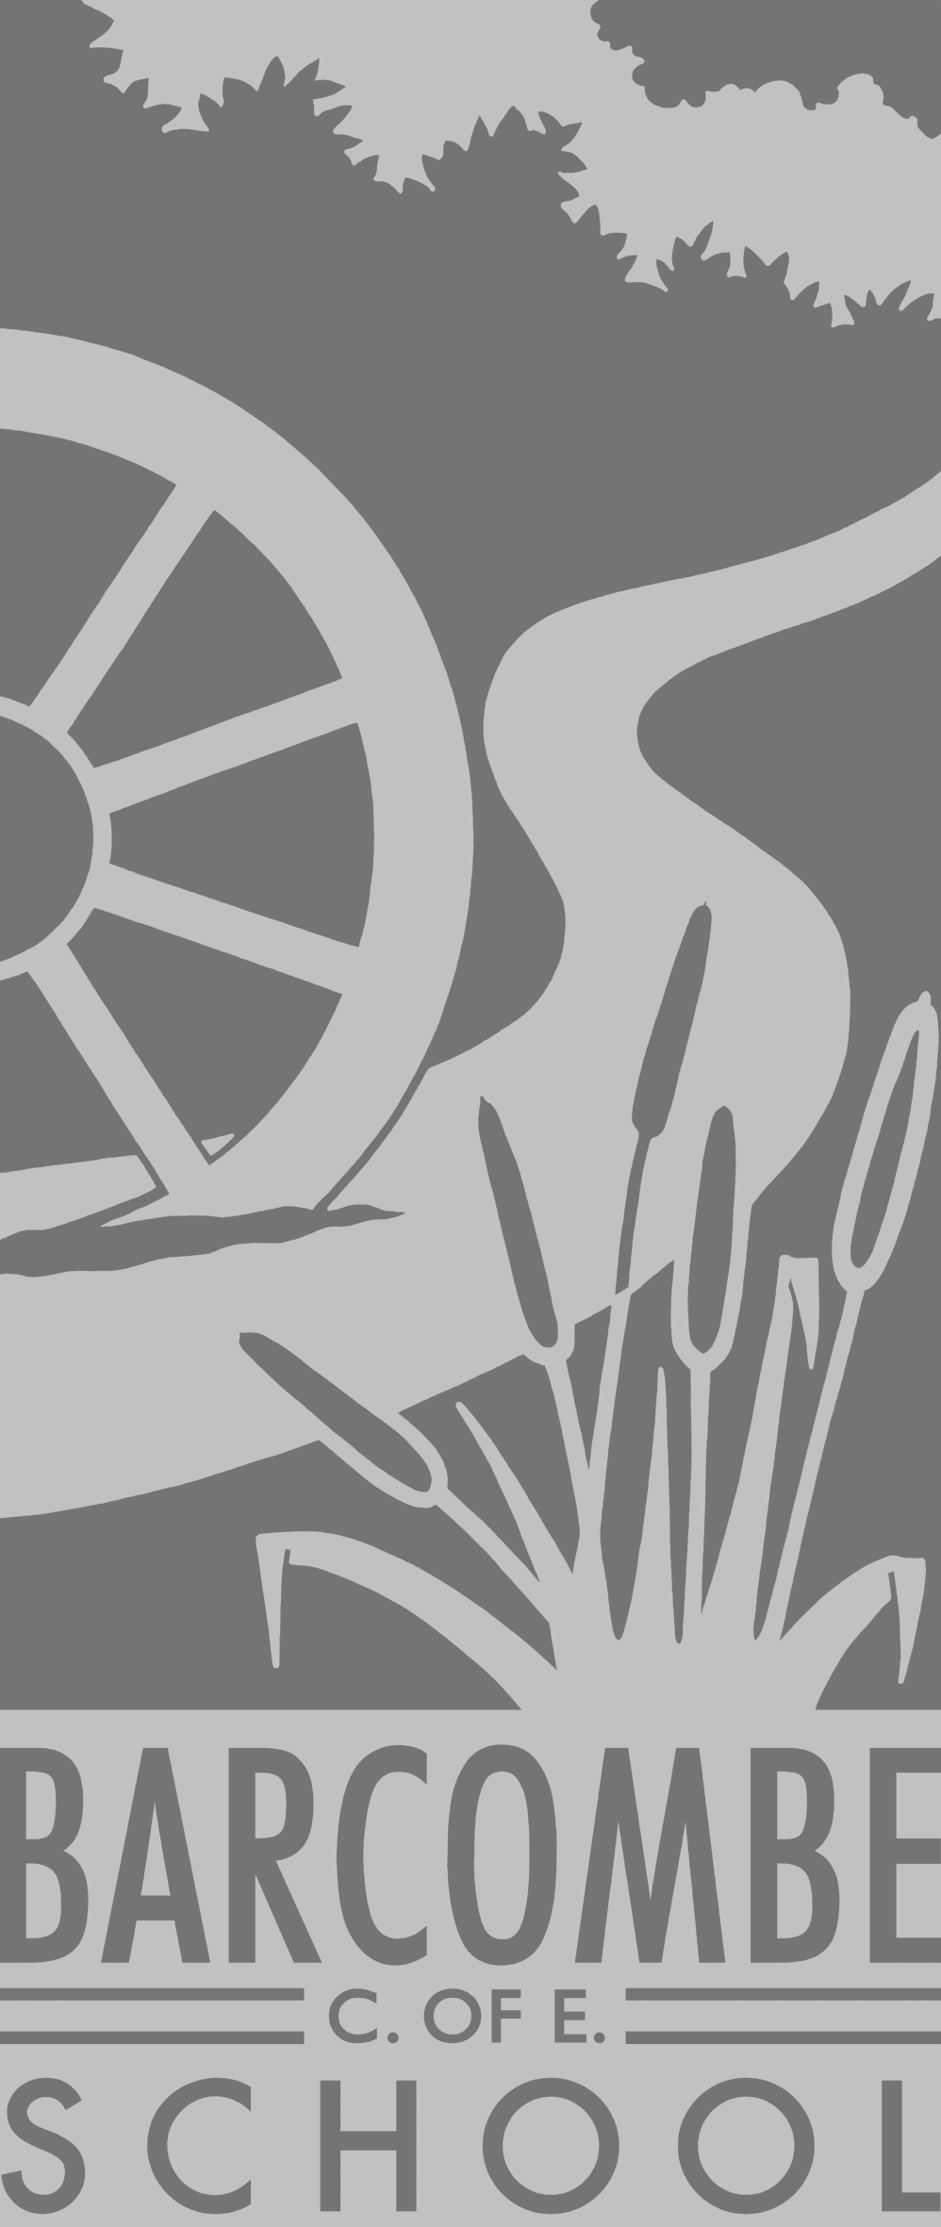
Our school website address is:
www.barcombe.e-sussex.sch.uk and our class blog is at http://barcombebadgers.wordpress.com where you will find information about the class, home learning, upcoming events and links to useful websites.
Dates for your diary:
- Class assembly – Thursday 30th January, 9am
- Barcombe Poetry Day – Tuesday 21st January
- South America food workshop – Wednesday 5th February
- Last day of term – Friday 14th February
- Cumnor House Science visit – Wednesday 18th March, pm
- Proposed Easter Service – Tuesday 31st March, am

Welcome to

Badger Class

Curriculum Information

Term 3 and 4
Badger Class information:
P.E.
Our P.E afternoon will continue to be Friday this term. Please ensure children have their full P.E kits in school.
Homework
Homework books will be sent home on a Friday. Creative homework will not be compulsory this year. We just ask that you read and do MyMaths and TimesTables Rockstars as much as possible at home.
Reading Diaries:
We recommend that children read at home at least 4 times a week. We are continuing our reading challenge this year and children who read at least 4 times a week are in with a chance of winning a prize each term. Reading diaries will be checked daily.
Please let Mrs Wilkins/Mrs Payne know if you are available to come into school and hear readers at any point in the week.

Teachers: Mrs Wilkins & Mrs Payne
Teaching Assistant: Mrs Tomsett

Our Learning Journeys are:
South America
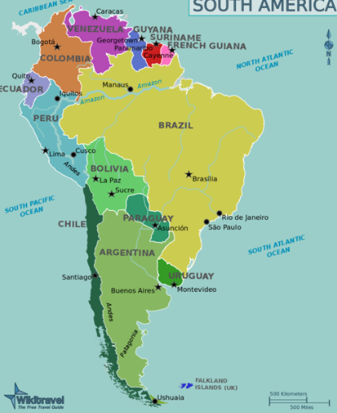
and
The Victorians
HISTORY and GEOGRAPHY
During our South America topic, the children will be using atlases to develop their understanding of the countries in South America. We will then focus on Brazil and look at the popular Rio Carnival, which takes place in February.
During term 4, our topic will be The Victorians. The children will travel back in time and get an insight into what life was like for Victorian children in Britain.

R.E.

This half, term we will be learning about Judaism. We will be exploring Mitzvot and why learning to do good deeds is important to Jewish people. We will talk about belonging and welcoming in relation to this. We will also explore the idea of Tikkan Olam, repairing the world, in Jewish living.
We will look at Jewish artefacts and talk about why they are important in the Jewish religion and how they are used.
Next term, the focus will be Easter and the importance of it for Christians.

ENGLISH

In English, we will be reading two books closely linked with our South American topic. Starting with the true story of Jemmy Button, the children will use poetry to explore the text and we will use drama techniques to explore the moral issues it raises. We will also dive into non-fiction again and create information pages about the characters and South America. Later in the term, we will use The Great Kapok Tree as the basis for our English learning - another fabulous text about the Amazon rainforest and the importance of trees.

Art and DT

In DT this term, the children will be looking at joining materials and will be attempting to sew a hand puppet representing a South American animal– wish us luck! The children will also continue to have the ever-popular weekly art sessions with Mrs Edwards.

MATHS

In maths this term, Badger class will be learning how to divide by using their times tables, by grouping and by sharing equally. The children will also be using their division knowledge to help them understand fractions of amounts and numbers. Furthermore, the children will be exploring measures and they will learn how to successfully gather and represent data in graphs.

FRENCH
We will be building on our learning in French so far by focusing on “Family and Friends” this half-term. We will learn words associated with family members and friends. We will then try and use these words within simple phrases.

SCIENCE
This term, our science focus is “sound”. We will explore how sounds are made, associating some of them with something vibrating. We will explore how sound travels, and how distance effects sound. We will find patterns in the sounds that are made by different objects and we will explore pitch and volume using musical instruments.

MUSIC

Badger class will continue to have weekly recorder lessons from an outside music provider. The children will also be using untuned musical instruments in science sessions and to explore poetry and bring it to life.

COMPUTING
In computing, we will be learning to code! The children will be creating instructions for characters or ‘sprites’ in games. They will also learn how to ‘de-bug’ by correcting simple errors in other people’s instructions. We will be using both the iPads and the laptops during our computing sessions.

