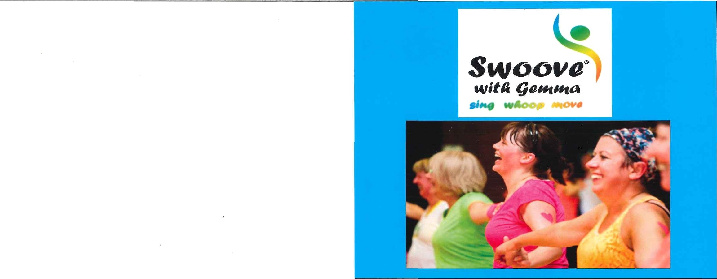

THE BEST VALUE FITNESS CLASS IN THE AREA!
www.swoovefitness.com
Swoove is a singalong exercise class that burns around 800 calories per hour. WoFk your whole body, de stress, increase your lung capacity and enjoy working out like never before!
Only £5 for over 15’s and £2.50 for under. No need to book.
Swoove with Gemma is on:
Thursdays 8-9pm euaz¥ly) — Barcombe Village Hall, BN8 SBH
Saturdays 10-11am - CheFry Tree Centre, BuFgess Hill, RH15 8QB
Please follow my Facebook page Swoove with Gemma for up to date Swoovy News!

