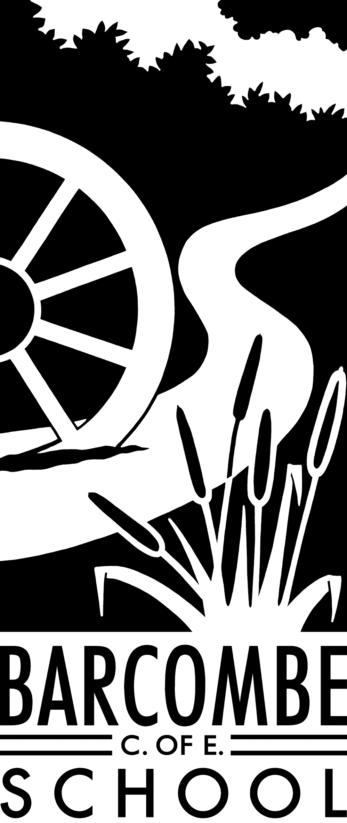

Teachers: Mrs Force and Mrs Matheson

Teaching Assistant: Mrs Edwards

**Owls Class information:**

**P.E**.

Our P.E afternoon will be on a **Wednesday** in Term 1. Please can children have their full P.E kits in school, remembering a tracksuit to keep warm in case we are able to go outside and the weather is a bit chilly.

**Homework**

Homework will be sent home on Fridays to be returned to school the following Thursday.

**Reading Diaries:**

Please try to hear your child read at least 4 times a week and update the reading diaries. Please bring reading books back to school every day. Our Reading Stars counting will be done on Thursday each week. Let’s get Owls to the top!

**Our school website address is:**

[www.barcombe.e-sussex.sch.uk](http://www.barcombe.e-sussex.sch.uk) and our class blog is at <http://barcombeowls.wordpress.com> Please visit our blog regularly for updates.

**Welcome to**

**Owl Class**

**Curriculum Information**

**Terms 1 and 2**

**Things you could try at home to enrich this term’s project:**

* Visit a bird sanctuary or wildlife centre, such as Bentley Wildlife and Motor Museum or Raystede Centre
* Visit Herstmonceux Science Centre
* Practise French greetings
* Visit an art gallery

**Dates for your diary:**

* Curriculum meeting: 9am on Thursday, 20th September
* Trip to Science Museum, London: Tuesday, 25th September
* Harvest Festival at St. Mary’s: 9am on Tuesday, 9th October
* Parent Consultations:

Tuesday, 16th October at 3.30pm – 6.00pm

Wednesday, 17th October at 3.50pm - 7.00pm

* INSET DAY: Thursday, 18th October
* Half term: Monday, 22rd October– Friday, 26th October
* Beginning of Term 2: Monday, 29th October
* Class assembly: Thursday, 8th November
* End of term and carol singing: Wednesday, 19th December

P.S.H.E

We are continuing to follow our Jigsaw scheme of work and, this term, we are focusing on Being Me in My World. This focusses on our own achievements and aspirations, how we work with those around us, and similarities and differences between us and our peers.

ART & DT

In Term 1, Art will be taught by Mrs Edwards and we will be focussing on painting and how to mix colours. There are plans to develop our own artwork in response to a Quentin Blake image. In Term 2, we will explore sculpture and sculptors.

R.E.

This term we will focus on Christianity and different perceptions of God, different experiences, differing viewpoints and the sources of information we can use and evaluate.

FRENCH

We will be learning how to develop sentences using nouns, adjectives and prepositions relating to things that fly and will use our knowledge to write a poem in the style of Baudelaire! C’est vrai!

OUTDOOR LEARNING

We will be getting outside as much as possible this year to do lots of our learning at Wild about Barcombe. We will get muddy and dirty but we will have great fun!

COMPUTING

Our first Computing unit is about e-safety. We will be learning how to stay safe online by finding out more about online conversations and connecting with others. We will also use Scratch to code games and music.

SCIENCE

Our first Science topic is Forces. We will use various enquiry techniques to compare how things move on different surfaces and through air and water. We will relate our learning to our History work about flying machines. Next term we will be investigating animals including humans, and how water and nutrients are transported round our bodies.

P.E.

In P.E. we will be looking at the skills involved in competitive games with the emphasis on communicating, collaborating and competing with each other. The children will develop their ability to use a variety of passes, using throwing techniques as well as with equipment. They will also be learning attacking and defending skills and putting them into use in competitive games. In Term 2, the children will focus on movement and co-ordination, and further development of flexibility, strength, technique and control.

MUSIC

Our music lessons in Term 1 will focus on attentive listening to pieces about things that fly and using ideas to compose our own flying pieces…

GEOGRAPHY and HISTORY

In Geography this term, we will be taking a trip across the English Channel to discover the continent of Europe and find out the names, locations and features of European countries and capitals. In History, we will be studying the development of flying machines from Leonardo da Vinci’s designs to today’s fighter jets and everything in between! In Term 2, we will explore Environmental Issues and will find out all about the Earth's extremes, from raging tropical storms to violent erupting volcanoes to terrifying towering tsunamis. We will also explore how these extremes affect people, communities and landscapes.

MATHEMATICS

In Maths, we will be developing a solid understanding of number and place value and exploring various techniques to add, subtract, multiply and divide, both mentally and using a formal written method. We will be investigating negative numbers, rounding, ordering and comparing numbers, estimating and applying this knowledge to real life situations. The children will also be developing their ability to reason with and solve problems involving number and place value. In Year 5 the emphasis will be on numbers up to 1,000,000 and in Year 6 the numbers will be even bigger! To see some fascinating big numbers, try looking at [www.internetlivestats.com](http://www.internetlivestats.com) Learning times tables at home for instant recall is one way you can really help your child learn!

ENGLISH

During English this term, we will be using the recently-published Fly Me Home by Polly Ho-Yen. In fact, Polly will be visiting us in week 3! Through the book, we will explore the development of characters and storylines, and how authors keep their readers engaged. We will then try to use some of the same techniques in our own writing. We will be exploring discussion texts and writing our own after discussing different questions, for example ‘Is the plane a good invention?’. In Term 2, we will use simple yet powerful books to develop persuasive and emotive language. Children’s understanding of grammar, punctuation and vocabulary will be developed throughout the year during all topics and handwriting will be practised frequently. Spellings will be practised in class.

Our Learning Journeys are

**Take One Flight**

and

**Our Wonderful World**