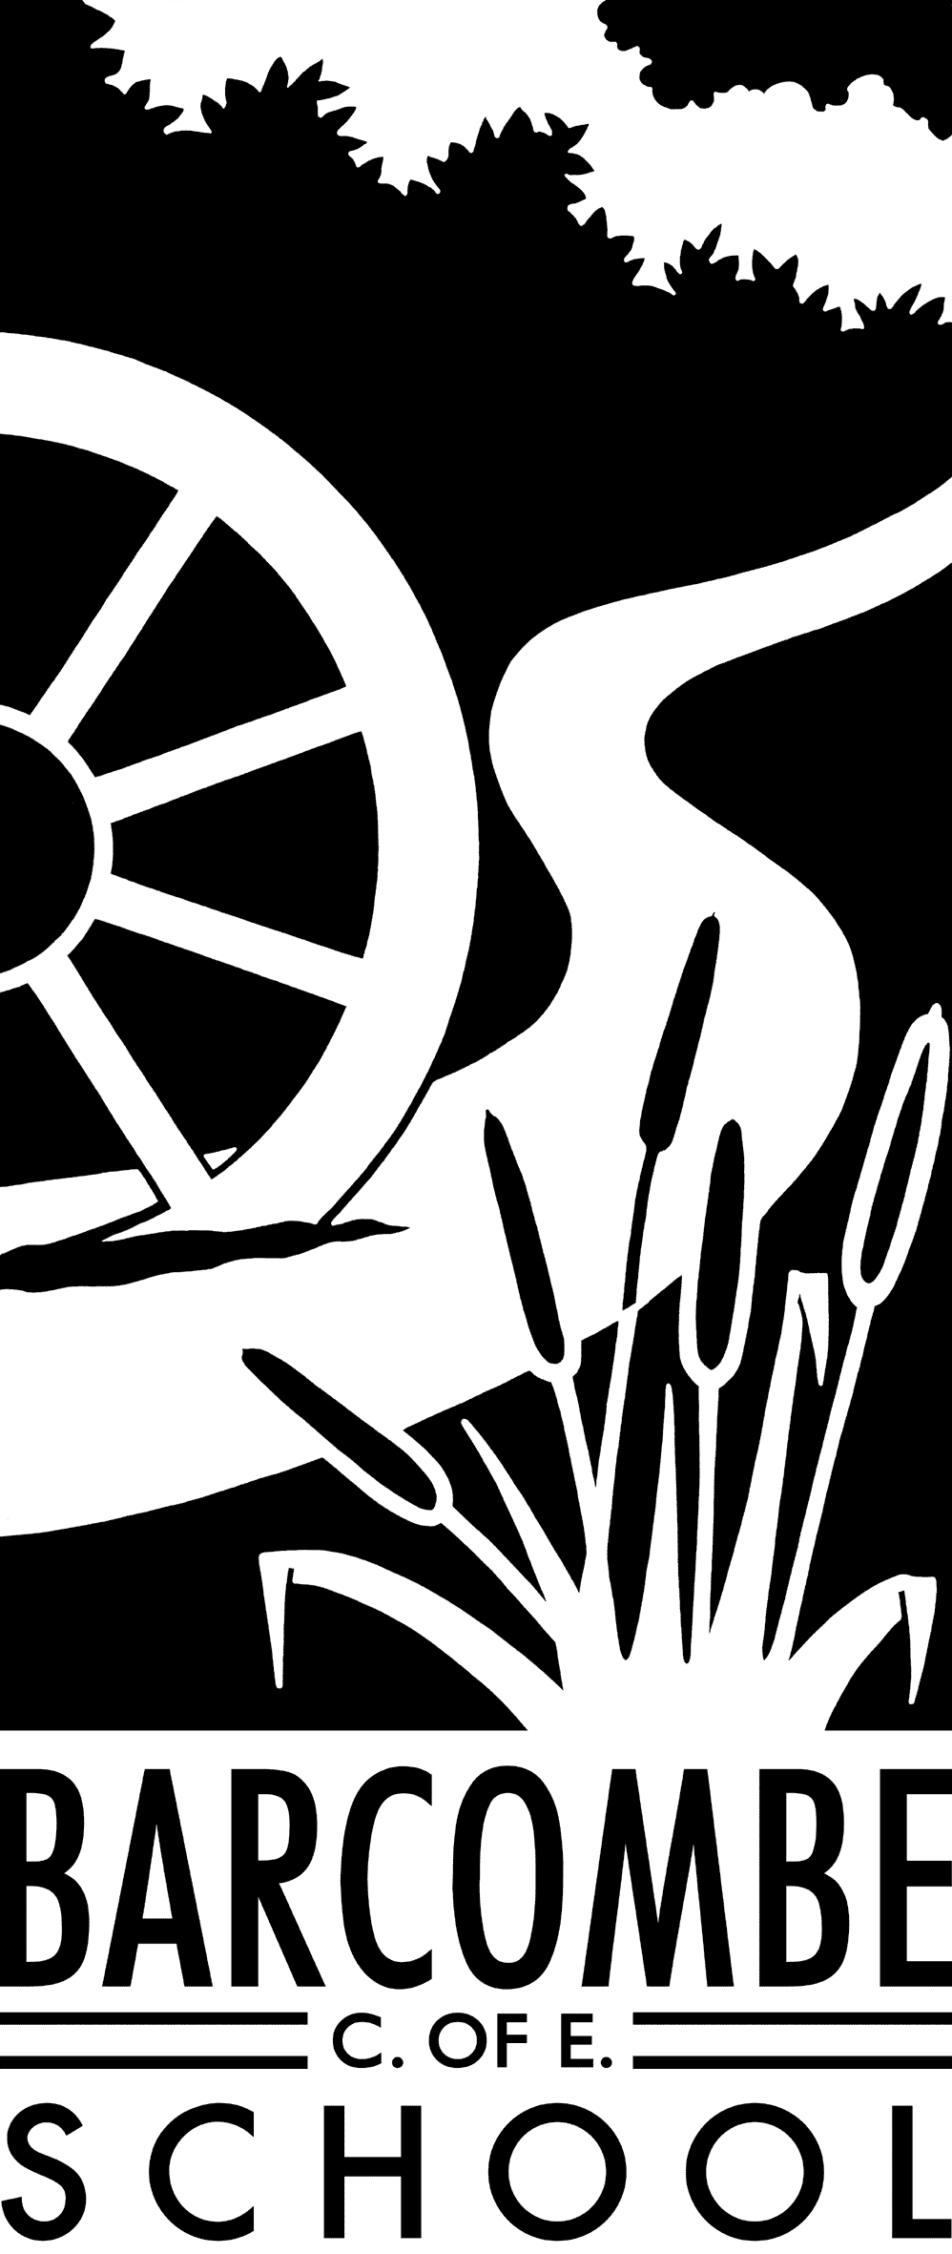

**Dates for your diary:**

* Please see the Barcombe website.

**School contact**

Our school website is [www.barcombe.e-sussex.sch.uk](http://www.barcombe.e-sussex.sch.uk). The link to Google Classrooms can be found on the website or you can visit https://classroom.google.com/ All the online learning and classroom meets will happen through Google Classroom.

**Foxes’ Class information:**

**P.E**.

Please encourage your child to participate in an activity that elevates their heart rate every day. To help keep active, there are a number of sites you can visit that do short P.E sessions for children:

Joe Wickes: <https://www.youtube.com/watch?v=I9sciRMnE1c>

Cosmic Yoga: <https://www.youtube.com/c/CosmicKidsYoga/videos>

Jump Start Jonny: <https://www.jumpstartjonny.co.uk/free-stuff>

**Homework**

Please practise times tables on Times Table Rock Stars and number bonds on Numbots daily.

**Reading Diaries:**

It is really important that your child keeps reading. Some sites which have books/stories for the children to listen to for free are

<https://stories.audible.com/discovery>

<https://www.storylineonline.net/>

**Things you could try at home to enrich this term’s project:**

* Explore your local area.
* Visit local attractions like the South Downs and Lewes Castle (subject to COVID restrictions)
* Explore local attractions online like the Lewes Castle website.
* Explore Google map and look at local Ordinance Survey maps.
* Plan a walk using local maps.
* Draw a map of your local area or create a map of a fictional place.
* Remember to create a key for your map and use grid references/coordinates.
* Research the work of local artists and paint your own artwork in their style.

Teacher: Ms Battle

Teaching Assistant: Mrs Edwards

**Welcome to**

**Fox Class**

**Curriculum Information**

**Term 3 and 4**

**P.E.**

In P.E., we will be focusing on socially-distanced team games and keeping active. Mr Timmins will be providing short P.E video sessions the children can try at home over the course of term 3. Keep an eye on Google Classroom for them!

**ENGLISH**

In term 3 and 4, we will be studying a mixture of fiction and non – fiction texts that are linked to our local area and the concept of home. We will be considering the question ‘What does it mean to belong?’ and as part of our work we shall be studying ‘Belonging’ by Jeannie Baker and thinking about how we belong to our local community. Our writing focus will include writing in role as an estate agent and writing persuasive texts, newspaper reports and narratives. In term 4, we will be continuing this theme of ‘Belonging’ and study a book called ‘Way Home’ that explores the challenges of homelessness. We will read a wide range of texts – fiction and non-fiction – to practise reading for different purposes and to identify themes and conventions within these texts. We will also focus on specific grammar and punctuation, such as simple, compound and complex sentences, main and subordinate clauses, fronted adverbials, direct and indirect speech and paragraphing. We will practise spelling in class and focus on different spelling rules each week.

**MUSIC**

In our music lessons, we will learn music notes and beats, how to read a simple score and compose our own tunes. We will continue to appreciate a range of music and state likes and dislikes.

Our Project is

**Geography/DT: Explore.**

**Home**

**The Big Question:**

**‘What does it mean to belong?**

**ART & DT**

In Art, we will be creating collaborative pieces of artwork to express our sense of belonging (including creating our own fictional village) and we will be experimenting with paint and collage techniques. We will be drawing and painting scenes from our local area and creating collages in the style of Jeannie Baker the author of ‘Belonging’.

Our DT focus is ‘Shelters’ and cookery. We will be designing, making and evaluating our own shelter for a practical purpose and baking yummy food to eat!

**COMPUTING**

This term, children will be using their computers daily and learn to navigate Google Classrooms. We will therefore continue to be mindful of e-safety. We will also be focusing coding lessons on PurpleMash.

**P.S.H.E**

Our first P.S.H.E topic for 2021 is Dreams and Goals. We will learn to understand why it is important to set goals and how to manage disappointment. Next term, the topic is Healthy Me. We will discuss and investigate ways to keep healthy.

**PROJECT: GEOGRAPHY**

Our focus for terms 3 and 4 will be Geography. We will be exploring our local area in the past and present and looking outwards to explore our place in the wider community and world. As part of this work, we will create our own fictional community that is affected by change and consider how we will respond to this change. We will be thinking about the different communities that we belong to, physical and human features in geography, making our own maps and studying OS maps, Google maps and aerial photography. We will continue to develop our map reading and compass skills and will also be analysing different sources of information that we use in our research.

**MATHEMATICS**

In Maths, we will continue to master number and place value, particularly in multiplication and division. In Year 4 the emphasis will be on multiplying two-digit and three-digit numbers by a one-digit number using the formal written layout. In Year 5 we will multiply numbers up to 4 digits by a one- or two-digit number using a formal written method, including long multiplication for two-digit numbers. We will also learn to divide numbers up to 4 digits by a one-digit number using the formal written method of short division. Later in the term, we will investigate fractions, including decimals, and solve problems and reason within context. We will also continue practising times tables as the class become Times Table Rocks.

**SCIENCE**

This term, we will be learning about living things and their habitats. We will be exploring our local area and considering the wildlife that lives in our habitat and how we can look after it in the years to come. We will be learning about the lifecycles of animals and plants and hopefully observing these life cycles taking place in our surroundings. Next term, we plan to explore Earth and Space and our place within our local environment as well as the wider world, our planet, and universe.

**R.E.**

In RE, we will be learning about Sikhism. We will be studying the importance of equality to the Sikh community and how this is practised within their personal relationships. In term 4, we will investigate the Christian concept of Salvation and answer the big questions ‘Why do Christians call the day Jesus died ‘Good Friday’?

**FRENCH**

We will be learning to say short sentences and create noun phrases by discussing animals and pets. Our focus will continue to be on remembering feminine and masculine nouns and using une/un and la/le

correctly.