Family Worship during the COVID-19 outbreak
Hello, everyone! Whilst I may not be able to physically worship with you or your children at the moment, here are some ways that we can continue to connect with each other and with God over the next few weeks.
Before I start, can I recommend this Bible?:
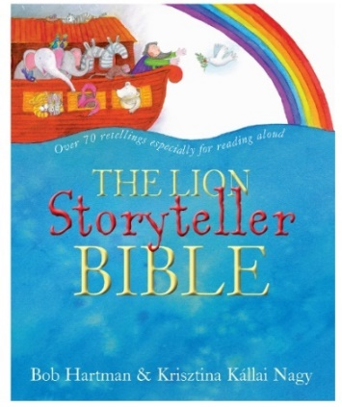
It’s such a well-written, carefully considered Bible for children, with suggested ‘join in’ actions at the back of the book. No story is more than 900 words and it’s brilliant for Primary aged children. I love it!
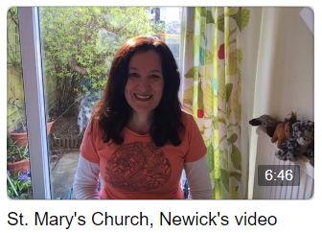
- Each morning at 8:45am for the next two weeks, I am live streaming a worship session from the Open the Book first series and making my way through the Lion Storyteller Bible, starting in the Old Testament. These can be viewed on: https://www.facebook.com/saintmarysnewick/
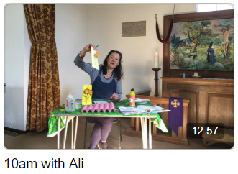
If you can’t make this time, you can follow the story at a different time, as the videos are saved onto the Facebook page. I shall also be suggesting activities and crafts that follow on from this story on a sheet posted onto the website on the links below and this will also be posted on the Facebook page each day.
- Each Sunday at 10am, I shall be live streaming a short children’s service with craft based on the Parables of Jesus. There will a craft sheet to accompany this on the FB page and on the St Mary’s Newick /Barcombe websites:
https://newickchurch.org/youth-news/
http://www.barcombe.net/church/family-faith/.
Other family resources will also be added to these pages.

This is a time for families to strengthen their bonds and to really stick together, giving over the tension, stress and anxiety to God through prayer and petition.
Psalm 145:18
When the peace of Christ rules in our hearts, thankfulness overflows. Even in the darkest of times, we can praise God for his love, his sovereignty, and his promise to be near us when we call.
Keep in touch! Ali xxx

