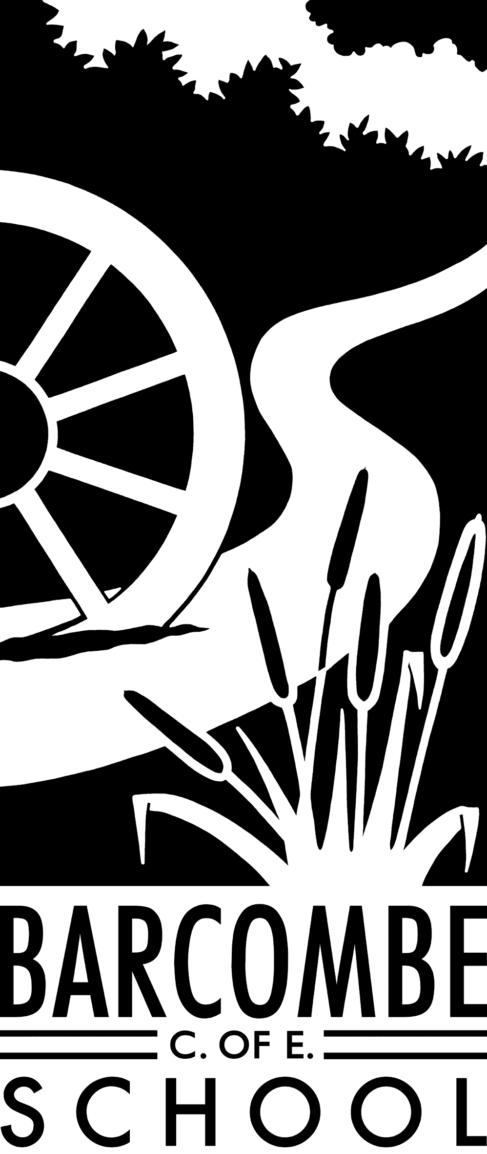

**Things you could try at home to enrich this term’s project:**

* Visit Fishbourne Museum
* Visit the Volcanoes and Earthquakes exhibition at the Natural History Museum
* Go on a nature hike
* Look at OS maps of the local area and identify the contour lines – try climbing some of the hills and seeing how the steepness is shown on the maps.

**Dates for your diary:**

* Monday, January 20th: Network Rail STEM ambassador visit
* Wednesday, 12th February: Cumnor House, 1.30 – 3pm
* Monday, 17th February – Friday, 21st February: Half term
* Friday, 6th March: Mr Spring’s last day
* 31st March: Easter Service at St Mary’s Church, 9 am
* Friday, 3rd April: End of term

**Fox Class information:**

**P.E**.

This term, PE will be on a Thursday. Please can children have their full P.E. kits in school, remembering a tracksuit to keep warm in case we are able to go outside.

**Homework**

Reading: please hear your child read at least 4 times a week and update the reading diaries. Bring reading books back to school every day.

Times Tables: use Times Tables Rockstars as much as possible

MyMaths: complete all set tasks on MyMaths

Creative homework is not compulsory.

**Our school website address is:**

[www.barcombe.e-sussex.sch.uk](http://www.barcombe.e-sussex.sch.uk) and our class blog is at <http://barcombefoxes.wordpress.com> where you will find information about the class, home learning, upcoming events and links to useful websites.

Teacher: Ms Battle

Teaching Assistant: Mrs Mann

**Welcome to**

**Fox Class**

**Curriculum Information**

**Term 3 and 4**

MUSIC

This term, our music work will focus on composition, developing our understanding of how pieces of music are put together and how layers of sound are combined. In term 4, we will further develop our singing and performing skills.

COMPUTING

In the Computing unit for term 3, we will explore writing for different audiences and in term 4, we will learn more about animation.

SCIENCE

This term, we will be learning about electricity and how to construct a simple circuit from basic parts. We will also learn to recognise some common conductors and insulators. Next term, the topic will be ‘Light’ where we will learn how shadows are formed and that they can change depending on the light source. We will learn that light travels in straight lines and that we can see objects because they give out light or reflect light into the eye.

P.S.H.E

Our first P.S.H.E topic for 2020 is Dreams and Goals. We will learn to understand why it is important set goals and how to manage disappointment. Next term, the topic is Healthy Me. We will discuss investigate ways to keep healthy.

GEOGRAPHY AND HISTORY

In Geography this term, we will learn about mountains and mountain ranges of the world. We will also learn more about volcanoes and how they are formed, as well why earthquakes occur. In term 2, explore a history topic: the Romans Empire and its impact on Britain. This will include learning about key figures such as Julius Caesar, Claudius and Boudica.

ART & DT

In Art this term, the children will use clay to make jewellery and in term 4, we will explore patterns and tessellations to make Roman mosaics.

The topic for DT in term 3 is ‘shelters’, where we will investigate, design and make structures. In term 4, we will investigate bridges to design and make.

MATHEMATICS

In Maths, we will continue to master number and place value, particularly in multiplication and division. In Year 4 the emphasis will be on multiplying two-digit and three-digit numbers by a one-digit number using the formal written layout. In Year 5 we will multiply numbers up to 4 digits by a one- or two-digit number using a formal written method, including long multiplication for two-digit numbers. We will also learn to divide numbers up to 4 digits by a one-digit number using the formal written method of short division. Later in the term, we will investigate fractions, including decimals, and solve problems and reason within context. We will also continue practising times tables as the class become Times Table Rock Stars.

R.E.

This term’s topic for RE is the Islam concept of submission and the importance of this to Muslims, thereby enhancing our knowledge and understanding of the Muslim community. In term 4, the RE topic is sacrifice and what that means to Christians and other religions.

Our Learning Journeys are:

**Active Earth**

and

**When in Rome…**

ENGLISH

In term 3 and 4 respectively, we will read The Promise by Nicola Davies and Escape from Pompei by Christina Balit. Our writing focus will include persuasive letters, as well as diary entries, instructions and poetry. We will read a wide range of texts – fiction and non-fiction – to practice reading for different purposes and to identify themes and conventions within these texts. These texts will form the basis and inspiration for our writing and used to extend vocabulary. We will also focus on specific grammar and punctuation, such as fronted adverbials and other sentence openers, subordinate conjunctions and the correct use of apostrophes. We will practice spelling in class and focus on different spelling rules each week. Children’s understanding of grammar, punctuation and vocabulary will be developed throughout the year during all topics and handwriting will be practised frequently.

P.E.

In P.E. we will be focusing on gymnastics. The children will develop certain skills, such as their ability to use balance, movement, rolling, symmetry and partner work to create and perform a gymnastic sequence. Term 4 will see Foxes dance! We will investigate both traditional and contemporary dances, as well as dances from different cultures.

FRENCH

Our theme in French this term is Getting To Know You where we will learn greetings in French, as well as how to count. In term 4, we will learn about our school. Our focus will be on listening and responding to topic vocabulary, as well as demonstrating understanding with actions.