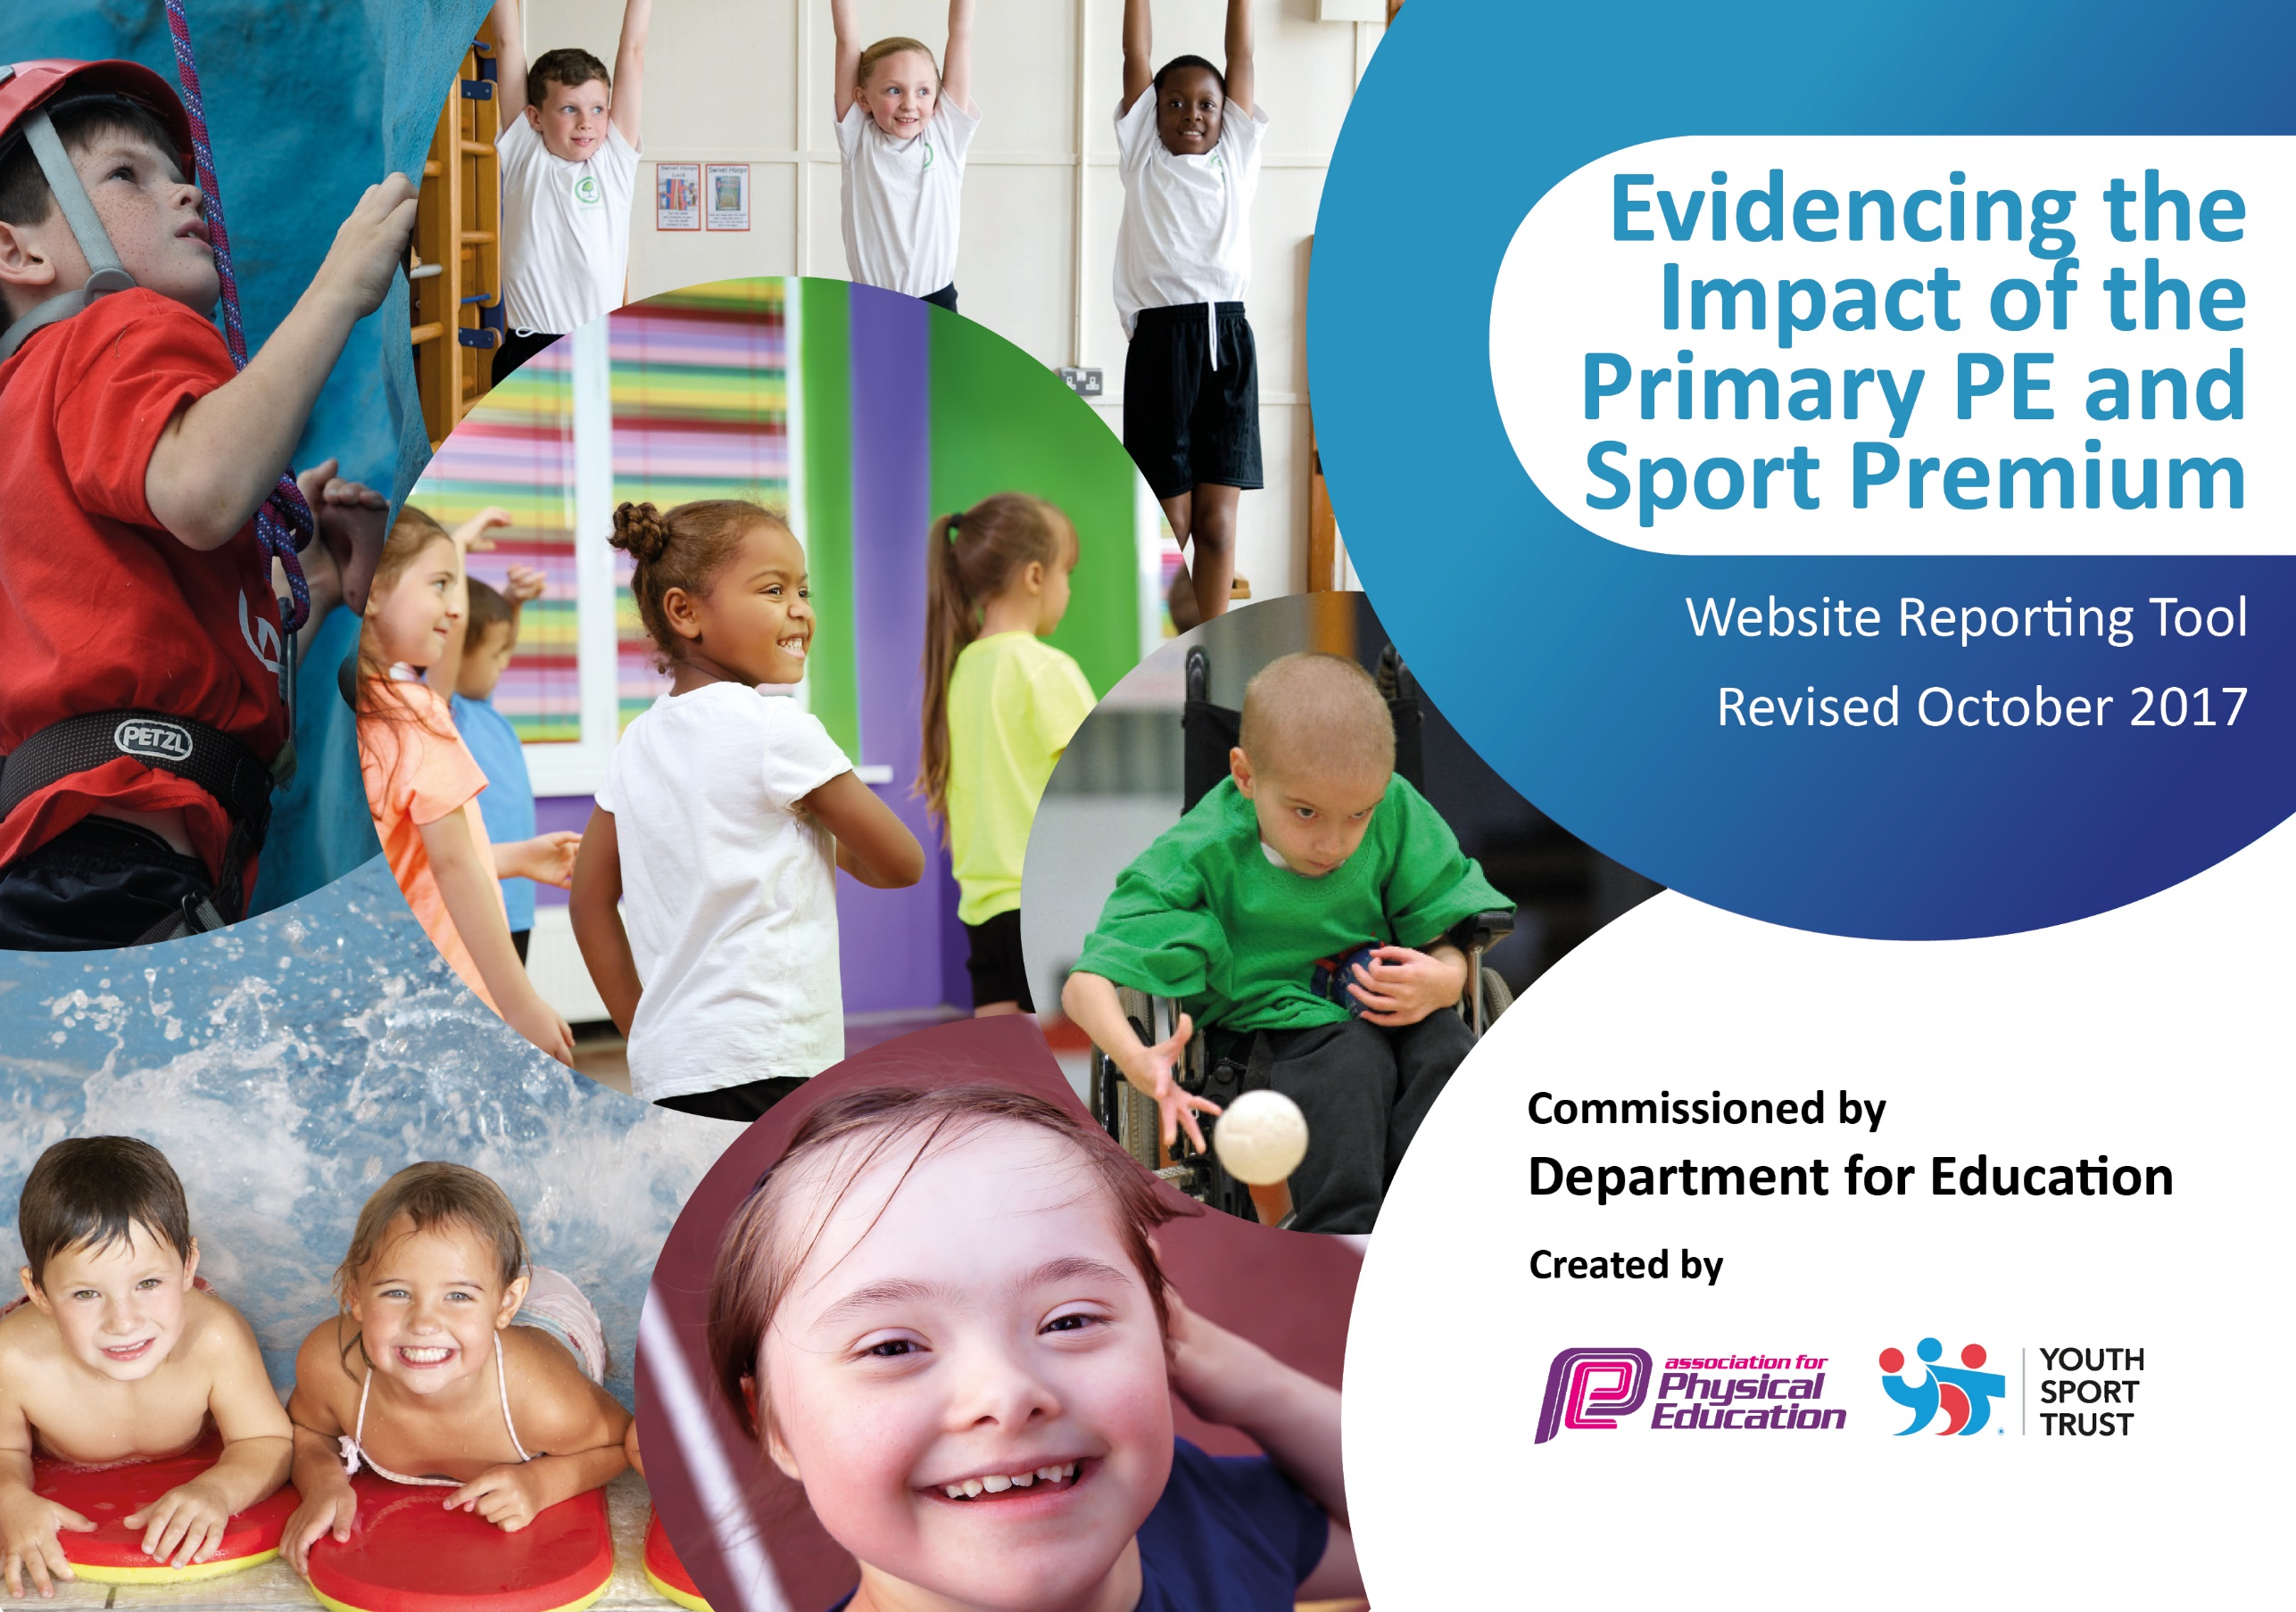

Schools must use the funding to make additional and sustainable improvements to the quality of PE and sport they offer. This means that you should use the Primary PE and Sport Premium to:

- develop or add to the PE and sport activities that your school already offers
- build capacity and capability within the school to ensure that improvements made now will benefit pupils joining the school in future years

Please visit gov.uk for the revised DfE guidance including the 5 key indicators across which schools should demonstrate an improvement. This document will help you to review your provision and to report your spend. DfE encourages schools to use this template as an effective way of meeting the reporting requirements of the Primary PE and Sport Premium.

We recommend you start by reflecting on the impact of current provision and reviewing the previous spend.
Under the Ofsted Schools Inspection Framework, inspectors will assess how effectively leaders use
the Primary PE and Sport Premium and measure its impact on outcomes for pupils, and how effectively governors hold them to account
for this.

Schools are required to publish details of how they spend this funding as well as on the impact it has on pupils’ PE
and sport participation and attainment.
We recommend regularly updating the table and
publishing it on your website as evidence
of your ongoing review into how you are using the money
to secure maximum, sustainable impact. To see an example of how to complete the table please click HERE.

Support for review and reflection - considering the 5 key indicators from DfE, what development needs are a priority for your setting and your students now and why? Use the space below to reflect on previous spend, identify current need and priorities for the future.

Barcombe:  Sports Premium Spend 2017-18 Total Allocation: £17300  Key achievements to date: | Areas for further improvement and baseline evidence of need:
Key indicator 1: The engagement of all pupils in regular physical activity – Chief Medical Officer guidelines recommend that primary school children undertake at least 30 minutes of physical activity a day in school.  Across the Federation of three schools, qualified Sports Coach supports and mentors teachers in the delivery of high quality PE provision.  P.E coach’s role increased to include working with vulnerable groups.  Sports lead to led children through a selection of physical activities before school on at least two occasions a week.  Training for playground buddies /MDSA’s  To support more children have opportunities to access playground games. To reduce incidents of inappropriate behavior during playtimes.  Update and replenish sports equipment and resources  Key indicator 2: The profile of PE and sport being raised across the school as a tool for whole school improvement.  Sports coach to focus on health and nutrition, use fitbits to measure heart rate and demonstrate increased physical health.  Continue with daily sport breakouts –Daily mile, circuits, etc.  Increase the amount of intra sporting competitions across the Federation.  Key indicator 3: Increased confidence, knowledge and skills of all staff in teaching PE and sport.  Coach to team teach with class teachers to raise the quality of PE provision and skill development within lessons.  Purchase new line markings for the school playground to support sporting activities during break times and ensuring team games and competitive games can be taught to the highest quality  .Key indicator 4: Broader experience of a range of sports and activities offered to all pupils.  Specialized P.E coach to teach a broad range of sports activities.  Introduce a range of new sports to the Federation –Extreme Frisbee, Stoolball, tennis coaching. Introduce more outdoor and adventurous activities –KS2 chn achieved John Muir award.  Key indicator 5: Increased participation in competitive sport.  Sports leader to raise the profile and frequency of intra sports competitions.  HLTA to shadow the sports leaders one afternoon a week to learn how to prepare and lead intra sporting events across the Federation.  School to buy into inter school academic cluster competitions | Sports Coach to work on improving social /communication skills within P.E nurture groups.  New sports leader to raise the profile and frequency of intra sports competitions.  Look into indoor exercise schemes, e.g. Jump Start Jonny for when the weather is too poor to run the daily mile.  Increase opportunities to use the outdoor environments to promote physical activity and a healthy lifestyle.  Ensure new line markings are being used and Play Leaders know which games can be played using them  Appoint a new Sports lead and ensure we take part and raise the profile of intra sports competitions.  Offer a wider range of physical activities both during and after school.

Meeting national curriculum requirements for swimming and water safety | Please complete all of the below:
What percentage of your Year 6 pupils could swim competently, confidently and proficiently over a distance of at least 25 metres when they left your primary school at the end of last academic year? | 88%
What percentage of your Year 6 pupils could use a range of strokes effectively [for example, front crawl, backstroke and breaststroke] when they left your primary school at the end of last academic year? | 88%
What percentage of your Year 6 pupils could perform safe self-rescue in different water-based situations when they left your primary school at the end of last academic year? | 25%
Schools can choose to use the Primary PE and Sport Premium to provide additional provision for swimming but this must be for activity over and above the national curriculum requirements. Have you used it in this way? | No

Action Plan and Budget Tracking
Capture your intended annual spend against the 5 key indicators. Clarify the success criteria and evidence of impact that you intend to measure to evaluate for students today and for the future.

Academic Year: 2018/19 | Total fund allocated: £ 17100 | Date Updated: 2.10.18
Key indicator 1: The engagement of all pupils in regular physical activity – Chief Medical Officer guidelines recommend that primary school children undertake at least 30 minutes of physical activity a day in school |  |  |  | Percentage of total allocation:
 |  |  |  | 40%
School focus with clarity on intended impact on pupils: | Actions to achieve: | Funding allocated: | Evidence and impact: | Sustainability and suggested next steps:
Continue to use a specialized sports coach to team teach P.E. P.E coach to Increase the role of the sports coach to improve social /communication skills and lead and support playtime games.  Introduction of Jump Start Jonny initiative. Chn to receive extra exercise each day and this can be done at any point in the day, whatever the weather.  Training for play leaders to ensure children have opportunities to access playground games. To increase enjoyment of physical activity and to reduce incidents of inappropriate behavior during playtimes.  Update and replenish sports equipment and resources | Sports lead to work with Inclusion Manager and class teachers to identify vulnerable pupils /groups of pupils.  Increased physical exercise opportunities  Sports lead to support playground leaders to set up a rota and train to lead a variety of playground games.  Buy new equipment to ensure teachers are able to deliver high quality PE sessions and a range of activities are offered. | £6920  (Sports Leader)  £100  £100  (equipment) | Sports Coach to deliver good quality P.E sessions to all the children in the school.  Identified individuals and vulnerable groups to show improvement in stamina and communication and processing when completing exercise.  Teachers to see an improvement in vulnerable groups communication, stamina and processing  More children having opportunities to access playground games using the new markings through the play leaders.  Less incidents of inappropriate behaviour at break times and pupil voice shows higher levels of enjoyment and participation in playground games  Teachers’ able to deliver high quality PE sessions with appropriate resources. | Sustainable. Sports coach raising profile of PE within the school, modelling good teaching of P.E and supporting vulnerable groups.  Sustainable. Play leaders to be trained and supported by the sports lead from now on.  New equipment has been purchased so teachers have the resources to deliver sessions. Sustainable but will need to be replenished.
Key indicator 2: The profile of PE and sport being raised across the school as a tool for whole school improvement |  |  |  | Percentage of total allocation:
 |  |  |  | 25%
School focus with clarity on intended impact on pupils: | Actions to achieve: | Funding allocated: | Evidence and impact: | Sustainability and suggested next steps:
Sports coach to focus on health and nutrition, use fitbits to measure heart rate and demonstrate increased physical health.  Continue with daily sport activities, e.g. daily mile, Jump Start Jonny, Circuits…  Appoint a sports Mentor to raise the profile of sports  Appoint a new Sports Lead for the school and increase the amount of intra sporting competitions across the Federation. | Sports Coach to show an increased use of the fitbits and sports watches to monitor progress and motivate pupils.  Continue to raise profile of daily sports breakouts – circuits etc…School Council to evaluate the enjoyment level of these and any other sports breakouts children would like to see happening.  Appoint a new Sports Lead to ensure we attend and raise the profile of intra sporting events | Sports mentor - £4251 | Children increase awareness and ability to monitor their physical health and wellbeing.  Children to have increased opportunities of carrying out more physical activities throughout the school day  Pupil voice shows children are aware of the exercise we do daily and they enjoy it.  Chn take part in addition sports session through attending intra sports events. | Monitoring needs to be completed weekly so children can challenge themselves to improve.

Key indicator 3: Increased confidence, knowledge and skills of all staff in teaching PE and sport |  |  |  | Percentage of total allocation:
 |  |  |  | 0%
School focus with clarity on intended  impact on pupils: | Actions to achieve: | Funding  allocated: | Evidence and impact: | Sustainability and suggested  next steps:
Coach to team teach with class teachers to raise the quality of PE provision and skill development within lessons. | Sports coach to team teach with teachers. | £8580  (Sports Leader – already accounted for) | Raise profile of high quality sports provision.  Children have access to high quality PE provision.  Teachers improve knowledge and skill development in delivering high quality PE. | Not currently sustainable, over time the teachers will have the skills to deliver high quality PE sessions.
Key indicator 4: Broader experience of a range of sports and activities offered to all pupils |  |  |  | Percentage of total allocation:
 |  |  |  | 30%
School focus with clarity on intended  impact on pupils: | Actions to achieve: | Funding  allocated: | Evidence and impact: | Sustainability and suggested  next steps:
Introduce a range of new sports to the Federation –Extreme Frisbee, Stoolball, tennis coaching.  Introduce after school sports clubs for activities not taught in lessons, e.g. Netball  Promoting the use of the outdoor environments to offer a wider range of outdoor activities and survival skills. (Forest School) | Speak with sports providers.  Work with local coaches.  Staff to be trained in the use of the outdoor space/possible activities | £4829 | Across the year a range of after school clubs will be offered.  The school will work with local stoolball coach.  Outdoor environments are increasingly used to promote being active and are used weekly by class teachers. | Increase range of clubs on offer.  Increase outdoor physical learning opportunities
Key indicator 5: Increased participation in competitive sport |  |  |  | Percentage of total allocation:
 |  |  |  | 6%
School focus with clarity on intended  impact on pupils: | Actions to achieve: | Funding  allocated: | Evidence and impact: | Sustainability and suggested  next steps:
New Sports leader to raise the profile and frequency of intra sports competitions. Parents to become more involved to help raise the profile of sports.  School to buy into inter school academic cluster competitions | Sports leader to organise and lead intra sporting events, termly across the Federation. Sports lead to liase with parents to ensure they are involved too.  Buy into competition support from Chailey Secondary School | £1000 | At least one intra sports tournament a term across the Federation.  Sports Lead to plan and prepare all risk assessments / paper work and organisation.  School to buy into support offered by local secondary school. | Sustainable – This needs to be developed further with support from SLT  Currently an agreement with local secondary.  If funding was withdrawn it is likely intra school competitions will not be organised.

