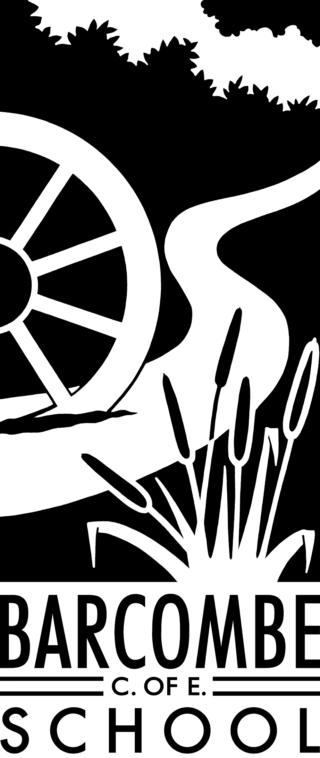

**Things you could try at home to enrich this term’s project:**

* Look at OS maps of the local area and identify the contour lines – try climbing some of the hills and seeing how the steepness is shown on the maps.
* Visit Fishbourne Museum
* Try out some Roman recipes – there are lots of ideas online, but please don’t cook any real dormice!

**Dates for your diary:**

* Network Rail STEM ambassador visit: Monday, January 20th
* Cumnor House Science visit: Wednesday, January 22nd
* Half term: Monday, 17th February – Friday, 21st February
* Easter Service at St Mary’s Church: 31st March at 9am
* Owls to Chailey School Show: Wednesday, March 4th (tbc)
* End of term 4: Friday, April 3rd

**Our school website address is:**

[www.barcombe.e-sussex.sch.uk](http://www.barcombe.e-sussex.sch.uk) and our class blog is at <http://barcombeowls.wordpress.com> where you will find information about the class, home learning, upcoming events and links to useful websites.

**Owl Class information:**

**P.E**.

This term, PE will be on a Monday. Please can children have their full P.E. kits in school, remembering a tracksuit to keep warm in case we are able to go outside.

**Homework**

Reading: please hear your child read at least 4 times a week and update the reading diaries. Bring reading books back to school every day.

Times Tables: use Times Tables Rockstars as much as possible

MyMaths: complete all set tasks on MyMaths

Creative homework is not compulsory, but just to give ideas for you to do if you wish.

Teachers: Mrs Force and

Mrs Matheson

Teaching Assistant: Mrs Edwards

**Welcome to**

**Owl Class**

**Curriculum Information**

**Term 3 and 4**

Our Learning Journeys are:

**Active Earth**

and

**When in Rome…**

P.E.

In P.E, we will be focusing on gymnastics. Mr Timmins, out new sports coach, will lead the lessons. The children will develop certain skills, such as their ability to use balance, movement, rolling, symmetry and partner work to create and perform a gymnastic sequence. Term 4 will see Owls dance! We will investigate both traditional and contemporary dances, as well as dances from different cultures.

FRENCH

We start the term by looking at ourselves – identifying body parts and describing the appearance of others including clothing and colours. We then move on to Food Glorious Food

ART & DT

In art this term, the children will use clay to make different forms including jewellery and in term 4, we will explore patterns and tessellations to make Roman mosaics.

The topic for DT in term 3 is ‘shelters’, where we will investigate, design and make structures. In term 4, we will investigate bridges to design and make.

COMPUTING

In the Computing unit for term 3, we will explore coding, creating games. Our unit for term 4 is called ‘Text Adventures’ where the children will learn to code a map-based text adventure.

MUSIC

This term, our music work will focus on composition, developing our understanding of how pieces of music are put together and how layers of sound are combined. In term 4, we will further develop our singing and performing skills.

P.S.H.E

Our first P.S.H.E topic for 2020 is Dreams and Goals, where we will explore the children’s own goals, how these compare and contrast with other people’s depending on circumstance, and how we can achieve our dreams.

SCIENCE

This term we will be learning about electricity, applying our existing knowledge to create a product. We will also be learning how to draw circuit diagrams and correct circuits when they go wrong! Next term, the topic will be ‘Light’ where we will learn how shadows are formed and that they can change depending on the light source. We will learn that light travels in straight lines and that we can see objects because they give out light or reflect light into the eye.

MATHEMATICS

In Maths, we will continue to work on fractions and their links with decimals and percentages. We will also work on algebra (which is far less scary than anyone thinks!) and learn about ratio and proportion. Arithmetic forms an important part of our lessons, particularly for Year 6, and time tables continue to be a daily focus. We will continue to develop our understanding of shape and position and direction, as well as applying our skills in all areas of maths in many different types of problems, both reasoning activities and worded problems.

GEOGRAPHY AND HISTORY

In Geography this term, we will learn about mountains and mountain ranges of the world. We will also learn more about volcanoes and how they are formed, as well why earthquakes occur. In term 2, we will explore a history topic: the Roman Empire and its impact on Britain. This will include learning about key figures such as Julius Caesar, Claudius and Boudica.

ENGLISH

In term 3 and 4 respectively, we will read The Savage by David Almond and Escape from Pompeii by Christina Balit. We will read a wide range of texts – fiction and non-fiction – to practise reading for different purposes and to identify themes and conventions within these texts. These texts will form the basis and inspiration for our writing and used to extend vocabulary. We will also focus on specific grammar and punctuation, such as fronted adverbials and other sentence openers, subordinating conjunctions and the correct use of apostrophes. We will practise spelling in class and focus on different spelling rules each week. Children’s understanding of grammar, punctuation and vocabulary will be developed throughout the term during all topics and handwriting will be practised frequently.

R.E.

This term’s focus is on the Hindu concept of Moksha – there being many paths one can take to reach the ultimate goal of being with God. We will look at how everyone needs guidance at times and where Hindus frequently turn. Methods of showing devotion as well as passing on stories will also be discussed.