MEDICAL INFORMATION

Barcombe Primary School-September 2020-2021

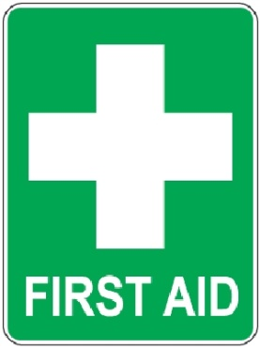

Vinny Bosence Yr 6 Owls

Asthma – Ventolin
2 puffs when required

Arthur Wales Yr 6 Owls

Asthma – Ventolin inhaler
Needs it when running, usually 3 puffs max.
2 puffs before running, an extra squirt at the beginning to clear nozzle. Then could have 2 puffs after running if he can’t get breathe back.

Ciaran Tol Yr 5 Owls

Asthmatic – Ventolin Evohaler
2 puffs via spacer 30 mins before exercise/sports

Albert Hibberd Yr 4 Foxes

Asthmatic

Maggie-Jo Atkinson-Byrne Yr 3 Badgers

Asthma
Will need Ventolin before playtime and after PE

Grace Burnham-Middleton Yr 3 Badgers

Mild Asthma & Eczema
Ventolin as required

Siezures – Instructions on Staff room wall

Ethan Forward Yr 3 Badgers

Eczema

Alfred Milner Yr 3 Badgers

Mild Eczema
Fred has had 2 Febrile seizures in 2014. (fit after high temp)- None since them but caution should be taken if he has a fever, he needs calpol.
Allergic to dairy:- milk, cheese, yoghurt and ice cream.
He is allergic to eggs in that he gets a blocked nose, eczema and slightly upset tummy (sometimes).
Not too bad an allergy to worry about.
Can have occasional treat for children’s birthday, Easter etc…

Kieran Hunnisett Yr 2 Squirrels  Medication :-None- Mum administers at home  Triggers:- Possibly fast flashing lights, Spontaneous having a bug or a virus.  Symptoms:- Becomes red in the face, hot body, arms go out to the side or hugging himself. Being sick and crying. Frequency- less than once a month.  Response/Protocol/Procedures:- Keeping calm, stay with him, reassure him, direct another member of staff to ring parents immediately. Keep him cool, take T shirt off if needed. He may feel v.tired and may need to rest afterwards. Call an ambulance if he has a defined prolonged seizure with stiffness of limbs or repetitive jerking of limbs for more than 5 minutes. | 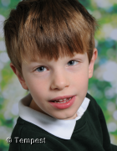

Jackson Matthews- Colbourne Yr 2 Squirrels

Dairy Free - Cows milk, protein allergy

Mireya Richards Yr 2 Badgers

Allergys:-

Dairy- cows milk, protein, eggs.
Nuts and seeds, avocado and salmon.

- Asthma and Eczema

Trigger signs where ambulance and Grandma MUST be called:-
Hives, swelling of throat and mouth, lips, wheezing, eyes often swell first.

Epi-pen x 2 - in classroom
must still be given even when not showing symptoms of having eaten nuts.

EPI PEN x 2 in classroom

Felicia Richards Yr 4 Foxes

Asthmatic

Epi-pen in Badgers classroom
All nuts allergy, dust, pollen, cats, pine trees & seeds

Pupil  &  Symptom | Yr & class
Hannah Cooper  Wears corrective glasses | Yr 6 Owls
Oscar Ogden  Mild allergy to some animal fur, hayfever | Yr 6 Owls | 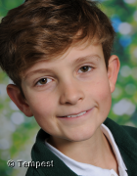
Hannah Price  Squint, wears glasses | Yr 6 Owls
Lily-May Washington  Eyesight problems–Browns Disorder | Yr 5 Foxes
Noah Birch  Bleeds a lot, is being investigated | Yr 4 Foxes | 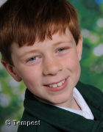

Jackson Christie  Milk allergy | Yr 4 Foxes
Marley Regan  Pineapple & milk | Yr 4 Foxes
Max Richardson  Grommits in ears prone to infections | Yr 3 Badgers
Kamil Gunes  Halal/Pescatarian | Yr 1 Squirrels
Lucas Oakman  Strawberry Allergy/reaction | Yr 2 Squirrels

Lauris Prince  Occasional hearing problems – due to tonsils,  waiting for ENT apt | Reception
Cosmo Minns  Mild Eczema in winter.  NO Salmon – gets very ill | Reception | 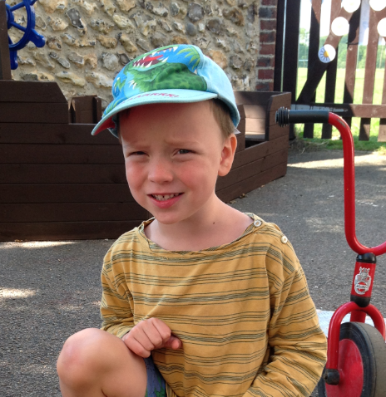
Henry Church  Dextrocardia, causes no ill effects | Reception

Amenah Engineer  Eczema occasionally in the winter | Reception | 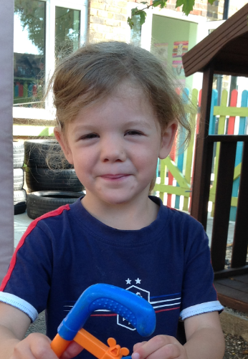
Ascia Gunes  Halal/Pescatarian | Reception
Ollie Barron-Kelly  Epimax- Topical  Epi-max® is cost effective and proven to relieve dry skin and dry skin conditions such as eczema and psoriasis. Epi-max® products are dermatologically designed and tested. They are hypo-allergenic, SLS-free and contain no artificial colourants or perfumes. | Reception

