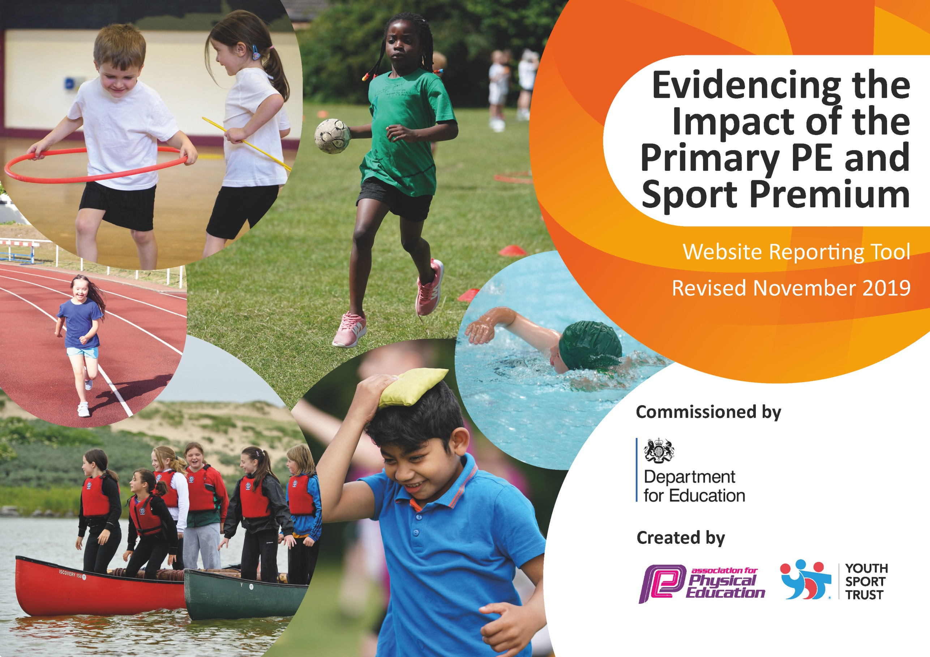
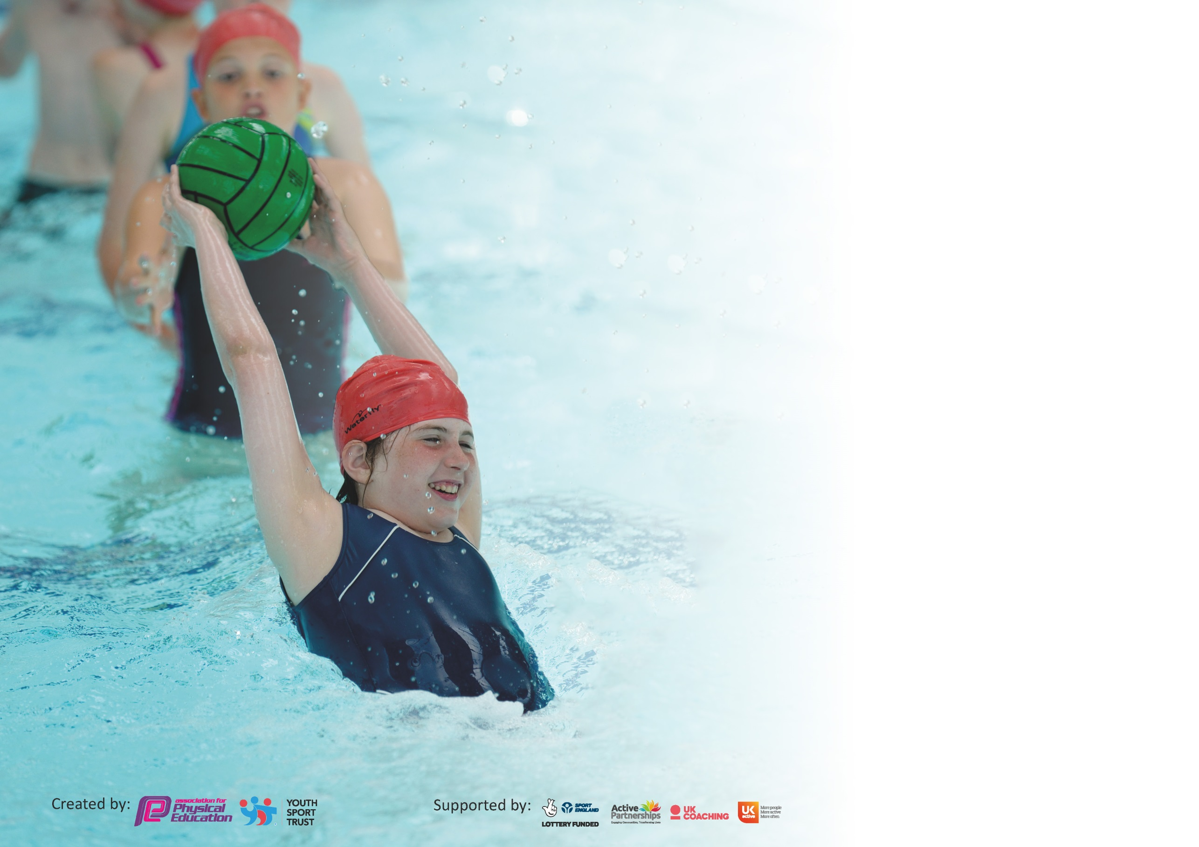

It is important that your grant is used effectively and based on school need. The Education Inspection Framework (Ofsted 2019 p64) makes clear there will be a focus on ‘whether leaders and those responsible for governors all understand their respective roles and perform these in a way that enhances the effectiveness of the school’.

Under the Quality of Education criteria (p41) inspectors consider the extent to which schools can articulate their curriculum (INTENT), construct their curriculum (IMPLEMENTATION) and demonstrate the outcomes which result (IMPACT).

To assist schools with common transferable language this template has been developed to utilise the same three headings which should make your plans easily transferable between working documents.

Schools must use the funding to make additional and sustainable improvements to the quality of Physical Education, School Sport and Physical Activity (PESSPA) they offer. This means that you should
use the Primary PE and Sport Premium to:

- Develop or add to the PESSPA activities that your school already offer
- Build capacity and capability within the school to ensure that improvements made now will benefit pupils joining the school in future years

Please visit gov.uk for the revised DfE guidance including the 5 key indicators across which schools should demonstrate an improvement. This document will help you to review your provision and to report your spend. DfE encourages schools to use this template as an effective way of meeting the reporting requirements of the Primary PE and Sport Premium.

We recommend you start by reflecting on the impact of current provision and reviewing the previous spend.

Schools are required to publish details of how they spend this funding as well as on the impact it has on pupils’ PE and sport participation and attainment by the end of the summer term or by 31st July 2020 at the latest.

We recommend regularly updating the table and publishing it on your website throughout the year. This evidences your ongoing self-evaluation of how you are using the funding to secure maximum, sustainable impact. Final copy must be posted on your website by the end of the academic year and no later than the 31st July 2020. To see an example of how to complete the table please click HERE.

Support for review and reflection - considering the 5 key indicators from DfE, what development needs are a priority for your setting and your pupils now and why? Use the space below to reflect on previous spend and key achievements and areas for development.

Key achievements to date until July 2019: | Areas for further improvement and baseline evidence of need:
Key Indicator 1: Engagement of all pupils in regular physical activity  All children have the opportunity to participate in at least 30 minutes of physical activity per day. KS1 and KS2 have the opportunity to take part in extra-curricular sporting activities. Hall timetables facilitate regular opportunities for all in PE.  Update and replace sports equipment and play resources as required.  Playground equipment purchased to promote ongoing physical activity.  Emphasis on more children having opportunities to enjoy an increasing range of playground games (reducing the dominance of football games, for example).  Further training for Playground Leaders and Playground Buddies. Further training for MDSAs.  Key Indicator 2: The profile of PE and sport being raised across the school as a tool for whole school improvement  PE curriculum delivery is consolidated throughout the school; teachers’ confidence increased and PE teaching is progressive and effective.  Continue with daily sports break-outs (including wet weather options).  All sporting achievements are celebrated and shared with the school in assemblies and with parents/carers via the school’s newsletters. A dedicated PE board is updated to display participation and achievements in sporting events.  High number of Barcombe children participating in Brighton Half Marathon event. Within our Chailey Cluster, Barcombe children regularly perform well across a variety of events including football, netball, athletics and swimming.  Range of equipment purchased to enable all children to receive a broad and balanced PE curriculum. Children exposed to a range of sports beyond the sports in which they regularly participate.  Key Indicator 3: Increased confidence, knowledge and skills of all staff in teaching PE and sport  All Class Teachers have received CPD from Optimum Coaching; these sessions have been supplemented further by follow-up CPD throughout the year to ensue staff confidence, knowledge and skills are secure, and are developed further.  Our CPD approach enables Class Teachers to recognise and build on the clear progression of skills between year groups.  Key Indicator 4: Broader experience of a range of sports and activities offered to all pupils  Broad range of activities planned and delivered within the curriculum. Children exposed to a range of sports outside the regular sports in which they participate. Taster days to include golf and cricket.  Barcombe offers a range of sports and activities, including a variety of extra-curricular clubs such as dance, football, netball and multi-skills.  Successful Sports Day enjoyed utilizing previous year’s model. This was an enjoyable event with children from Reception to Year 6 engaging in a carousel of sporting activities; all children could participate with minimal time waiting.  Key Indicator 5: Increased participation in competitive sport  High participation of our children representing the school in events such as the Brighton Half Marathon (June 2019).  Within our Primary PE Partnership, Barcombe children regularly compete in a range of competitions including a football league, netball tournaments, cross country championships and swimming galas. District Sports (athletics competition) was open to all children in KS2 (all trialled within their PE lessons). Successful participants are then celebrated in the newsletter, within an assembly and on the PE display. | Key Indicator 1: Engagement of all pupils in regular physical activity  2019/2020-involvement with Optimum Coaching and Phoenix Sports Coaching to encourage and develop further physical activity initiatives across the school.  Introduction of new Sports Coach (move from Optimum to Phoenix) from January 2020 to provide additional support for vulnerable and less-active pupils, and assist/facilitate active playtimes.  Revise interventions schedules for work with vulnerable pupils to ensure that regular coaching is received. Record impact of this and next steps. Sports Coach to be utilised to support attendance, behaviour and self-esteem for our pupils.  Increased opportunity for participation in intra-school and inter-school sporting activities for all children (including cross country championships, for example).  Refresher training for staff in PE delivery and outdoor learning. Forest School provision to continue for every year group.  Local secondary school will provide Year 10 sports leaders who will deliver sessions to KS1 and KS2 pupils.  Key Indicator 2: The profile of PE and sport being raised across the school as a tool for whole school improvement  Introduction of new Sports Coach in January 2020 to provide additional support for vulnerable and less-active pupils and support/facilitate active playtimes; different approach planned to invigorate provision.  Revise intervention schedules for work with vulnerable pupils to ensure that regular coaching is received. Record impact of this and next steps. Sports Coach to support attendance initiatives, behaviour and self-esteem for pupils.  Increased opportunity for participation in inter-class sporting activities for all children.  Increase the number of visits from sporting heroes including Paralympians; this links with our school values and our promotion of MHEW awareness across the school.  Key Indicator 3: Increased confidence, knowledge and skills of all staff in teaching PE and sport  Additional benefit from working with the new Sports Coach (from January 2020). Sports Coach will team teach with Class Teachers in order to model the skills and techniques needed to form an inspiring PE lesson. Class Teachers who lack confidence will be targeted to ensure that the CPD is effective and purposeful.  Staff skills/knowledge will be used to monitor this in order to enhance the confidence with, and teaching of, PE and sport in our school.  Subject Leader to provide Class Teachers with a whole school tracking system to ensure progression and consistency.  Key Indicator 4: Broader experience of a range of sports and activities offered to all pupils  Broad range of activities planned and delivered within the curriculum.  Throughout the year a range of extra-curricular activities are offered to attract a wider range of pupils. Local secondary school Year 10 Sports Leaders deliver sessions to KS1.  Continue to investigate different taster days in order to widen the children’s experiences and promote other sports.  Key Indicator 5: Increased participation in competitive sport  Continue to participate in all competition within the Primary PE Partnership. Continue to develop links with cluster schools in the area to organise a range of inter-school competitions.  Secure places for the children to enter the Brighton Half Marathon in June 2020. Set up cross country competitions within the school to promote engagement and train the children for the event.

Meeting national curriculum requirements for swimming and water safety.
What percentage of your current Year 6 cohort swim competently, confidently and proficiently over a distance of at least 25 metres?  N.B. Even though your pupils may swim in another year please report on their attainment on leaving  primary school at the end of the summer term 2020. | %  Unable to complete this information due to COVID-19
What percentage of your current Year 6 cohort use a range of strokes effectively [for example, front crawl, backstroke and breaststroke]? | %  Unable to complete this information due to COVID 19
What percentage of your current Year 6 cohort perform safe self-rescue in different water-based situations? | %  Unable to complete this information due to COVID 19
Schools can choose to use the Primary PE and Sport Premium to provide additional provision for swimming but this must be for activity over and above the national curriculum requirements. Have you used it in this way? | No-due to COVID 19

Action Plan and Budget Tracking
Capture your intended annual spend against the 5 key indicators. Clarify the success criteria and evidence of impact that you intend to measure to evaluate for pupils today and for the future.

Academic Year: 2019/20 | Total fund allocated: £17100 | Date Updated: July 2020
Key indicator 1: The engagement of all pupils in regular physical activity – Chief Medical Officer guidelines recommend that primary school pupils undertake at least 30 minutes of physical activity a day in school |  |  |  | Percentage of total allocation:
 |  |  |  | 28.16%
Intent | Implementation |  | Impact
Your school focus should be clear what you want the pupils to know and be able to do and about  what they need to learn and to  consolidate through practice: | Make sure your actions to achieve are linked to your intentions: | Funding allocated: | Evidence of impact: what do pupils now know and what can they now do? What has changed? | Sustainability and suggested next steps:
- Outdoor play equipment purchased to promote ongoing physical activity. Regular classroom ‘brain breaks.’  - Qualified Sports Coach supports and mentors Class Teachers in the delivery of high-quality PE provision.  - Focus on involvement of all pupils; Sports Coach to work with vulnerable children.  - Training for Playground Buddies, Play Leaders and MDSAs; more children to have more access to a diverse range of playground games.  - New physical activity equipment ordered for playtimes and lunchtimes to improve the fitness and skill levels of all children.  - Daily physical activity in classrooms promoted by PE Leader and Sports Coach.  - Physical activity sessions planned for Breakfast Club and After School Wrap Around Care. | - Invest in play equipment to promote regular physical activity for all children at break/lunch time.  - All classes have an indoor and outdoor PE timetable with allocated slots on a rotation for each term.  - Classes to participate in daily physical activity ‘brain breaks’ to help increase the opportunity to participate in at least 30 minutes of physical activity per day.  - Storage of equipment to be reviewed to ensure it is sustainable.  - Class Teachers to promote programmes that are most effective for their year groups.  - Member of staff to be identified to undertake activities in which all pupils can be involved.  - Purchase music system to be used outside at break/lunch in addition to PE lessons. Use of music to engage the least active through dance (particular focus on inactive girls). | £100 (sports equipment)  £3860 (sports coach; Optimum Coaching); £756 (sports coach; Phoenix Sport)  £100 (sports equipment; see above)  £100 (Jump Start Jonny)  Funding for music system to be allocated | - All classes are now experiencing 30 minutes of daily physical activity. Children are active and ready to learn as a result. Early morning sessions ensure an active, purposeful start to the school day.  - Playtime and lunchtime supervisors are trained to monitor and lead active play. Children respond positively to the variety of equipment available.  - Children are more active in PE lessons and outside at playtimes. This results in improved fitness and skill levels for a greater number of Barcombe’s children.  - More children are participating in class-based physical activity.  - Children have the opportunity to exercise indoors if the weather precludes outdoor activity. | Monitor use of lunch time and PE equipment to ensure this is being taken care of and is stored appropriately. School Council to be included in how to ensure equipment is sustainable.  New play equipment to be embedded and used across all break/lunch times.  Training of support staff (including those new to the school) and additional children as Play Leaders to monitor and encourage use of play equipment and promote physical activity at playtimes.  Opportunity for pupil feedback. Staff are trained appropriately to promote this.
Key indicator 2: The profile of PESSPA being raised across the school as a tool for whole school improvement |  |  |  | Percentage of total allocation:
 |  |  |  | 2.33%
Intent | Implementation |  | Impact
Your school focus should be clear what you want the pupils to know and be able to do and about  what they need to learn and to  consolidate through practice: | Make sure your actions to achieve are linked to your intentions: | Funding allocated: | Evidence of impact: what do pupils now know and what can they now do? What has changed? | Sustainability and suggested next steps:
- PE delivery to be consolidated throughout the school; teachers’ confidence increased and PE teaching is effective and progressive. All staff then to receive further training in this area in December 2020. As a result, the children will receive a broad and balanced curriculum.  - PE priorities referred to and promoted throughout the whole school through PE lessons, assemblies and whole school values. This will encourage the children to foster the values being championed.  - New physical activity equipment ordered for PE lessons to improve the skills and progression of all pupils. | - All to display the current term’s priority/focus to promote whole school improvement. PE Co-ordinator to monitor classroom displays re this.  - Continue to utilise PE working wall in the communal area. This is to be contributed to by all year groups. Emphasis on the aspects of PE that promote development in personal, social, cognitive, creative, physical and health/fitness skills and awareness. PE Co-ordinator to monitor.  - SLT to be aware of current PE focus and use it in inspirational assemblies; link to whole school values.  - SLT to be aware of current sporting events and children’s achievements (and those of staff) and celebrate these.  - Purchase music system to be used outside at break/lunch time in addition to PE lessons. Use of music to engage the least active through dance (particular focus on inactive girls).  - Invest in play equipment to promote regular physical activity for all children at break/lunch time. | Funding for music system to be allocated  £400 (resources) | - Increase in staff confidence in PE.  - Children understand their learning in PE and are clear about their next steps to progress.  - Children are aware of the current focus in PE; attitudes to learning improve as a result.  - Pupil voice; children’s self-esteem and confidence raised by sport.  - Increased enjoyment and parental participation in sporting activities.  - Children are inspired and gain a better understanding of sportsmanship qualities (linked to our sport values) and the commitment required in competitive sport. | Ensure that as many children as possible get a positive mention during the school year for sporting achievements and endeavours.  PE Co-ordinator to continue monitoring PE lessons to ensure sessions have challenge and assessment opportunities. Subject Leader time used to monitor the delivery of lessons and analysis of assessment data.  Monitor use of PE equipment to ensure this is being taken care of and is stored appropriately.

Key indicator 3: Increased confidence, knowledge and skills of all staff in teaching PE and sport |  |  |  | Percentage of total allocation:
 |  |  |  | 0%
Intent | Implementation |  | Impact
Your school focus should be clear | Make sure your actions to | Funding | Evidence of impact: what do | Sustainability and suggested
what you want the pupils to know | achieve are linked to your | allocated: | pupils now know and what | next steps:
and be able to do and about | intentions: |  | can they now do? What has
what they need to learn and to |  |  | changed?
consolidate through practice:
- Further training for staff. Lessons showcased for each year group to provide on-going CPD. This will improve the quality of physical education that the children are receiving.  - Sports Coach teaches with Class Teachers to raise the quality of PE provision and skill development within lessons. This will improve the quality of PE that the children are receiving.  - Development of PE Co-ordinator’s leadership through coaching with Sports Coach will result in the quality of provision being improved for all pupils. | - All teaching staff to attend training in Term 1 and Term 2 2019. This will increase confidence, knowledge and skills of all teachers in delivering outstanding PE lessons.  - Planning and assessment of PE and sports opportunities is robust and moves children’s learning forward. Colleagues’ confidence with PE continues to improve.  - Purchase of PE equipment to ensure lessons are well resourced and progressive. | See Key Indicator 1 for details of Sports Coach costs  £100 (sports equipment; see Key Indicator 1) | - SLT and PE Co-ordinator will monitor PE planning to ensure it is thorough and appropriate.  - Opportunities for differentiated learning are evident.  - PE is assessed appropriately.  - New PE equipment will increase teachers’ confidence and ability to teach purposeful and effective PE lessons. | Ongoing commitment to PE to continue to increase staff confidence and children’s skill development  Enhanced focus of development for staff new to Barcombe.
Key indicator 4: Broader experience of a range of sports and activities offered to all pupils |  |  |  | Percentage of total allocation:
 |  |  |  | 68.97%
Intent | Implementation |  | Impact
Your school focus should be clear | Make sure your actions to | Funding | Evidence of impact: what do | Sustainability and suggested
what you want the pupils to know | achieve are linked to your | allocated: | pupils now know and what | next steps:
and be able to do and about | intentions: |  | can they now do? What has
what they need to learn and to |  |  | changed?
consolidate through practice:
Additional achievements:  - All children will be exposed to a wider range of sports and activities through PE lessons, after school clubs, sport-themed days and competitions with other schools.  - At Barcombe we offer a range of after school clubs including dance, netball, football and multi-skills. This promotes a love of sport and encourages children to participate in extra-curricular activities.  - Forest School to continue throughout the school. Gardening to be offered to each year group during the school year. Children to continue to explore active, outdoor learning and ways of working collaboratively. New outdoor classroom to be introduced to facilitate this.  - PE Co-ordinator to organise range of sport-themed days including golf, cricket and archery.  - Barcombe to participate in National Skipping Day 2020, Sport Relief, Soccer Aid and the Brighton Half Marathon. | - After school clubs advertised and promoted, regularly, in school newsletters.  - Sports Coach to run after school clubs particularly aimed at the less active or engaged.  - Retain and develop Forest School staff team.  - All KS2 children given the opportunity to participate in inter-class sporting activities.  - PE leader to explore different workshops/coaches to visit every year group and deliver high quality experiences in PE and sport.  - Outdoor classroom to be introduced to facilitate wider range of sports and Forest School initiatives.  - Looking at different sports from around the world. Sports Relief.  - Purchase of music system to be used outside at break/lunch in addition to PE lessons. Use of music to engage the least active through dance; particular focus on girls. | £2120 (Forest School Leader-KS2); £120 (Forest School TA-KS2); £430 (Forest School Leader-KS1); £124 (Forest School TA-KS1)  £9000 (allocated for outdoor classroom)

Key indicator 5: Increased participation in competitive sport |  |  |  | Percentage of total allocation:
 |  |  |  | 3.11%
Intent | Implementation |  | Impact
Your school focus should be clear | Make sure your actions to | Funding | Evidence of impact: what do | Sustainability and suggested
what you want the pupils to know | achieve are linked to your | allocated: | pupils now know and what | next steps:
and be able to do and about | intentions: |  | can they now do? What has
what they need to learn and to |  |  | changed?
consolidate through practice:
Barcombe regularly participates in a range of inter-school competitions and festivals against other primary schools in our area through the Primary Sports Partnership. This has enabled a wide range of our pupils to participate in: boys’ football tournaments; girls’ football tournaments; mixed netball leagues; cross country championships; athletics competitions (District Sports); swimming galas.  Since 2019 our school has participated in the Brighton Half Marathon at the Withdean Stadium.  Within school, our pupils participate in competitive sport within PE lessons in addition to inter-class and year group competitions in order to foster and develop the attributes necessary within sport. | - Continue to work closely with Chailey School and ensure we enter as many competitive sports events as possible.  - PE Co-ordinator to continue to plan and implement inter-class and inter-year group competitions.  - Participation in the Brighton Half Marathon in June 2020.  - PE Co-ordinator to plan Sports Day for Reception, KS1 and KS2 with a competitive element. | £416.67 (PE support from local secondary schools)  £40 (swimming gala costs-not spent due to COVID-19)  £75 (sports day costs-not spent due to COVID-19) | - Children become better equipped with skills and self-confidence to compete in a range of sporting activities.  - Sporting achievements relating to range of competitions to be celebrated in assemblies and the newsletter.  - Children applying sporting attributes to their everyday lives, both in school and out of school.  - Children’s resilience and enjoyment of competitive sport will increase each year. | Continue to maintain link with Chailey School.  Forge new links with other local secondary schools such as Priory, to establish new events in the future. This will also aid Year 6 children’s transition to secondary school.  Organise inter-school competitions outside of the ones organised by the Primary Sports Partnership.  Investigate other competitive events in the wider community in addition to the Brighton Half Marathon.

Signed off by
Head Teacher:
Date:
Subject Leader:
Date:
Governor:
Date:

